Archived Information

Adult Education

and Family Literacy Act

Program Year 2000-2001

Report to Congress
on State Performance
U.S. Department of Education
Office of Vocational and Adult Education
2003

Adult Education and Family Literacy Act

Report to Congress on State Performance

Program Year 2000-2001

U.S. Department of Education
Rod Paige
Secretary

Office of Vocational and Adult Education
Carol D’Amico
Assistant Secretary

June 2003

This report is in the public domain. Authorization to reproduce it in whole or in part is granted. While permission to reprint this publication is not necessary, the citation should be: U.S. Department of Education, Office of Vocational and Adult Education, Adult Education and Family Literacy Act, Report to Congress on State Performance, Program Year 2000-2001, Washington, DC, 2002.

This report is available on the Department’s Web site at: www.ed.gov/offices/OVAE.

Contents

Introduction | 1
How to Read the Data in This Document | 3
Summary of National Results by Performance Measure | 5
National Profile of Selected Program and Student Information | 12
Individual State Performance Data | 15

Introduction

The Adult Education and Family Literacy Act (AEFLA), enacted as Title II of the Workforce Investment Act (WIA) of 1998, is the principal source of Federal support to States for adult education and literacy programs and activities. Congress appropriated $442 million for AEFLA grants to States for Program Year (PY) 2000-2001 (or Fiscal Year 2000), the time period discussed in this report. Nationally, this amount represented about 25 percent of the total amount expended at the State and local levels to support adult education and literacy in PY 2000-2001. States distribute 82.5 percent of the Federal funds they receive competitively, using 12 quality criteria identified in the law, to local adult education providers. These may include local educational agencies, community-based organizations, volunteer literacy organizations, institutions of higher education, and others. Local providers use these funds to offer adult basic education, adult secondary education, and English literacy instruction in a variety of settings, including through workplace literacy programs and family literacy programs that serve young children and parents simultaneously. In PY 2000-2001, over two and one-half million individuals received services from an estimated 3,500 to 4,000 local providers.

When AEFLA was reauthorized in 1998, Congress made accountability for results a central focus of the new law, setting out new performance accountability requirements for States and local programs that measure program effectiveness on the basis of student academic achievement and other outcomes. The law identifies three core indicators that must be used to assess State performance. These are:

- Demonstrated improvements in the literacy skill levels in reading, writing and speaking English, numeracy, problem-solving, English language acquisition, and other literacy skills;
- Placement in, retention in, or completion of postsecondary education, training, unsubsidized employment, or career advancement; and
- Receipt of a secondary school diploma or a recognized equivalent.

If they choose, States also may identify additional performance indicators for adult education and literacy activities and incorporate these indicators, as well as annual levels of performance for them, in their State plans.

The Department and each State reach agreement on annual levels of performance for each of the core indicators. Levels for Program Years 1999 through 2003, the authorization period of the law, have been agreed upon. The Department is required to report State performance results to the Congress and the public each year. This report sets out the performance data submitted by States for Program Year 2000-2001, the first full year of state reporting under all accountability requirements of AEFLA.

In order to implement the accountability provisions of AEFLA, the Department expanded its collaborative work with States on the development of the National Reporting System (NRS) for adult education. The NRS standardizes the measurement of the core indicators across States and establishes procedures for collecting and reporting student outcome data to enhance its validity and reliability.

To measure education gain, as required by AEFLA, the NRS establishes a hierarchy of educational functioning levels from beginning literacy through adult secondary education. The NRS describes the reading, writing, numeracy, functional and workplace skills (and, for English literacy, speaking and listening skills) comprised within each educational functioning level. It identifies a corresponding set of benchmarks on commonly used standardized assessments, such as the Tests of Adult Basic Education (TABE) and the Comprehensive Adult Student Assessment System (CASAS), as examples of how students functioning at each level would perform on these tests.

The remaining core indicators identified in the law measure outcomes achieved by students following their participation in adult education, such as attainment of a high school diploma or its equivalent, placement in employment, and placement in postsecondary education or other training. The NRS sets out common definitions for each of these measures, the applicable student population, and appropriate methods of collecting student data.

How to Read the Data in This Document

What follows is a series of tables, displaying the highlights of the national performance picture and then each State’s1 statistical profile. The data demonstrate that, on average, most States met or exceeded their performance targets in this first year of reporting under the National Reporting System.

While the NRS promotes greater standardization in how States measure and collect data on student outcomes, it does not demand uniformity. States retain considerable flexibility to design accountability systems that accommodate differences in State and local needs, priorities, resources, and delivery systems. As a result, data in this report are not directly comparable across States.

For example, although the NRS sets out a framework for describing and measuring educational functioning levels, each State establishes the assessment procedures that local programs use to identify a student’s functioning level at intake and then after a period of instruction. One State may choose to use a standardized test, such as CASAS, while another may choose to use a validated portfolio assessment that reflects the basic skill areas identified in the NRS. Differences in the methods States use to collect data also limit the comparability of data across States. States that use UI wage records to determine the employment status of former students may report more accurate results than States that rely on voluntary self-reports by former students.

Although the outcome data included in this report are not entirely comparable across States, they do give us the best overview of national adult education performance available in the program’s history. A State’s success in improving the effectiveness of its adult education programs is best measured by comparing the student outcomes it achieves from year to year, and not by comparing its outcomes to those reported by other States in the same year.

A national table on “Meeting/Not Meeting Performance Targets” identifies the number of states meeting or not meeting the agreed upon levels of performance on each of the five core outcome measures – educational gain, high school completion, transition to postsecondary education or training, entered employment, and job retention. The results of this year’s data show that more states exceeded their performance targets than did not meet their targets (Exhibit 1). Thirteen states exceeded their performance targets on five outcome measures including all educational gain sub-measures.

National tables on each of the core outcome measures compare actual performance to targeted performance and provide national totals for the number of adults achieving each of the program outcomes (Exhibits 2 – 7). The data show that nationally the average performance on each of the core outcome measures exceeded the average performance target for each measure.

State tables included in this report begin with a one-page demographic display of each State’s program including the amount of Federal adult education funds allocated to the State for FY 2001. The second page of each State analysis contains a summary of the State’s performance on each performance measure required by AEFLA. The State’s performance target is compared to its actual performance on each measure, a “status” column displays an arrow indicating whether the State exceeded, met, or did not meet its target, and the last column identifies the total number of adults achieving each outcome. Information is also included that describes the methodologies used by the State to collect and validate information for each of the core measures.

Summary of National Performance Results

The central measures of the adult education performance accountability system are the student outcome measures. The five core outcome measures address the requirements for core indicators of performance in the Adult Education and Family Literacy Act of the Workforce Investment Act

The 2000-2001 program year data represents the first year of reporting under the full requirements of the Adult Education and Family Literacy Act. The data from the 2000-2001 program year establishes performance benchmarks for each of the five core outcome measures and will be used to evaluate continuous improvement efforts of the states over the remaining years of AEFLA.

Exhibit 1

States Meeting/Not Meeting

Performance Targets for Core Performance Measures

Core Performance Measures
Core Measures | Improved Literacy Skills |  | High School Completion | Transition Post-secondary Education | Entered Employment | Job Retention
Sub Measures | Basic Literacy Skills | English Literacy Skills
Number of States Meeting/Exceeding Targets | 472 | 413 | 45 | 44 | 47 | 48
Number of States Not Meeting/Exceeding Targets | 5 | 11 | 7 | 8 | 5 | 4
Number of States Meeting/Exceeding All Targets | Thirteen States Met or Exceeded Performance Targets on All Core Measures
Number of States Reporting | 52 | 52 | 52 | 52 | 52 | 52
*The fifty states, the District of Columbia and Puerto Rico are included

Exhibit 1, above, identifies the number of states by core outcome measure that met or exceeded their performance targets and the number of states that did not meet their targets. Forty-seven states met or exceeded the average performance targets negotiated for the basic literacy sub-measures for educational gain with five states not meeting negotiated targets. Forty-one states met or exceeded the average performance targets negotiated for the English literacy (English language acquisition) sub-measures for educational gain with eleven states not meeting targets. Forty-one states met or exceeded their targets for the high school completion measure with forty-four states meeting or exceeding their performance targets for transitioning into postsecondary education or training. Forty-eight states met or exceeded their performance targets for the employment measures of entered employment and job retention. Overall, thirteen states met or exceeded all their targets on the core performance measures.

Exhibits (2-7) provide a national comparison of actual performance to the average performance targets established for each of the five core outcome measures.

Exhibit 2
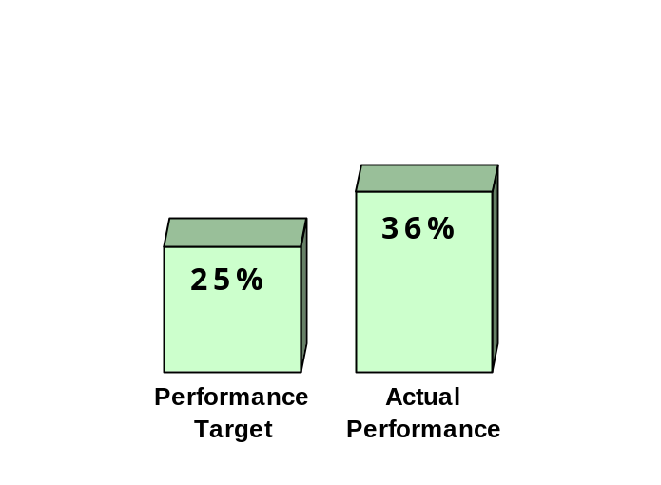
Education Gain – Basic Literacy Skills
Percent of adults enrolled who acquired the level of basic skills needed to complete at least one education level (minimum Grade Level Equivalent – 2 years)

• 466,846 adults advanced one or more education levels

Exhibit 2 compares actual to targeted performance for the basic skill educational gain measure. Nationally, thirty-six percent of adults enrolled in basic skills instruction (reading, numeracy, English language arts, problem solving, etc.) demonstrated improvement in basic skills and advanced one or more educational functioning levels. Each enrolled adult is initially placed (through formalized assessment) in one of five educational levels, which are arranged in a hierarchy from beginning literacy to the high school level, and demonstrate educational gain through subsequent formal assessment.

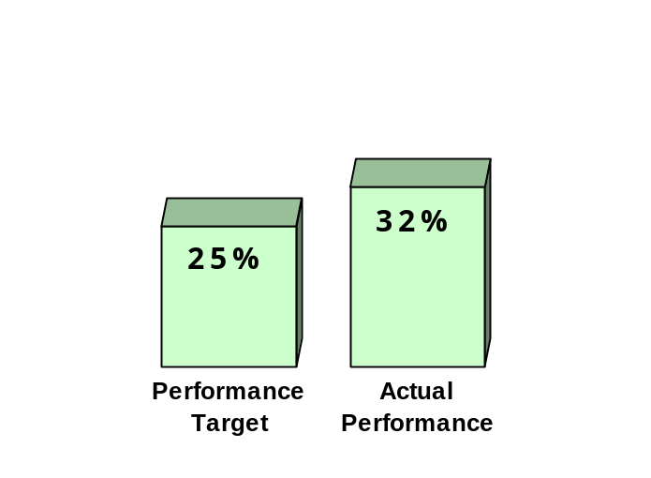Exhibit 3

Education Gain - English Language Acquisition
Percent of enrolled adults who acquired the level of English language skills needed to complete at least one educational level.

• 350,271 adults advanced one or more educational levels.

Exhibit 3 compares actual performance to targeted performance for the English Literacy educational gain measure. Nationally, thirty-two percent of adults enrolled in English literacy instruction demonstrated improvement in English language skills and advanced one or more educational functioning levels. Each enrolled adult is initially placed (through formalized assessment) into one of six educational levels, which are arranged in a hierarchy of skills from non-speakers of English to highly proficient speakers of English and demonstrate English language acquisition through subsequent formal assessment.

Exhibit 4
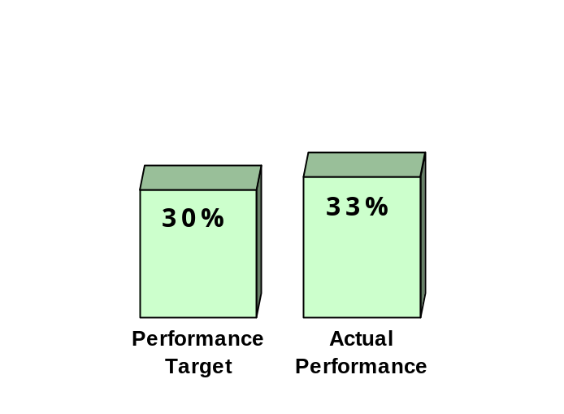

High School Completion
Percent of enrolled adults with a high school completion goal who earned a high school diploma or GED.

• 197,720 adults earned a high school diploma or a GED.

Exhibit 4 compares actual performance to targeted performance for the high school completion measure. Nationally, thirty-three percent of all enrolled adults with a high school completion goal obtained a high school diploma or GED.

Exhibit 5
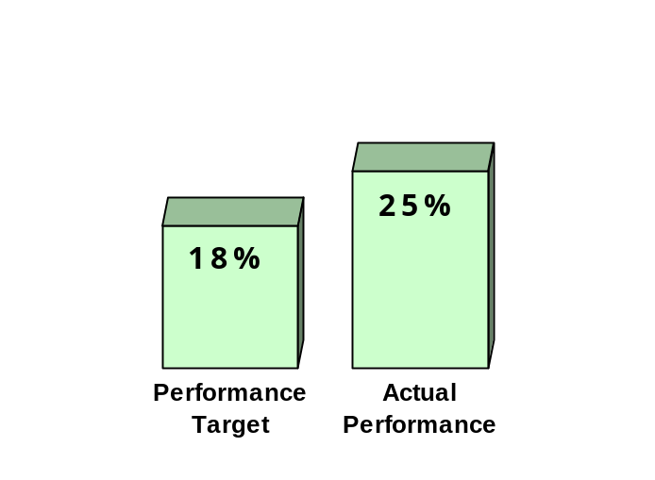

Entered Postsecondary Education or Training
Percent of enrolled adults with a goal to transition to postsecondary education or training who enrolled in postsecondary education or training after exiting the program

• 53,860 adults enrolled in postsecondary education or training.

Exhibit 5 compares actual performance to targeted performance for the postsecondary education or training measure. Nationally, twenty-five percent of enrolled adults who had a goal of furthering their education after completing adult education transitioned into a postsecondary education or training program.

Exhibit 6
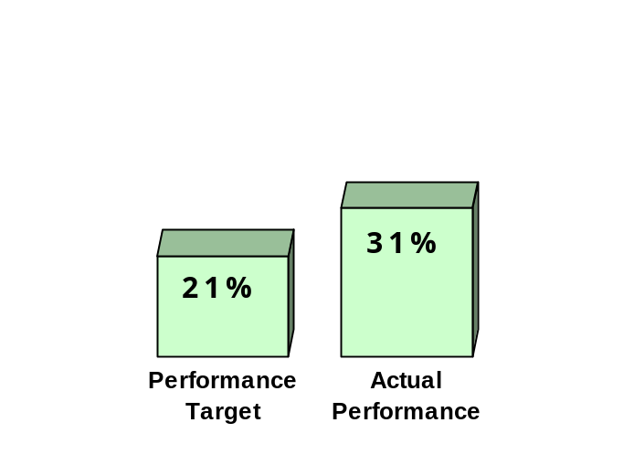
Entered Employment
Percent of enrolled adults with an employment goal who were employed one quarter after program exit.

• 137,649 adults were employed one quarter after program exit.

Exhibit 6 compares actual performance to targeted performance for the entered employment measure. Nationally, thirty-one percent of enrolled adults with an employment goal were employed one quarter after exiting the program.

Exhibit 7
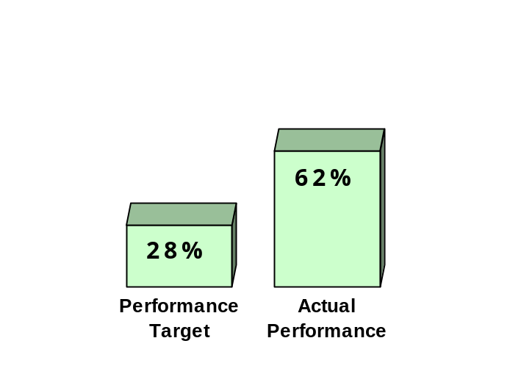

Job Retention
Percent of adults who retained a job three quarters after program exit.

• 232,723 adults retained employment three quarters after leaving the program.

Exhibit 7 compares actual performance to targeted performance for the job retention measure. Nationally, sixty-two percent of adults who had obtained a job one quarter after exiting the program and/or enrolled in the program with a goal to retain or improve their job status were still employed three quarters after exiting the program.

National Profile of Selected Program and
Student Information

UNITED STATES

PROGRAM FACTS – 2000-2001

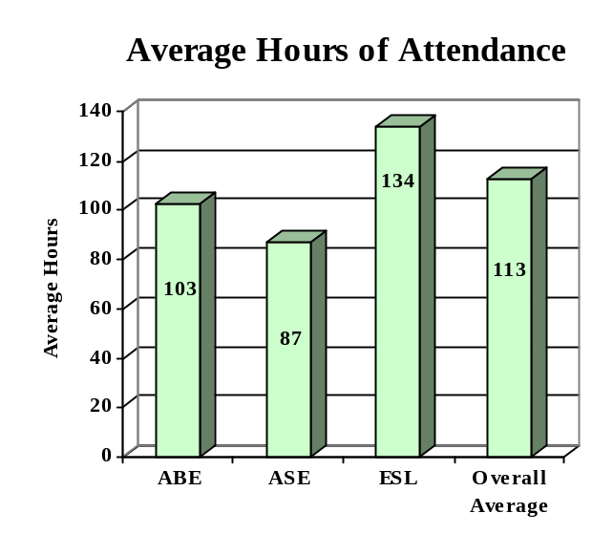

ENROLLMENT

Adult Basic Education 998,152 (37%)

Adult Secondary Education 555,855 (21%)
English Literacy 1,119,685 (42%)

TOTAL 2,673,692

PARTICIPANT STATUS

Employed - 947,902

Unemployed - 958,773

Correctional Setting - 248,134

On Public Assistance - 254,267

Other Institutionalized - 47,361

AGE

16 - 18 383,668 (14%)

19 - 24 711,346 (27%)
25 - 44 1,178,023 (44%)

45 - 59 296,418 (11%)
60 + 104,237 (04%)

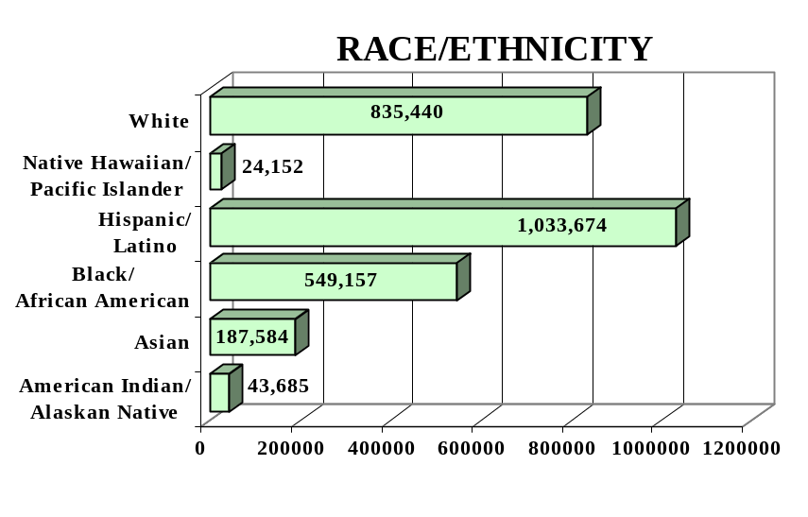
GENDER

Male - 1,265,650 (47%) Female - 1,408,042 (53%)

FEDERAL ALLOCATION
FY 2000

Basic Grant - $416,416,000
EL/Civics - $ 25,500,000

TOTAL - $441,916,000

Individual State Performance Data

ALABAMA

PROGRAM FACTS – 2000-2001

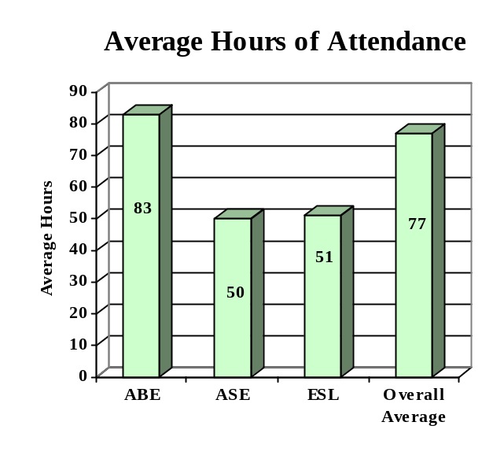

ENROLLMENT

Adult Basic Education 19,404 (82%)

Adult Secondary Education 2,672 (11%)
English Literacy 1,590 (07%)

TOTAL 23,666

PARTICIPANT STATUS

Employed - 8,290

Unemployed - 11,209

Correctional Setting - 3,534

On Public Assistance - 3,945

Other Institutionalized - 1,065

AGE

16 - 18 6,557 (28%)

19 - 24 6,381 (27%)
25 - 44 8,110 (34%)

45 - 59 2,027 (09%)
60 + 591 (02%)

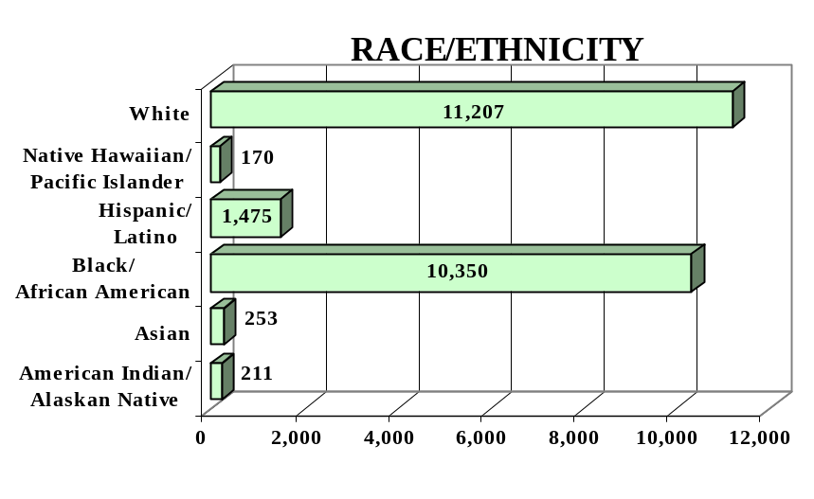
GENDER

Male - 11,639 (49%) Female - 12,027 (51%)

FEDERAL ALLOCATION
FY 2000

Basic Grant - $ 8,554,513
EL/Civics - $ 0

TOTAL - $ 8,554,513

ALABAMA | Average  Performance Target | Actual  Performance | Status | Adults Completing  at Least One Level
Performance Measure I – Demonstrated Improvement in Literacy Skills  Sub Measures  Adult Basic and Secondary Education:^{1/} The percentage of adults enrolled in basic literacy programs who acquired the basic skills needed to complete the level of instruction in which they were initially enrolled.  English Literacy: ^{2/} The percentage of adults enrolled in English Literacy programs who acquired the level of English language skills needed to complete the level of instruction in which they were initially enrolled. | 23%  23% | 26%  26% | ↑  ↑ | 5,472  408
 | Performance Target | Actual  Performance | Status | Adults Achieving  Outcome
Performance Measure II – High School Completion  The percentage of adult learners with a high school completion goal who earned a high school diploma or GED.  Performance Measure III – Entered Postsecondary Education or Training  The percentage of adult learners with a goal to continue their education who enter postsecondary education or training.  Performance Measure IV - Entered Employment  The percentage of unemployed adult learners (in the workforce) with an employment goal who were employed at the end of first quarter after they exited the program.  Performance Measure V – Retained Employment  The percentage of adult learners with a) a job retention goal at the time of enrollment and b) those adults with an employment goal who obtained work by the end of the first quarter after leaving the program who were employed at the end of third quarter after exiting the program. | 35%  20%  20%  24% | 54%  31%  49%  70% | ↑  ↑  ↑  ↑ | 2,289  102  107  95

Key
↑ Exceeded Performance Target

Follow-up Methodology Used to Collect Performance Data

Educational Gains
√ Standardized Test(s)

High School Completion Measure
√ State developed individual student follow-up survey

Postsecondary Transition
√ State developed individual student follow-up survey

Entered Employment
√ State developed individual student follow-up survey

Job Retention
√ State developed individual student follow-up survey
↔ Met Performance Target
↓ Did Not Meet Performance Target

^{1/} Adult Basic and Secondary Education programs consist of a series of instructional levels with each level representing a hierarchy of basic skills ranging from beginning literacy to high school completion.

^{2/} English Literacy education programs consist of a set of instructional levels with each level representing a hierarchy of English language skills ranging from beginning language literacy to oral language proficiency.

ALASKA

PROGRAM FACTS – 2000-2001

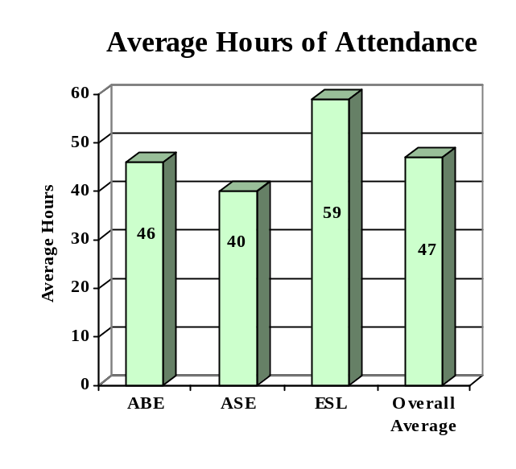

ENROLLMENT

Adult Basic Education 2,525 (48%)

Adult Secondary Education 1,696 (32%)
English Literacy 1,091 (20%)

TOTAL 5,312

PARTICIPANT STATUS

Employed - 1,336

Unemployed - 3,216

Correctional Setting - 895

On Public Assistance - 1,018

Other Institutionalized - 3

AGE

16 - 18 803 (15%)

19 - 24 1,338 (25%)
25 - 44 2,240 (42%)

45 - 59 717 (14%)
60 + 214 (04%)

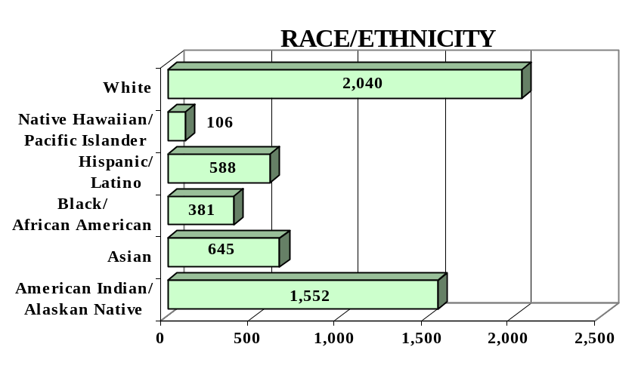
GENDER

Male - 2,538 (48%) Female - 2,774 (52%)

FEDERAL ALLOCATION
FY 2000

Basic Grant - $ 704,065
EL/Civics - $ 0

TOTAL - $ 704,065

ALASKA | Average  Performance Target | Actual  Performance | Status | Adults Completing  at Least One Level
Performance Measure I – Demonstrated Improvement in Literacy Skills  Sub Measures  Adult Basic and Secondary Education:^{1/} The percentage of adults enrolled in basic literacy programs who acquired the basic skills needed to complete the level of instruction in which they were initially enrolled.  English Literacy: ^{2/} The percentage of adults enrolled in English Literacy programs who acquired the level of English language skills needed to complete the level of instruction in which they were initially enrolled. | 20%  44% | 55%  36% | ↑  ↓ | 1,820  1,785
 | Performance Target | Actual  Performance | Status | Adults Achieving  Outcome
Performance Measure II – High School Completion  The percentage of adult learners with a high school completion goal who earned a high school diploma or GED.  Performance Measure III – Entered Postsecondary Education or Training  The percentage of adult learners with a goal to continue their education who enter postsecondary education or training.  Performance Measure IV - Entered Employment  The percentage of unemployed adult learners (in the workforce) with an employment goal who were employed at the end of first quarter after they exited the program.  Performance Measure V – Retained Employment  The percentage of adult learners with a) a job retention goal at the time of enrollment and b) those adults with an employment goal who obtained work by the end of the first quarter after leaving the program who were employed at the end of third quarter after exiting the program. | 28%  10%  10%  10% | 58%  42%  52%  65% | ↑  ↑  ↑  ↑ | 1,,291  303  673  339

Follow-up Methodology Used to Collect Performance Data

Educational Gains
√ Standardized tests

High School Completion Measure
√ State developed individual student follow-up survey

Postsecondary Transition
√ State developed individual student follow-up survey

Entered Employment
√ Data matching (UI employment records)

Job Retention
√ Data matching (UI employment records)

Key
↑ Exceeded Performance Target
↔ Met Performance Target
↓ Did Not Meet Performance Target

^{1/} Adult Basic and Secondary Education programs consist of a series of instructional levels with each level representing a hierarchy of basic skills ranging from beginning literacy to high school completion.

^{2/} English Literacy education programs consist of a set of instructional levels with each level representing a hierarchy of English language skills ranging from beginning language literacy to oral language proficiency.

ARIZONA

PROGRAM FACTS – 2000-2001

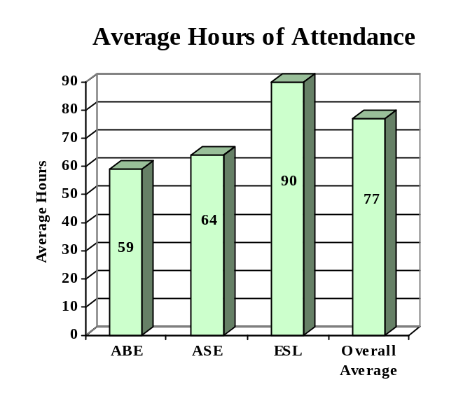

ENROLLMENT

Adult Basic Education 10,675 (34%)

Adult Secondary Education 2,523 (08%)
English Literacy 17,938 (58%)

TOTAL 31,136

PARTICIPANT STATUS

Employed - 14,614

Unemployed - 10,197

Correctional Setting - 1,962

On Public Assistance - 1,576

Other Institutionalized - 161

AGE

16 - 18 2,607 (08%)

19 - 24 8,059 (26%)
25 - 44 16,272 (52%)

45 - 59 3,407 (11%)
60 + 791 (03%)

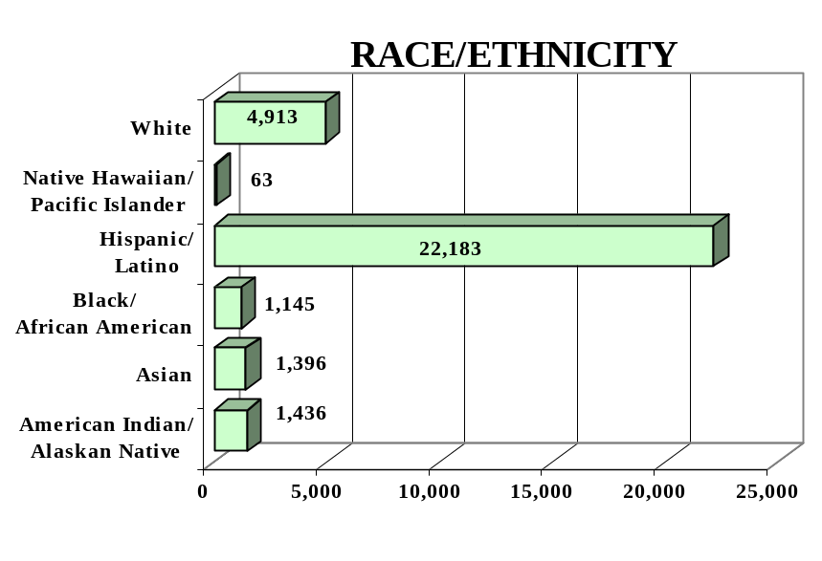
GENDER

Male - 12,999 (42%) Female - 18,137 (58%)

FEDERAL ALLOCATION
FY 2000

Basic Grant - $ 5,388,874
EL/Civics - $ 316,654

TOTAL - $ 5,705,528

ARIZONA | Average  Performance Target | Actual  Performance | Status | Adults Completing  at Least One Level
Performance Measure I – Demonstrated Improvement in Literacy Skills  Sub Measures  Adult Basic and Secondary Education:^{1/} The percentage of adults enrolled in basic literacy programs who acquired the basic skills needed to complete the level of instruction in which they were initially enrolled.  English Literacy: ^{2/} The percentage of adults enrolled in English Literacy programs who acquired the level of English language skills needed to complete the level of instruction in which they were initially enrolled. | 20%  20% | 34%  34% | ↑  ↑ | 4,231  6,122
 | Performance Target | Actual  Performance | Status | Adults Achieving  Outcome
Performance Measure II – High School Completion  The percentage of adult learners with a high school completion goal who earned a high school diploma or GED.  Performance Measure III – Entered Postsecondary Education or Training  The percentage of adult learners with a goal to continue their education who enter postsecondary education or training.  Performance Measure IV - Entered Employment  The percentage of unemployed adult learners (in the workforce) with an employment goal who were employed at the end of first quarter after they exited the program.  Performance Measure V – Retained Employment  The percentage of adult learners with a) a job retention goal at the time of enrollment and b) those adults with an employment goal who obtained work by the end of the first quarter after leaving the program who were employed at the end of third quarter after exiting the program. | 30%  10%  12%  35% | 28%  38%  37%  45% | ↓  ↑  ↑  ↑ | 1,735  587  1,005  1,450

Follow-up Methodology Used to Collect Performance Data

Educational Gains
√ Standardized tests

High School Completion Measure
√ Data matching (Official state GED records)

Postsecondary Transition
√ Data matching (community college enrollment database)
√ State developed individual student follow-up survey

Entered Employment
√ State developed individual student follow-up survey

Job Retention
√ State developed individual student follow-up survey

Key
↑ Exceeded Performance Target
↔ Met Performance Target
↓ Did Not Meet Performance Target

^{1/} Adult Basic and Secondary Education programs consist of a series of instructional levels with each level representing a hierarchy of basic skills ranging from beginning literacy to high school completion.

^{2/} English Literacy education programs consist of a set of instructional levels with each level representing a hierarchy of English language skills ranging from beginning language literacy to oral language proficiency.

ARKANSAS

PROGRAM FACTS – 2000-2001

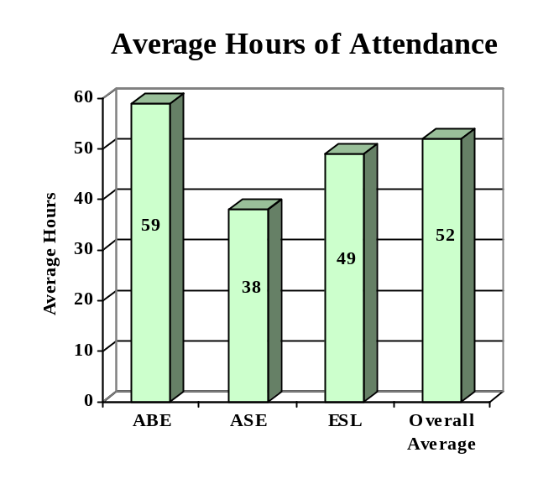

ENROLLMENT

Adult Basic Education 22,542 (58%)

Adult Secondary Education 12,243 (31%)
English Literacy 4,082 (11%)

TOTAL 38,867

PARTICIPANT STATUS

Employed - 16,183

Unemployed - 18,133

Correctional Setting - 3,481

On Public Assistance - 6,222

Other Institutionalized - 1,960

AGE

16 - 18 6,110 (16%)

19 - 24 9,548 (25%)
25 - 44 15,739 (40%)

45 - 59 5,157 (13%)
60 + 2,313 (06%)

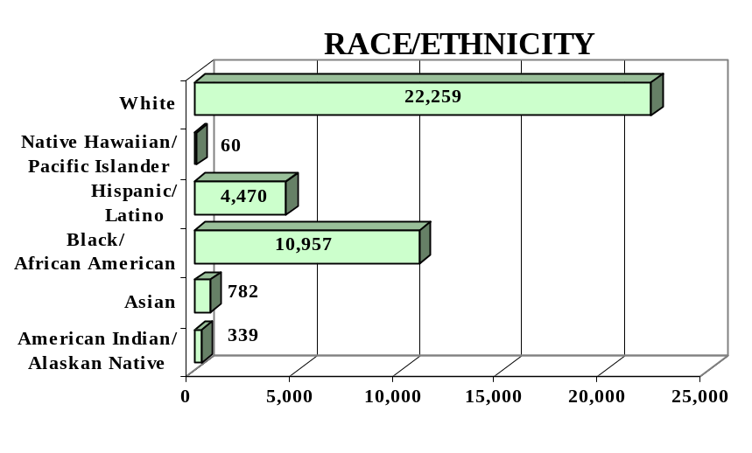
GENDER

Male - 17,879 (46%) Female - 20,988 (54%)

FEDERAL ALLOCATION
FY 2000

Basic Grant - $ 5,127,764
EL/Civics - $ 0

TOTAL - $ 5,127,764

ARKANSAS | Average  Performance Target | Actual  Performance | Status | Adults Completing  at Least One Level
Performance Measure I – Demonstrated Improvement in Literacy Skills  Sub Measures  Adult Basic and Secondary Education:^{1/} The percentage of adults enrolled in basic literacy programs who acquired the basic skills needed to complete the level of instruction in which they were initially enrolled.  English Literacy: ^{2/} The percentage of adults enrolled in English Literacy programs who acquired the level of English language skills needed to complete the level of instruction in which they were initially enrolled. | 18%  17% | 36%  29% | ↑  ↑ | 10,324  1,180
 | Performance Target | Actual  Performance | Status | Adults Achieving  Outcome
Performance Measure II – High School Completion  The percentage of adult learners with a high school completion goal who earned a high school diploma or GED.  Performance Measure III – Entered Postsecondary Education or Training  The percentage of adult learners with a goal to continue their education who enter postsecondary education or training.  Performance Measure IV - Entered Employment  The percentage of unemployed adult learners (in the workforce) with an employment goal who were employed at the end of first quarter after they exited the program.  Performance Measure V – Retained Employment  The percentage of adult learners with a) a job retention goal at the time of enrollment and b) those adults with an employment goal who obtained work by the end of the first quarter after leaving the program who were employed at the end of third quarter after exiting the program. | 25%  15%  18%  17% | 77%  70%  78%  82% | ↑  ↑  ↑  ↑ | 5,283  1,047  2,492  3345

Follow-up Methodology Used to Collect Performance Data

Educational Gains
√ Standardized tests

High School Completion Measure
√ Data matching (Official state GED records)

Postsecondary Transition
√ Individual student follow-up survey

Entered Employment
√ Individual student follow-up survey

Job Retention
√ Individual student follow-up survey

Key
↑ Exceeded Performance Target
↔ Met Performance Target
↓ Did Not Meet Performance Target

^{1/} Adult Basic and Secondary Education programs consist of a series of instructional levels with each level representing a hierarchy of basic skills ranging from beginning literacy to high school completion.

^{2/} English Literacy education programs consist of a set of instructional levels with each level representing a hierarchy of English language skills ranging from beginning language literacy to oral language proficiency.

CALIFORNIA

PROGRAM FACTS – 2000-2001

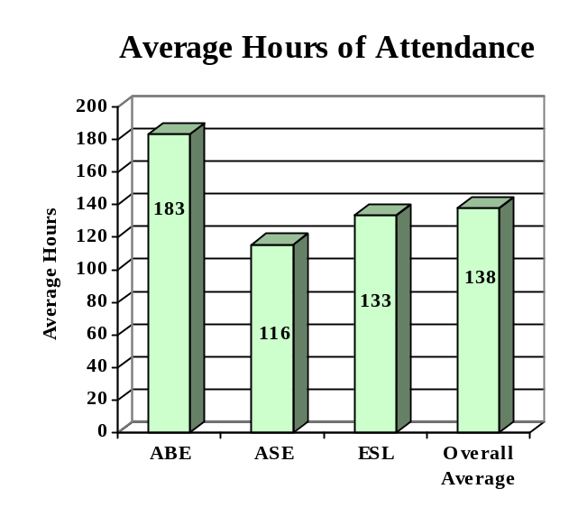

ENROLLMENT

Adult Basic Education 63,684 (13%)

Adult Secondary Education 42,362 (09%)
English Literacy 367,004 (78%)

TOTAL 473,050

PARTICIPANT STATUS

Employed - 154,194

Unemployed - 95,022

Correctional Setting - 22,076

On Public Assistance - 23,989

Other Institutionalized - NA

AGE

16 - 18 42,977 (09%)

19 - 24 111,583 (24%)
25 - 44 238,178 (50%)

45 - 59 54,467 (12%)
60 + 25,845 (05%)

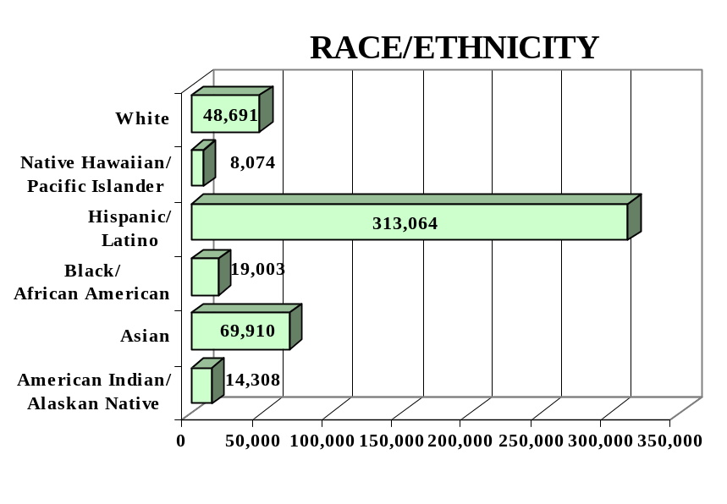
GENDER

Male - 217,335 (46%) Female -255,715 (54%)

FEDERAL ALLOCATION
FY 2000

Basic Grant - $47,505,017
EL/Civics - $ 7,650,885

TOTAL - $55,155,902

CALIFORNIA | Average  Performance Target | Actual  Performance | Status | Adults Completing  at Least One Level
Performance Measure I – Demonstrated Improvement in Literacy Skills  Sub Measures  Adult Basic and Secondary Education:^{1/} The percentage of adults enrolled in basic literacy programs who acquired the basic skills needed to complete the level of instruction in which they were initially enrolled.  English Literacy: ^{2/} The percentage of adults enrolled in English Literacy programs who acquired the level of English language skills needed to complete the level of instruction in which they were initially enrolled. | 19%  22% | 25%  31% | ↑  ↑ | 22,807  113,410
 | Performance Target | Actual  Performance | Status | Adults Achieving  Outcome
Performance Measure II – High School Completion  The percentage of adult learners with a high school completion goal who earned a high school diploma or GED.  Performance Measure III – Entered Postsecondary Education or Training  The percentage of adult learners with a goal to continue their education who enter postsecondary education or training.  Performance Measure IV - Entered Employment  The percentage of unemployed adult learners (in the workforce) with an employment goal who were employed at the end of first quarter after they exited the program.  Performance Measure V – Retained Employment  The percentage of adult learners with a) a job retention goal at the time of enrollment and b) those adults with an employment goal who obtained work by the end of the first quarter after leaving the program who were employed at the end of third quarter after exiting the program. | 08%  06%  09%  11% | 27%  12%  18%  34% | ↑  ↓  ↑  ↑ | 7,609  1,249  1907  2,075

Follow-up Methodology Used to Collect Performance Data

Educational Gains
√ Standardized tests

High School Completion Measure
√ State developed individual student follow-up survey

Postsecondary Transition
√ State developed individual student follow-up survey

Entered Employment
√ State developed individual student follow-up survey

Job Retention
√ State developed individual student follow-up survey

Key
↑ Exceeded Performance Target
↔ Met Performance Target
↓ Did Not Meet Performance Target

^{1/} Adult Basic and Secondary Education programs consist of a series of instructional levels with each level representing a hierarchy of basic skills ranging from beginning literacy to high school completion.

^{2/} English Literacy education programs consist of a set of instructional levels with each level representing a hierarchy of English language skills ranging from beginning language literacy to oral language proficiency.

COLORADO

PROGRAM FACTS – 2000-2001

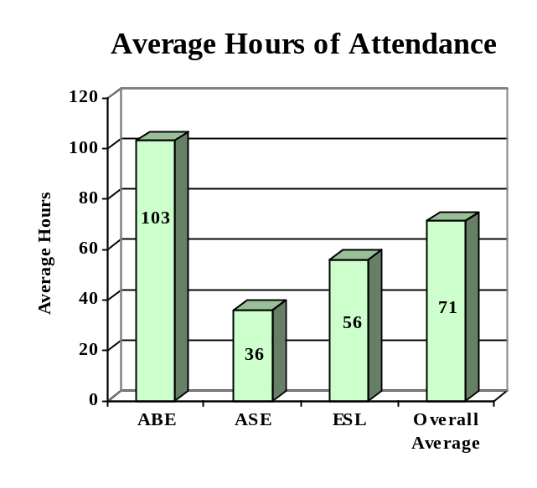

ENROLLMENT

Adult Basic Education 5,148 (37%)

Adult Secondary Education 1,570 (11%)
English Literacy 7,100 (52%)

TOTAL 13,818

PARTICIPANT STATUS

Employed - 6,599

Unemployed - 3,613

Correctional Setting - 1,950

On Public Assistance - 1,409

Other Institutionalized - 52

AGE

16 - 18 2,483 (18%)

19 - 24 3,739 (27%)
25 - 44 6,325 (46%)

45 - 59 1,003 (07%)
60 + 268 (02%)

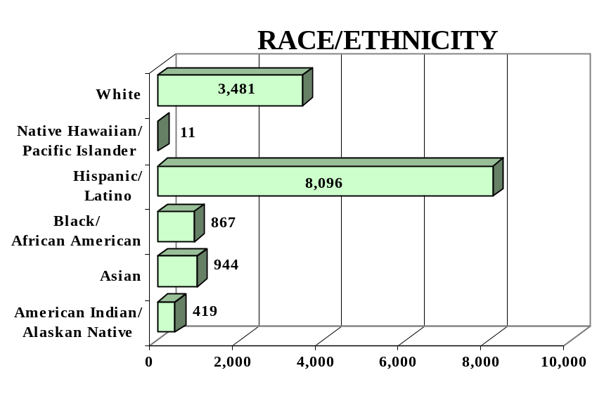
GENDER

Male - 6,780 (49%) Female - 7,038 (51%)

FEDERAL ALLOCATION
FY 2000

Basic Grant - $ 3,584,761
EL/Civics - $ 232,990

TOTAL - $ 3,817,751

COLORADO | Average  Performance Target | Actual  Performance | Status | Adults Completing  at Least One Level
Performance Measure I – Demonstrated Improvement in Literacy Skills  Sub Measures  Adult Basic and Secondary Education:^{1/} The percentage of adults enrolled in basic literacy programs who acquired the basic skills needed to complete the level of instruction in which they were initially enrolled.  English Literacy: ^{2/} The percentage of adults enrolled in English Literacy programs who acquired the level of English language skills needed to complete the level of instruction in which they were initially enrolled. | 32%  28% | 48%  46% | ↑  ↑ | 2,932  3,246
 | Performance Target | Actual  Performance | Status | Adults Achieving  Outcome
Performance Measure II – High School Completion  The percentage of adult learners with a high school completion goal who earned a high school diploma or GED.  Performance Measure III – Entered Postsecondary Education or Training  The percentage of adult learners with a goal to continue their education who enter postsecondary education or training.  Performance Measure IV - Entered Employment  The percentage of unemployed adult learners (in the workforce) with an employment goal who were employed at the end of first quarter after they exited the program.  Performance Measure V – Retained Employment  The percentage of adult learners with a) a job retention goal at the time of enrollment and b) those adults with an employment goal who obtained work by the end of the first quarter after leaving the program who were employed at the end of third quarter after exiting the program. | 22%  17%  11%  17% | 25%  20%  26%  25% | ↑  ↑  ↑  ↑ | 1,665  851  407  42

Follow-up Methodology Used to Collect Performance Data

Educational Gains
√ Combination of standardized tests and performance-based assessment

High School Completion Measure
√ State developed individual student follow-up survey

Postsecondary Transition
√ State developed individual student follow-up survey

Entered Employment
√ State developed individual student follow-up survey

Job Retention
√ State developed individual student follow-up survey

Key
↑ Exceeded Performance Target
↔ Met Performance Target
↓ Did Not Meet Performance Target

^{1/} Adult Basic and Secondary Education programs consist of a series of instructional levels with each level representing a hierarchy of basic skills ranging from beginning literacy to high school completion.

^{2/} English Literacy education programs consist of a set of instructional levels with each level representing a hierarchy of English language skills ranging from beginning language literacy to oral language proficiency.

CONNECTICUT

PROGRAM FACTS – 2000-2001

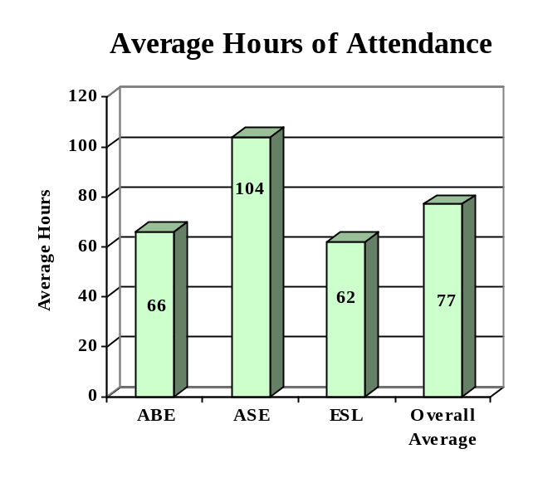

ENROLLMENT

Adult Basic Education 5,428 (18%)

Adult Secondary Education 10,876 (35%)
English Literacy 14,540 (47%)

TOTAL 30,844

PARTICIPANT STATUS

Employed - 15,685

Unemployed - 13,140

Correctional Setting - 1,021

On Public Assistance - 1,732

Other Institutionalized - 269

AGE

16 - 18 5,979 (20%)

19 - 24 7,165 (23%)
25 - 44 13,351 (43%)

45 - 59 3,426 (11%)
60 + 923 (03%)

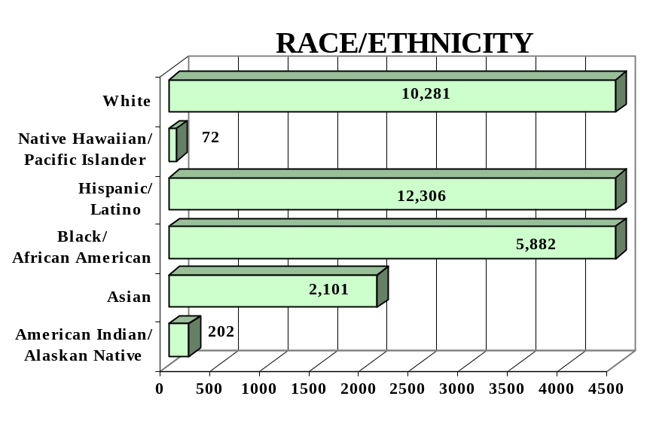
GENDER

Male - 13,856 (45%) Female - 16,988 (55%)

FEDERAL ALLOCATION
FY 2000

Basic Grant - $4,720,018
EL/Civics - $ 287,247

TOTAL - $5,007,265

CONNECTICUT | Average  Performance Target | Actual  Performance | Status | Adults Completing  at Least One Level
Performance Measure I – Demonstrated Improvement in Literacy Skills  Sub Measures  Adult Basic and Secondary Education:^{1/} The percentage of adults enrolled in basic literacy programs who acquired the basic skills needed to complete the level of instruction in which they were initially enrolled.  English Literacy: ^{2/} The percentage of adults enrolled in English Literacy programs who acquired the level of English language skills needed to complete the level of instruction in which they were initially enrolled. | 31%  31% | 28%  28% | ↓  ↓ | 2007  4080
 | Performance Target | Actual  Performance | Status | Adults Achieving  Outcome
Performance Measure II – High School Completion  The percentage of adult learners with a high school completion goal who earned a high school diploma or GED.  Performance Measure III – Entered Postsecondary Education or Training  The percentage of adult learners with a goal to continue their education who enter postsecondary education or training.  Performance Measure IV - Entered Employment  The percentage of unemployed adult learners (in the workforce) with an employment goal who were employed at the end of first quarter after they exited the program.  Performance Measure V – Retained Employment  The percentage of adult learners with a) a job retention goal at the time of enrollment and b) those adults with an employment goal who obtained work by the end of the first quarter after leaving the program who were employed at the end of third quarter after exiting the program. | 25%  13%  13%  25% | 76%  48%  47%  69% | ↑  ↑  ↑  ↑ | 1,623  198  1,364  3,706

Follow-up Methodology Used to Collect Performance Data

Educational Gains
√ Standardized tests and granting of high school credits

High School Completion Measure
√ Data matching (Official state GED records)

Postsecondary Transition
√ State developed individual student follow-up survey

Entered Employment
√ Data matching (UI employment records)

Job Retention
√ Data matching (UI employment records)

Key
↑ Exceeded Performance Target
↔ Met Performance Target
↓ Did Not Meet Performance Target

^{1/} Adult Basic and Secondary Education programs consist of a series of instructional levels with each level representing a hierarchy of basic skills ranging from beginning literacy to high school completion.

^{2/} English Literacy education programs consist of a set of instructional levels with each level representing a hierarchy of English language skills ranging from beginning language literacy to oral language proficiency.

DELAWARE

PROGRAM FACTS – 2000-2001

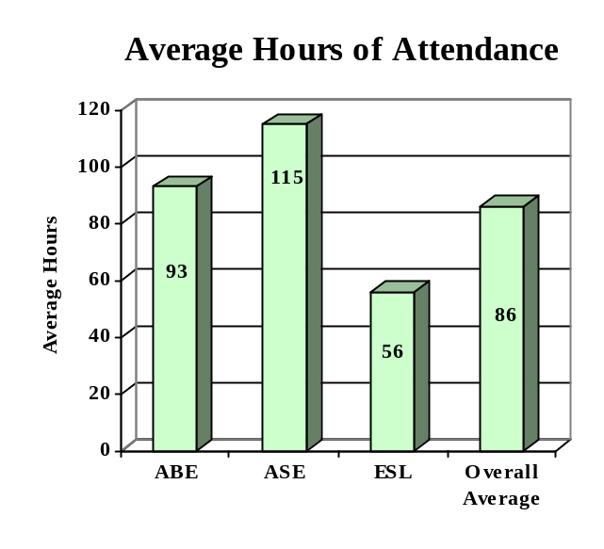

ENROLLMENT

Adult Basic Education 2,616 (60%)

Adult Secondary Education 526 (12%)
English Literacy 1,200 (28%)

TOTAL 4,342

PARTICIPANT STATUS

Employed - 1,735

Unemployed - 885

Correctional Setting - 864

On Public Assistance - 398

Other Institutionalized - 76

AGE

16 - 18 869 (20%)

19 - 24 1,237 (28%)
25 - 44 1,823 (42%)

45 - 59 332 (08%)
60 + 81 (02%)

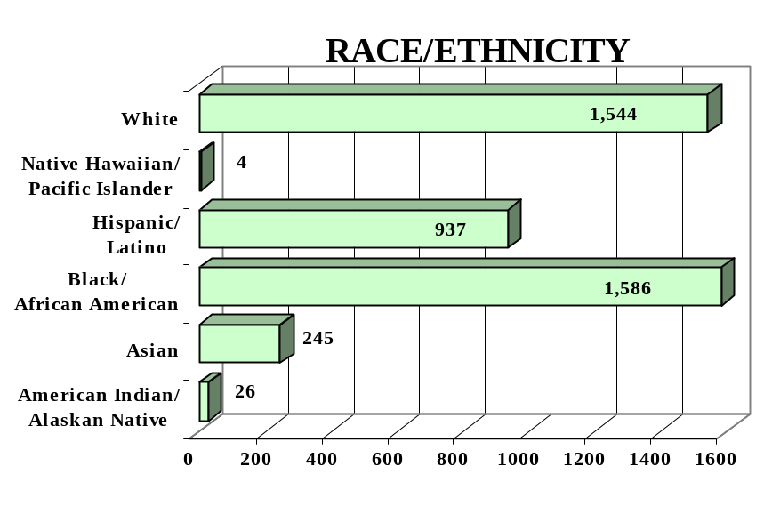
GENDER

Male - 2,403 (55%) Female - 1,939 (45%)

FEDERAL ALLOCATION
FY 2000

Basic Grant - $1,202,975
EL/Civics - $ -0-

TOTAL - $1,202,975

DELAWARE | Average  Performance Target | Actual  Performance | Status | Adults Completing  at Least One Level
Performance Measure I – Demonstrated Improvement in Literacy Skills  Sub Measures  Adult Basic and Secondary Education:^{1/} The percentage of adults enrolled in basic literacy programs who acquired the basic skills needed to complete the level of instruction in which they were initially enrolled.  English Literacy: ^{2/} The percentage of adults enrolled in English Literacy programs who acquired the level of English language skills needed to complete the level of instruction in which they were initially enrolled. | 25%  25% | 27%  20% | ↑  ↓ | 825  243
 | Performance Target | Actual  Performance | Status | Adults Achieving  Outcome
Performance Measure II – High School Completion  The percentage of adult learners with a high school completion goal who earned a high school diploma or GED.  Performance Measure III – Entered Postsecondary Education or Training  The percentage of adult learners with a goal to continue their education who enter postsecondary education or training.  Performance Measure IV - Entered Employment  The percentage of unemployed adult learners (in the workforce) with an employment goal who were employed at the end of first quarter after they exited the program.  Performance Measure V – Retained Employment  The percentage of adult learners with a) a job retention goal at the time of enrollment and b) those adults with an employment goal who obtained work by the end of the first quarter after leaving the program who were employed at the end of third quarter after exiting the program. | 25%  25%  25%  25% | 37%  37%  64%  75% | ↑  ↑  ↑  ↑ | 349  90  151  516

Follow-up Methodology Used to Collect Performance Data

Educational Gains
√ Standardized tests and portfolios with standardized tests

High School Completion Measure
√ Data matching (Official state GED data base) and high school graduation records

Postsecondary Transition
√ State developed, locally administered follow-up.

Entered Employment
√ State developed, locally administered follow-up

Job Retention
√ State developed, locally administered follow-up

Key
↑ Exceeded Performance Target
↔ Met Performance Target
↓ Did Not Meet Performance Target

^{1/} Adult Basic and Secondary Education programs consist of a series of instructional levels with each level representing a hierarchy of basic skills ranging from beginning literacy to high school completion.

^{2/} English Literacy education programs consist of a set of instructional levels with each level representing a hierarchy of English language skills ranging from beginning language literacy to oral language proficiency.

DISTRICT OF COLUMBIA

PROGRAM FACTS – 2000-2001

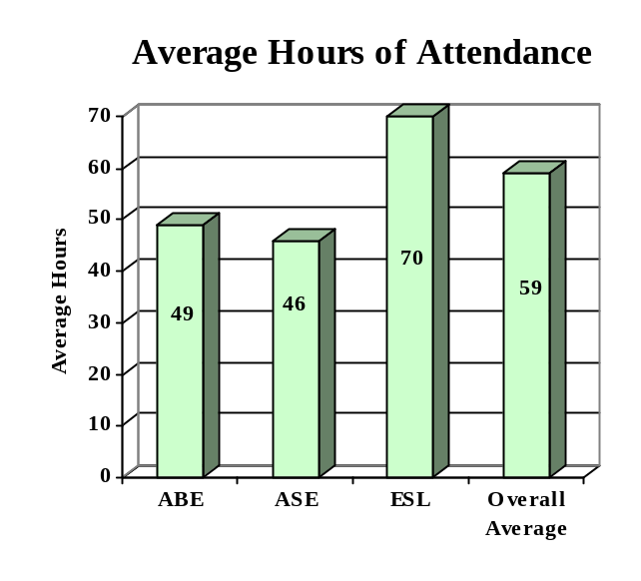

ENROLLMENT

Adult Basic Education 1,385 (38%)

Adult Secondary Education 369 (10%)
English Literacy 1,913 (52%)

TOTAL 3,667

PARTICIPANT STATUS

Employed - 2,084

Unemployed - 1,087

Correctional Setting - 125

On Public Assistance - 322

Other Institutionalized - 8

AGE

16 - 18 213 (06%)

19 - 24 1,027 (28%)
25 - 44 1,789 (49%)

45 - 59 496 (13%)
60 + 142 (04%)

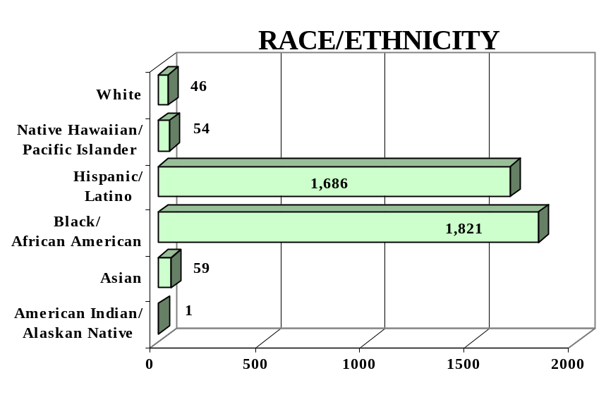
GENDER

Male - 1,656 (45%) Female - 2,011 (55%)

FEDERAL ALLOCATION
FY 2000

Basic Grant - $1,367,111
EL/Civics - $ 104,495

TOTAL - $1,471,606

DISTRICT OF COLUMBIA | Average  Performance Target | Actual  Performance | Status | Adults Completing  at Least One Level
Performance Measure I – Demonstrated Improvement in Literacy Skills  Sub Measures  Adult Basic and Secondary Education:^{1/} The percentage of adults enrolled in basic literacy programs who acquired the basic skills needed to complete the level of instruction in which they were initially enrolled.  English Literacy: ^{2/} The percentage of adults enrolled in English Literacy programs who acquired the level of English language skills needed to complete the level of instruction in which they were initially enrolled. | 22%  22% | 55%  36% | ↑  ↑ | 3,732  1,785
 | Performance Target | Actual  Performance | Status | Adults Achieving  Outcome
Performance Measure II – High School Completion  The percentage of adult learners with a high school completion goal who earned a high school diploma or GED.  Performance Measure III – Entered Postsecondary Education or Training  The percentage of adult learners with a goal to continue their education who enter postsecondary education or training.  Performance Measure IV - Entered Employment  The percentage of unemployed adult learners (in the workforce) with an employment goal who were employed at the end of first quarter after they exited the program.  Performance Measure V – Retained Employment  The percentage of adult learners with a) a job retention goal at the time of enrollment and b) those adults with an employment goal who obtained work by the end of the first quarter after leaving the program who were employed at the end of third quarter after exiting the program. | 12%  20%  23%  12% | 62%  85%  62%  42% | ↑  ↑  ↑  ↑ | 74  102  267  364

Follow-up Methodology Used to Collect Performance Data

Educational Gains
√ Standardized tests

High School Completion Measure
√ Data matching (Official state GED records)

Postsecondary Transition
√ Individual student follow-up survey

Entered Employment
√ Individual student follow-up survey

Job Retention
√ Individual student follow-up survey

Key
↑ Exceeded Performance Target
↔ Met Performance Target
↓ Did Not Meet Performance Target

^{1/} Adult Basic and Secondary Education programs consist of a series of instructional levels with each level representing a hierarchy of basic skills ranging from beginning literacy to high school completion.

^{2/} English Literacy education programs consist of a set of instructional levels with each level representing a hierarchy of English language skills ranging from beginning language literacy to oral language proficiency.

FLORIDA

PROGRAM FACTS – 2000-2001

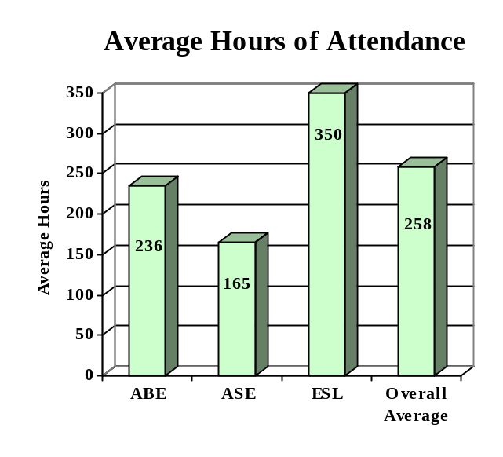

ENROLLMENT

Adult Basic Education 134,146 (33%)

Adult Secondary Education 117,972 (29%)
English Literacy 152,794 (38%)

TOTAL 404,912

PARTICIPANT STATUS

Employed - 92,943

Unemployed -308,447

Correctional Setting - 27,693

On Public Assistance - 35,623

Other Institutionalized - 15,535

AGE

16 - 18 82,439 (20%)

19 - 24 115,230 (29%)
25 - 44 154,503 (38%)

45 - 59 41,399 (10%)
60 + 11,341 (03%)

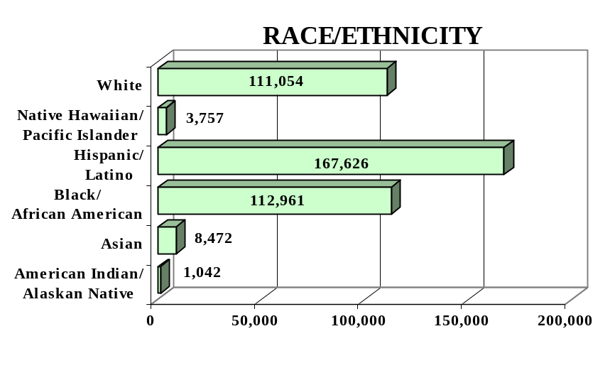
GENDER

Male -197,398 (49%) Female - 207,514 (51%)

FEDERAL ALLOCATION
FY 2000

Basic Grant - $ 22,795,924
EL/Civics - $ 2,183,536

TOTAL - $ 24,979,460

FLORIDA | Average  Performance Target | Actual  Performance | Status | Adults Completing  at Least One Level
Performance Measure I – Demonstrated Improvement in Literacy Skills  Sub Measures  Adult Basic and Secondary Education:^{1/} The percentage of adults enrolled in basic literacy programs who acquired the basic skills needed to complete the level of instruction in which they were initially enrolled.  English Literacy: ^{2/} The percentage of adults enrolled in English Literacy programs who acquired the level of English language skills needed to complete the level of instruction in which they were initially enrolled. | 17%  18% | 36%  26% | ↑  ↑ | 79,988  40,170
 | Performance Target | Actual  Performance | Status | Adults Achieving  Outcome
Performance Measure II – High School Completion  The percentage of adult learners with a high school completion goal who earned a high school diploma or GED.  Performance Measure III – Entered Postsecondary Education or Training  The percentage of adult learners with a goal to continue their education who enter postsecondary education or training.  Performance Measure IV - Entered Employment  The percentage of unemployed adult learners (in the workforce) with an employment goal who were employed at the end of first quarter after they exited the program.  Performance Measure V – Retained Employment  The percentage of adult learners with a) a job retention goal at the time of enrollment and b) those adults with an employment goal who obtained work by the end of the first quarter after leaving the program who were employed at the end of third quarter after exiting the program. | 26%  20%  20%  15% | 26%  15%  36%  74% | ↔  ↓  ↑  ↑ | 34,981  5,356  54,440  108,865

Follow-up Methodology Used to Collect Performance Data

Educational Gains
√ Combination of standardized tests and performance-based assessment

High School Completion Measure
√ Data matching (Official state GED records)

Postsecondary Transition
√ Data matching

Entered Employment
√ Data matching (UI employment records)

Job Retention
√ Data matching (UI employment records)

Key
↑ Exceeded Performance Target
↔ Met Performance Target
↓ Did Not Meet Performance Target

^{1/} Adult Basic and Secondary Education programs consist of a series of instructional levels with each level representing a hierarchy of basic skills ranging from beginning literacy to high school completion.

^{2/} English Literacy education programs consist of a set of instructional levels with each level representing a hierarchy of English language skills ranging from beginning language literacy to oral language proficiency.

GEORGIA

PROGRAM FACTS – 2000-2001

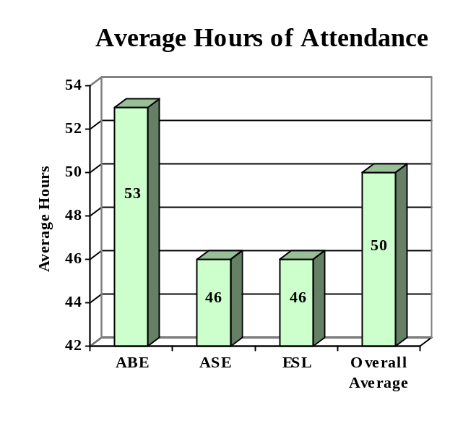

ENROLLMENT

Adult Basic Education 60,206 (56%)

Adult Secondary Education 15,410 (14%)
English Literacy 32,388 (30%)

TOTAL 108,004

PARTICIPANT STATUS

Employed - 45,497

Unemployed - 30,716

Correctional Setting - 8,862

On Public Assistance - 10,118

Other Institutionalized - 606

AGE

16 - 18 23,149 (21%)

19 - 24 34,901 (32%)
25 - 44 38,969 (36%)

45 - 59 8,781 (08%)
60 + 2,204 (02%)

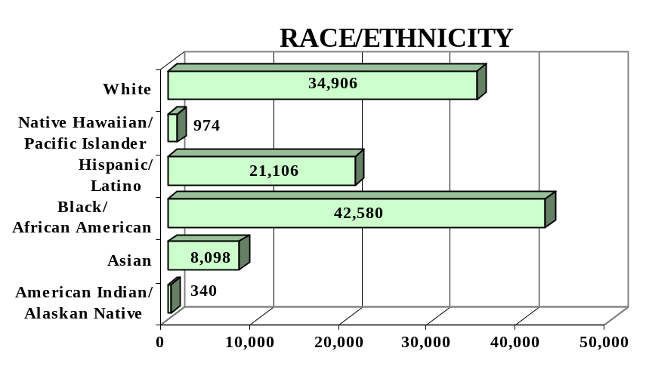
GENDER

Male - 53,404 (49%) Female - 54,600 (51%)

FEDERAL ALLOCATION
FY 2000

Basic Grant - $ 12,046,801
EL/Civics - $ 357,630

TOTAL - $ 12,404,431

GEORGIA | Average  Performance Target | Actual  Performance | Status | Adults Completing  at Least One Level
Performance Measure I – Demonstrated Improvement in Literacy Skills  Sub Measures  Adult Basic and Secondary Education:^{1/} The percentage of adults enrolled in basic literacy programs who acquired the basic skills needed to complete the level of instruction in which they were initially enrolled.  English Literacy: ^{2/} The percentage of adults enrolled in English Literacy programs who acquired the level of English language skills needed to complete the level of instruction in which they were initially enrolled. | 21%  21% | 29%  25% | ↑  ↑ | 19,645  8,105
 | Performance Target | Actual  Performance | Status | Adults Achieving  Outcome
Performance Measure II – High School Completion  The percentage of adult learners with a high school completion goal who earned a high school diploma or GED.  Performance Measure III – Entered Postsecondary Education or Training  The percentage of adult learners with a goal to continue their education who enter postsecondary education or training.  Performance Measure IV - Entered Employment  The percentage of unemployed adult learners (in the workforce) with an employment goal who were employed at the end of first quarter after they exited the program.  Performance Measure V – Retained Employment  The percentage of adult learners with a) a job retention goal at the time of enrollment and b) those adults with an employment goal who obtained work by the end of the first quarter after leaving the program who were employed at the end of third quarter after exiting the program. | 21%  15%  18%  18% | 35%  42%  42%  52% | ↑  ↑  ↑  ↑ | 4,424  2,029  3,202  2,581

Follow-up Methodology Used to Collect Performance Data

Educational Gains
√ Combination of standardized tests and performance-based assessment

High School Completion Measure
√ State developed individual student follow-up survey

Postsecondary Transition
√ State developed individual student follow-up survey

Entered Employment
√ State developed individual student follow-up survey

Job Retention
√ State developed individual student follow-up survey

Key
↑ Exceeded Performance Target
↔ Met Performance Target
↓ Did Not Meet Performance Target

^{1/} Adult Basic and Secondary Education programs consist of a series of instructional levels with each level representing a hierarchy of basic skills ranging from beginning literacy to high school completion.

^{2/} English Literacy education programs consist of a set of instructional levels with each level representing a hierarchy of English language skills ranging from beginning language literacy to oral language proficiency.

HAWAII

PROGRAM FACTS – 2000-2001

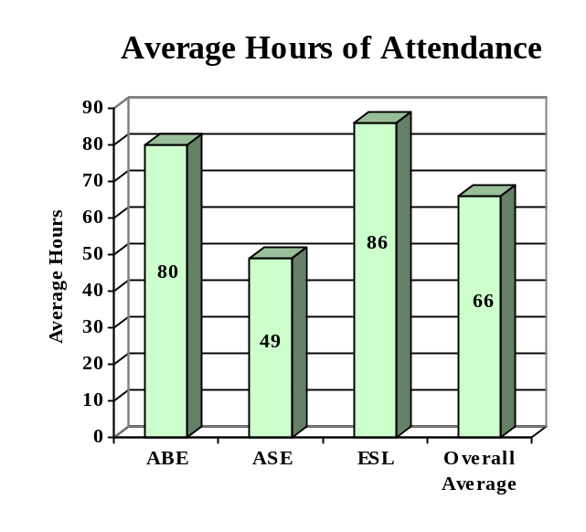

ENROLLMENT

Adult Basic Education 2,187 (21%)

Adult Secondary Education 5,568 (53%)
English Literacy 2,770 (26%)

TOTAL 10,525

PARTICIPANT STATUS

Employed - 2,878

Unemployed - 2,789

Correctional Setting - 139

On Public Assistance - 686

Other Institutionalized - 6

AGE

16 - 18 1,883 (18%)

19 - 24 1,834 (17%)
25 - 44 3,970 (38%)

45 - 59 1,712 (16%)
60 + 1,126 (11%)

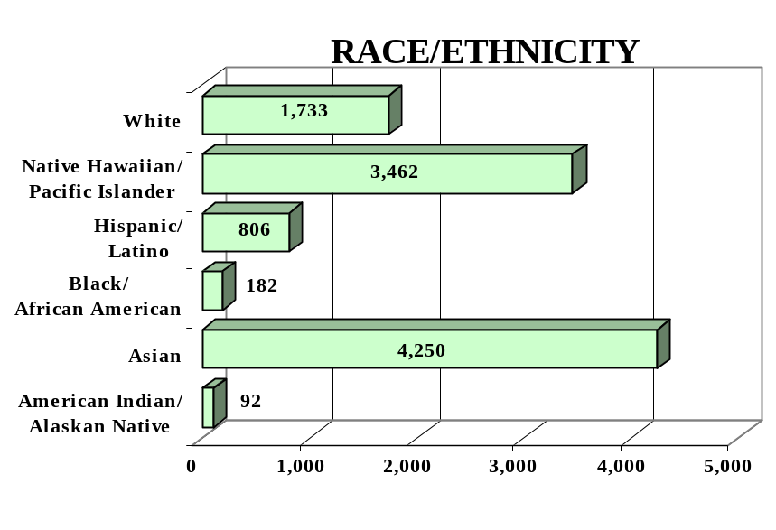
GENDER

Male - 3,663 (35%) Female - 6,862 (65%)

FEDERAL ALLOCATION
FY 2000

Basic Grant - $ 1,605,461
EL/Civics - $ 216,421

TOTAL - $ 1,821,882

HAWAII | Average  Performance Target | Actual  Performance | Status | Adults Completing  at Least One Level
Performance Measure I – Demonstrated Improvement in Literacy Skills  Sub Measures  Adult Basic and Secondary Education:^{1/} The percentage of adults enrolled in basic literacy programs who acquired the basic skills needed to complete the level of instruction in which they were initially enrolled.  English Literacy: ^{2/} The percentage of adults enrolled in English Literacy programs who acquired the level of English language skills needed to complete the level of instruction in which they were initially enrolled. | 13%  11% | 39%  16% | ↑  ↑ | 2,076  445
 | Performance Target | Actual  Performance | Status | Adults Achieving  Outcome
Performance Measure II – High School Completion  The percentage of adult learners with a high school completion goal who earned a high school diploma or GED.  Performance Measure III – Entered Postsecondary Education or Training  The percentage of adult learners with a goal to continue their education who enter postsecondary education or training.  Performance Measure IV - Entered Employment  The percentage of unemployed adult learners (in the workforce) with an employment goal who were employed at the end of first quarter after they exited the program.  Performance Measure V – Retained Employment  The percentage of adult learners with a) a job retention goal at the time of enrollment and b) those adults with an employment goal who obtained work by the end of the first quarter after leaving the program who were employed at the end of third quarter after exiting the program. | 09%  10%  07%  04% | 53%  60%  47%  40% | ↑  ↑  ↑  ↑ | 1,246  31  83  39

Follow-up Methodology Used to Collect Performance Data

Educational Gains
√ Standardized tests

High School Completion Measure
√ Data matching (Official state GED records)

Postsecondary Transition
√ State developed individual student follow-up survey

Entered Employment
√ State developed individual student follow-up survey

Job Retention
√ State developed individual student follow-up survey

Key
↑ Exceeded Performance Target
↔ Met Performance Target
↓ Did Not Meet Performance Target

^{1/} Adult Basic and Secondary Education programs consist of a series of instructional levels with each level representing a hierarchy of basic skills ranging from beginning literacy to high school completion.

^{2/} English Literacy education programs consist of a set of instructional levels with each level representing a hierarchy of English language skills ranging from beginning language literacy to oral language proficiency.

IDAHO

PROGRAM FACTS – 2000-2001

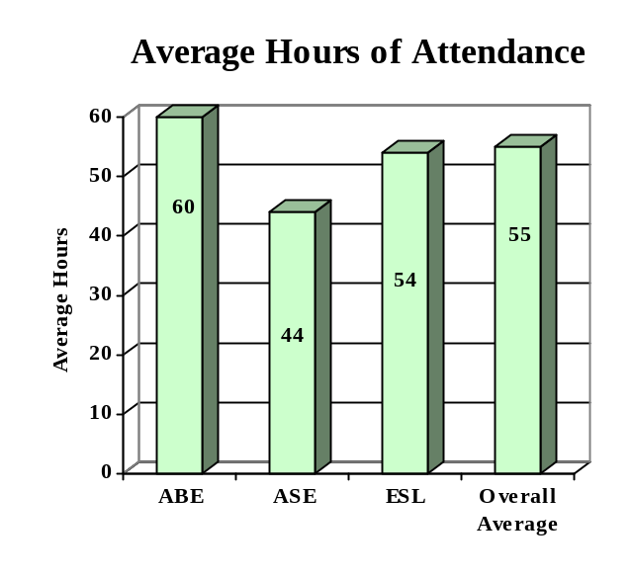

ENROLLMENT

Adult Basic Education 4,954 (47%)

Adult Secondary Education 2,439 (23%)
English Literacy 3,113 (30%)

TOTAL 10,506

PARTICIPANT STATUS

Employed - 4,274

Unemployed - 3,815

Correctional Setting - 441

On Public Assistance - 1,175

Other Institutionalized - 31

AGE

16 - 18 1,849 (17%)

19 - 24 2,733 (26%)
25 - 44 4,508 (43%)

45 - 59 1,122 (11%)
60 + 294 (03%)

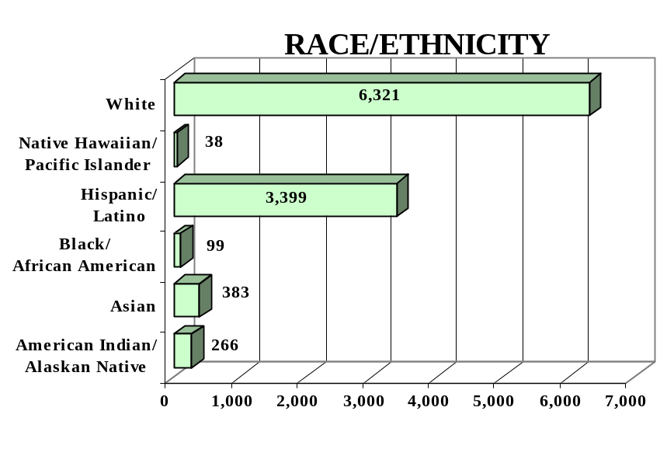
GENDER

Male - 5,504 (52%) Female - 5,002 (48%)

FEDERAL ALLOCATION
FY 2000

Basic Grant - $ 1,477,460
EL/Civics - $ 0

TOTAL - $ 1,477,460

IDAHO | Average  Performance Target | Actual  Performance | Status | Adults Completing  at Least One Level
Performance Measure I – Demonstrated Improvement in Literacy Skills  Sub Measures  Adult Basic and Secondary Education:^{1/} The percentage of adults enrolled in basic literacy programs who acquired the basic skills needed to complete the level of instruction in which they were initially enrolled.  English Literacy: ^{2/} The percentage of adults enrolled in English Literacy programs who acquired the level of English language skills needed to complete the level of instruction in which they were initially enrolled. | 46%  39% | 55%  35% | ↑  ↓ | 3,481  1,074
 | Performance Target | Actual  Performance | Status | Adults Achieving  Outcome
Performance Measure II – High School Completion  The percentage of adult learners with a high school completion goal who earned a high school diploma or GED.  Performance Measure III – Entered Postsecondary Education or Training  The percentage of adult learners with a goal to continue their education who enter postsecondary education or training.  Performance Measure IV - Entered Employment  The percentage of unemployed adult learners (in the workforce) with an employment goal who were employed at the end of first quarter after they exited the program.  Performance Measure V – Retained Employment  The percentage of adult learners with a) a job retention goal at the time of enrollment and b) those adults with an employment goal who obtained work by the end of the first quarter after leaving the program who were employed at the end of third quarter after exiting the program. | 30%  17%  20%  50% | 37%  27%  93%  33% | ↑  ↑  ↑  ↓ | 1,828  494  513  545

Follow-up Methodology Used to Collect Performance Data

Educational Gains
√ Standardized tests
(Combination of standardized tests and performance-based assessment)

High School Completion Measure
√ Data matching (Official state GED records)

Postsecondary Transition
√ Data Matching

Entered Employment
√ Data matching (UI employment records)

Job Retention
√ Data matching (UI employment records)

Key
↑ Exceeded Performance Target
↔ Met Performance Target
↓ Did Not Meet Performance Target

^{1/} Adult Basic and Secondary Education programs consist of a series of instructional levels with each level representing a hierarchy of basic skills ranging from beginning literacy to high school completion.

^{2/} English Literacy education programs consist of a set of instructional levels with each level representing a hierarchy of English language skills ranging from beginning language literacy to oral language proficiency.

ILLINOIS

PROGRAM FACTS – 2000-2001

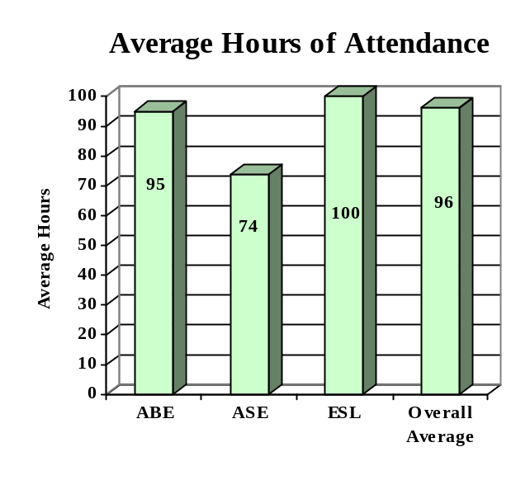

ENROLLMENT

Adult Basic Education 35,731 (29%)

Adult Secondary Education 15,331 (13%)
English Literacy 70,981 (58%)

TOTAL 122,043

PARTICIPANT STATUS

Employed - 39,189

Unemployed - 26,393

Correctional Setting - 5,205

On Public Assistance - 16,082

Other Institutionalized - 103

AGE

16 - 18 7,735 (06%)

19 - 24 36,061 (29%)
25 - 44 60,636 (50%)

45 - 59 13,272 (11%)
60 + 4,339 (04%)

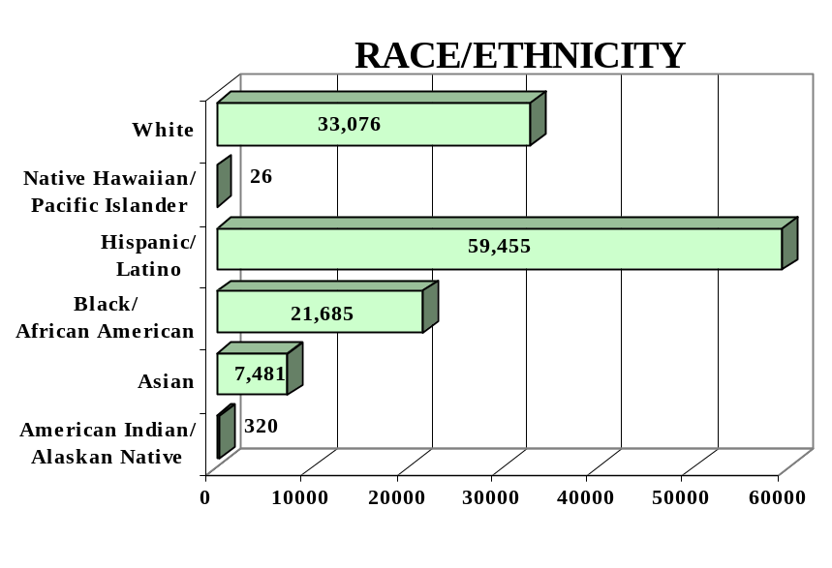
GENDER

Male - 56,743 (46%) Female - 65,300 (54%)

FEDERAL ALLOCATION
FY 2000

Basic Grant - $17,436,884
EL/Civics - $ 1,294,585

TOTAL - $18,731,469

ILLINOIS | Average  Performance Target | Actual  Performance | Status | Adults Completing  at Least One Level
Performance Measure I – Demonstrated Improvement in Literacy Skills  Sub Measures  Adult Basic and Secondary Education:^{1/} The percentage of adults enrolled in basic literacy programs who acquired the basic skills needed to complete the level of instruction in which they were initially enrolled.  English Literacy: ^{2/} The percentage of adults enrolled in English Literacy programs who acquired the level of English language skills needed to complete the level of instruction in which they were initially enrolled. | 21%  30% | 30%  26% | ↑  ↓ | 13,156  18,120
 | Performance Target | Actual  Performance | Status | Adults Achieving  Outcome
Performance Measure II – High School Completion  The percentage of adult learners with a high school completion goal who earned a high school diploma or GED.  Performance Measure III – Entered Postsecondary Education or Training  The percentage of adult learners with a goal to continue their education who enter postsecondary education or training.  Performance Measure IV - Entered Employment  The percentage of unemployed adult learners (in the workforce) with an employment goal who were employed at the end of first quarter after they exited the program.  Performance Measure V – Retained Employment  The percentage of adult learners with a) a job retention goal at the time of enrollment and b) those adults with an employment goal who obtained work by the end of the first quarter after leaving the program who were employed at the end of third quarter after exiting the program. | 20%  33%  32%  53% | 20%  11%  50%  83% | ↔  ↓  ↑  ↑ | 3,000  2,410  11,206  9,252

Follow-up Methodology Used to Collect Performance Data

Educational Gains
√ Standardized tests

High School Completion Measure
√ Data matching (Official state GED records & approved data collection system)

Postsecondary Transition
√ Data matching

Entered Employment
√ Data matching (UI employment records)

Job Retention
√ Data matching (UI employment records)

Key
↑ Exceeded Performance Target
↔ Met Performance Target
↓ Did Not Meet Performance Target

^{1/} Adult Basic and Secondary Education programs consist of a series of instructional levels with each level representing a hierarchy of basic skills ranging from beginning literacy to high school completion.

^{2/} English Literacy education programs consist of a set of instructional levels with each level representing a hierarchy of English language skills ranging from beginning language literacy to oral language proficiency.

INDIANA

PROGRAM FACTS – 2000-2001

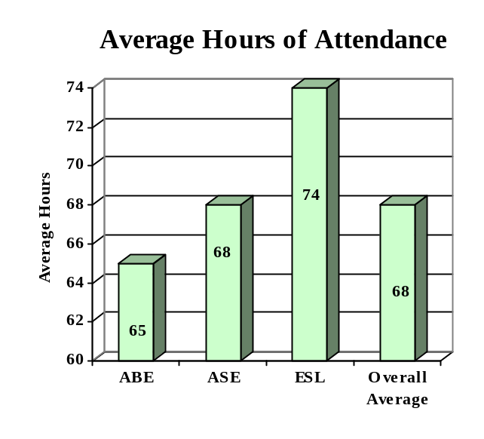

ENROLLMENT

Adult Basic Education 21,170 (50%)

Adult Secondary Education 12,320 (29%)
English Literacy 8,645 (21%)

TOTAL 42,135

PARTICIPANT STATUS

Employed - 18,297

Unemployed - 13,645

Correctional Setting - 5,924

On Public Assistance - 5,974

Other Institutionalized - 759

AGE

16 - 18 13,969 (33%)

19 - 24 10,363 (25%)
25 - 44 14,058 (33%)

45 - 59 2,998 (07%)
60 + 747 (02%)

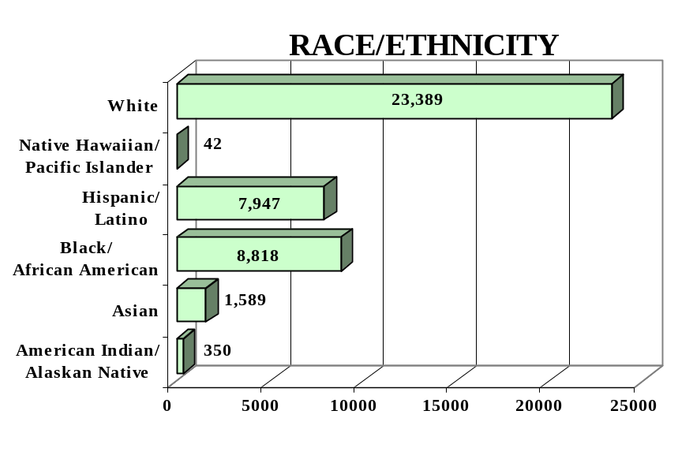
GENDER

Male - 22,068 (52%) Female - 20,067 (48%)

FEDERAL ALLOCATION
FY 2000

Basic Grant - $ 8,688,970
EL/Civics - $ 119,727

TOTAL - $ 8,808,697

INDIANA | Average  Performance Target | Actual  Performance | Status | Adults Completing  at Least One Level
Performance Measure I – Demonstrated Improvement in Literacy Skills  Sub Measures  Adult Basic and Secondary Education:^{1/} The percentage of adults enrolled in basic literacy programs who acquired the basic skills needed to complete the level of instruction in which they were initially enrolled.  English Literacy: ^{2/} The percentage of adults enrolled in English Literacy programs who acquired the level of English language skills needed to complete the level of instruction in which they were initially enrolled. | 28%  28% | 38%  34% | ↑  ↑ | 9,895  2,927
 | Performance Target | Actual  Performance | Status | Adults Achieving  Outcome
Performance Measure II – High School Completion  The percentage of adult learners with a high school completion goal who earned a high school diploma or GED.  Performance Measure III – Entered Postsecondary Education or Training  The percentage of adult learners with a goal to continue their education who enter postsecondary education or training.  Performance Measure IV - Entered Employment  The percentage of unemployed adult learners (in the workforce) with an employment goal who were employed at the end of first quarter after they exited the program.  Performance Measure V – Retained Employment  The percentage of adult learners with a) a job retention goal at the time of enrollment and b) those adults with an employment goal who obtained work by the end of the first quarter after leaving the program who were employed at the end of third quarter after exiting the program. | 34%  20%  20%  40% | 46%  53%  62%  63% | ↑  ↑  ↑  ↑ | 6,248  1,327  4,715  2,922

Follow-up Methodology Used to Collect Performance Data

Educational Gains
√ Standardized tests

High School Completion Measure
√ Data matching (Official state GED records)
√ State developed individual student follow-up survey

Postsecondary Transition
√ State developed individual student follow-up survey

Entered Employment
√ State developed individual student follow-up survey

Job Retention
√ State developed individual student follow-up survey

Key
↑ Exceeded Performance Target
↔ Met Performance Target
↓ Did Not Meet Performance Target

^{1/} Adult Basic and Secondary Education programs consist of a series of instructional levels with each level representing a hierarchy of basic skills ranging from beginning literacy to high school completion.

^{2/} English Literacy education programs consist of a set of instructional levels with each level representing a hierarchy of English language skills ranging from beginning language literacy to oral language proficiency.

IOWA

PROGRAM FACTS – 2000-2001

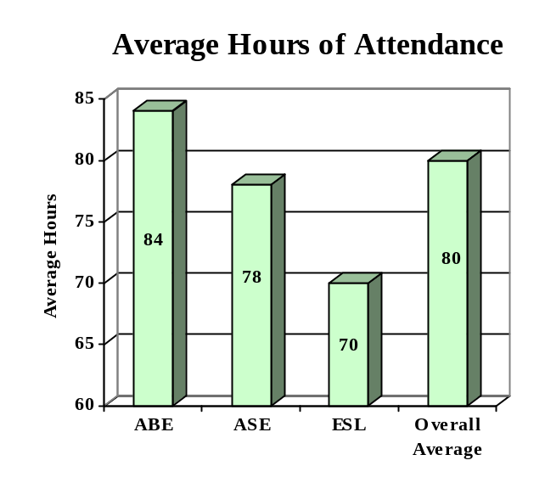

ENROLLMENT

Adult Basic Education 11,792 (59%)

Adult Secondary Education 3,690 (18%)
English Literacy 4,679 (23%)

TOTAL 20,161

PARTICIPANT STATUS

Employed - 9,215

Unemployed - 6,646

Correctional Setting - 1,570

On Public Assistance - 1,834

Other Institutionalized - N/A

AGE

16 - 18 2,756 (14%)

19 - 24 6,478 (32%)
25 - 44 8,054 (40%)

45 - 59 2,137 (11%)
60 + 736 (03%)

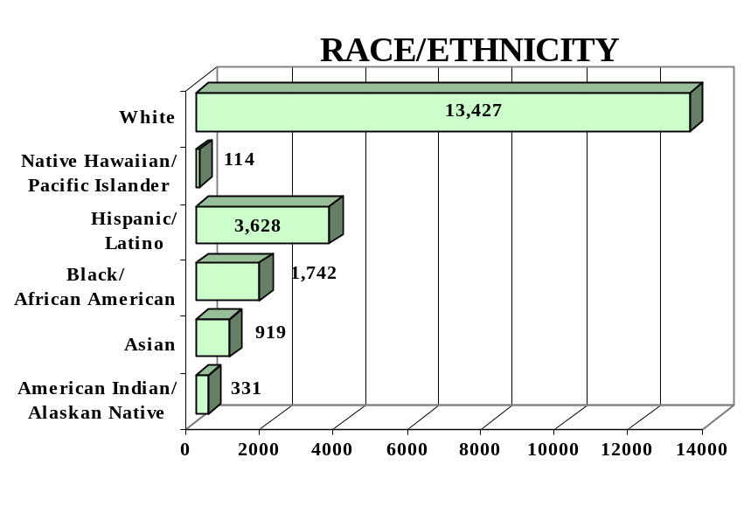
GENDER

Male - 10,214 (51%) Female - 9,947 (49%)

FEDERAL ALLOCATION
FY 2000

Basic Grant - $ 3,622,245
EL/Civics - $ 0

TOTAL - $ 3,622,245

IOWA | Average  Performance Target | Actual  Performance | Status | Adults Completing  at Least One Level
Performance Measure I – Demonstrated Improvement in Literacy Skills  Sub Measures  Adult Basic and Secondary Education:^{1/} The percentage of adults enrolled in basic literacy programs who acquired the basic skills needed to complete the level of instruction in which they were initially enrolled.  English Literacy: ^{2/} The percentage of adults enrolled in English Literacy programs who acquired the level of English language skills needed to complete the level of instruction in which they were initially enrolled. | 21%  27% | 27%  03% | ↑  ↓ | 3,971  157
 | Performance Target | Actual  Performance | Status | Adults Achieving  Outcome
Performance Measure II – High School Completion  The percentage of adult learners with a high school completion goal who earned a high school diploma or GED.  Performance Measure III – Entered Postsecondary Education or Training  The percentage of adult learners with a goal to continue their education who enter postsecondary education or training.  Performance Measure IV - Entered Employment  The percentage of unemployed adult learners (in the workforce) with an employment goal who were employed at the end of first quarter after they exited the program.  Performance Measure V – Retained Employment  The percentage of adult learners with a) a job retention goal at the time of enrollment and b) those adults with an employment goal who obtained work by the end of the first quarter after leaving the program who were employed at the end of third quarter after exiting the program. | 40%  12%  50%  75% | 51%  10%  75%  71% | ↑  ↓  ↑  ↓ | 3,424  269  667  262

Key

Follow-up Methodology Used to Collect Performance Data

Educational Gains
√ Standardized tests

High School Completion Measure
√ Data matching (Official state GED records)

Postsecondary Transition
√ Data matching (community college enrollment data base)

Entered Employment
√ Data matching (UI employment records)

Job Retention
√ Data matching (UI employment records)
↑ Exceeded Performance Target
↔ Met Performance Target
↓ Did Not Meet Performance Target

^{1/} Adult Basic and Secondary Education programs consist of a series of instructional levels with each level representing a hierarchy of basic skills ranging from beginning literacy to high school completion.

^{2/} English Literacy education programs consist of a set of instructional levels with each level representing a hierarchy of English language skills ranging from beginning language literacy to oral language proficiency.

KANSAS

PROGRAM FACTS – 2000-2001

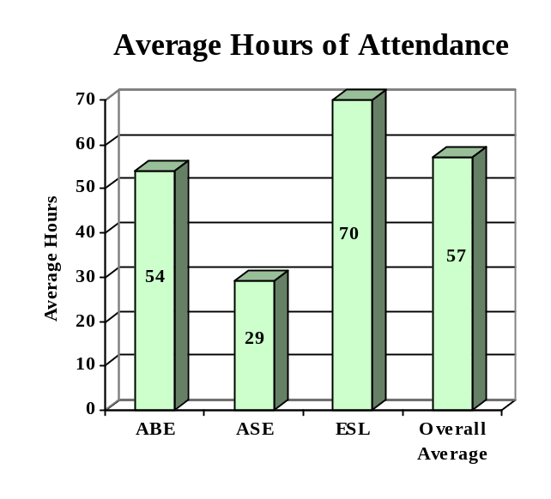

ENROLLMENT

Adult Basic Education 5,722 (51%)

Adult Secondary Education 1,254 (11%)
English Literacy 4,272 (38%)

TOTAL 11,248

PARTICIPANT STATUS

Employed - 5,676

Unemployed - 3,665

Correctional Setting - 799

On Public Assistance - 1,296

Other Institutionalized - 191

AGE

16 - 18 2,698 (24%)

19 - 24 3,010 (27%)
25 - 44 4,416 (39%)

45 - 59 884 (08%)
60 + 240 (02%)

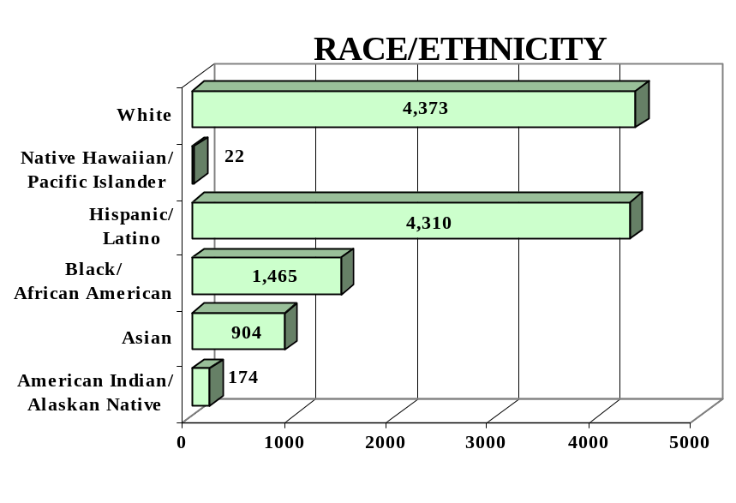
GENDER

Male - 5,123 (46%) Female - 6,125 (54%)

FEDERAL ALLOCATION
FY 2000

Basic Grant - $ 3,136,897
EL/Civics - $ 103,436

TOTAL - $ 3,240,333

KANSAS | Average  Performance Target | Actual  Performance | Status | Adults Completing  at Least One Level
Performance Measure I – Demonstrated Improvement in Literacy Skills  Sub Measures  Adult Basic and Secondary Education:^{1/} The percentage of adults enrolled in basic literacy programs who acquired the basic skills needed to complete the level of instruction in which they were initially enrolled.  English Literacy: ^{2/} The percentage of adults enrolled in English Literacy programs who acquired the level of English language skills needed to complete the level of instruction in which they were initially enrolled. | 31%  23% | 53%  42% | ↑  ↑ | 3,592  1,785
 | Performance Target | Actual  Performance | Status | Adults Achieving  Outcome
Performance Measure II – High School Completion  The percentage of adult learners with a high school completion goal who earned a high school diploma or GED.  Performance Measure III – Entered Postsecondary Education or Training  The percentage of adult learners with a goal to continue their education who enter postsecondary education or training.  Performance Measure IV - Entered Employment  The percentage of unemployed adult learners (in the workforce) with an employment goal who were employed at the end of first quarter after they exited the program.  Performance Measure V – Retained Employment  The percentage of adult learners with a) a job retention goal at the time of enrollment and b) those adults with an employment goal who obtained work by the end of the first quarter after leaving the program who were employed at the end of third quarter after exiting the program. | 42%  19%  38%  30% | 50%  25%  50%  53% | ↑  ↑  ↑  ↑ | 1,822  21  311  394

Follow-up Methodology Used to Collect Performance Data

Educational Gains
√ Standardized tests

High School Completion Measure
√ Data matching (Official state GED records)
√ State developed individual student follow-up survey

Postsecondary Transition
√ State developed individual student follow-up survey

Entered Employment
√ Data matching (UI employment records)
√ State developed individual student follow-up survey

Job Retention
√ Data matching (UI employment records)
√ State developed individual student follow-up survey

Key
↑ Exceeded Performance Target
↔ Met Performance Target
↓ Did Not Meet Performance Target

^{1/} Adult Basic and Secondary Education programs consist of a series of instructional levels with each level representing a hierarchy of basic skills ranging from beginning literacy to high school completion.

^{2/} English Literacy education programs consist of a set of instructional levels with each level representing a hierarchy of English language skills ranging from beginning language literacy to oral language proficiency.

KENTUCKY

PROGRAM FACTS – 2000-2001

ENROLLMENT

Adult Basic Education 17,964 (58%)

Adult Secondary Education 10,369 (33%)
English Literacy 2,717 (09%)

TOTAL 31,050
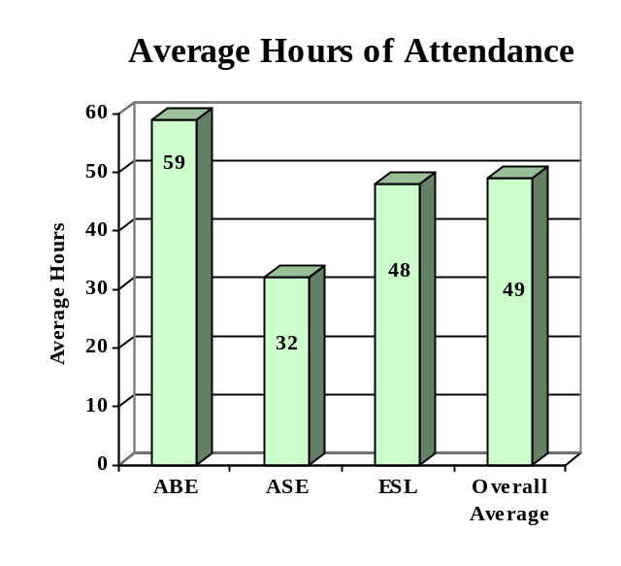

PARTICIPANT STATUS

Employed - 11,293

Unemployed - 13,134

Correctional Setting - 6,350

On Public Assistance - 3,114

Other Institutionalized - 0

AGE

16 - 18 5,276 (17%)

19 - 24 9,614 (31%)
25 - 44 11,989 (39%)

45 - 59 3,489 (11%)
60 + 682 (02%)

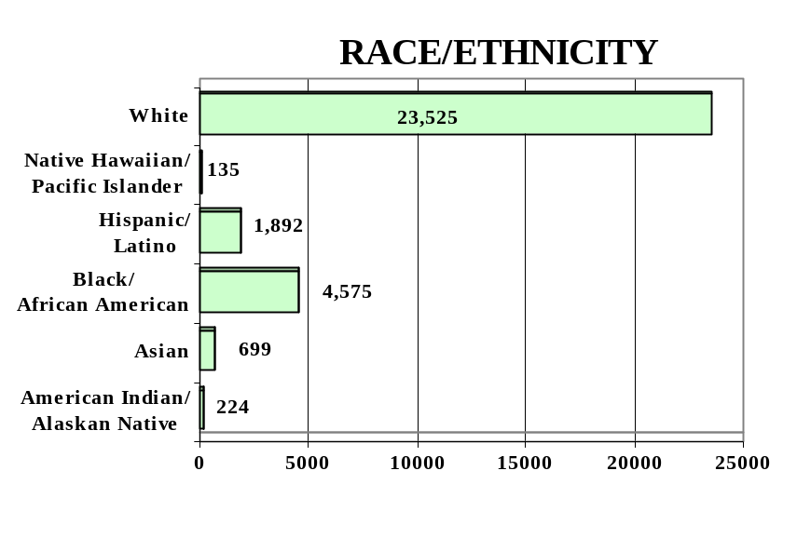
GENDER

Male - 15,157 (49%) Female - 15,893 (51%)

FEDERAL ALLOCATION
FY 2000

Basic Grant - $ 8,314,079
EL/Civics - $ 0

TOTAL - $ 8,314,079

KENTUCKY | Average  Performance Target | Actual  Performance | Status | Adults Completing  at Least One Level
Performance Measure I – Demonstrated Improvement in Literacy Skills  Sub Measures  Adult Basic and Secondary Education:^{1/} The percentage of adults enrolled in basic literacy programs who acquired the basic skills needed to complete the level of instruction in which they were initially enrolled.  English Literacy: ^{2/} The percentage of adults enrolled in English Literacy programs who acquired the level of English language skills needed to complete the level of instruction in which they were initially enrolled. | 25%  18% | 58%  32% | ↑  ↑ | 12,887  1,032
 | Performance Target | Actual  Performance | Status | Adults Achieving  Outcome
Performance Measure II – High School Completion  The percentage of adult learners with a high school completion goal who earned a high school diploma or GED.  Performance Measure III – Entered Postsecondary Education or Training  The percentage of adult learners with a goal to continue their education who enter postsecondary education or training.  Performance Measure IV - Entered Employment  The percentage of unemployed adult learners (in the workforce) with an employment goal who were employed at the end of first quarter after they exited the program.  Performance Measure V – Retained Employment  The percentage of adult learners with a) a job retention goal at the time of enrollment and b) those adults with an employment goal who obtained work by the end of the first quarter after leaving the program who were employed at the end of third quarter after exiting the program. | 50%  30%  27%  30% | 66%  73%  74%  80% | ↑  ↑  ↑  ↑ | 9,475  2,496  4,044  9,499

Follow-up Methodology Used to Collect Performance Data

Educational Gains
√ Standardized tests

High School Completion Measure
√ Data matching (Official state GED records)

Postsecondary Transition
√ Data matching

Entered Employment
√ State developed individual student follow-up survey

Job Retention
√ State developed individual student follow-up survey

Key
↑ Exceeded Performance Target
↔ Met Performance Target
↓ Did Not Meet Performance Target

^{1/} Adult Basic and Secondary Education programs consist of a series of instructional levels with each level representing a hierarchy of basic skills ranging from beginning literacy to high school completion.

^{2/} English Literacy education programs consist of a set of instructional levels with each level representing a hierarchy of English language skills ranging from beginning language literacy to oral language proficiency.

LOUISIANA

PROGRAM FACTS – 2000-2001

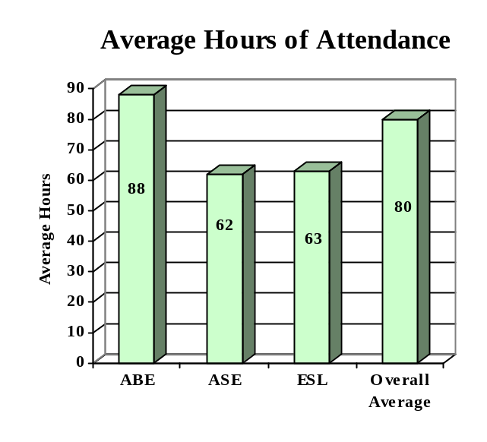

ENROLLMENT

Adult Basic Education 21,136 (68%)

Adult Secondary Education 8,519 (28%)
English Literacy 1,274 (04%)

TOTAL 30,929

PARTICIPANT STATUS

Employed - 9,635

Unemployed -13,373

Correctional Setting - 4,997

On Public Assistance - 3,315

Other Institutionalized - 687

AGE

16 - 18 11,631 (37%)

19 - 24 8,587 (28%)
25 - 44 8,584 (28%)

45 - 59 1,615 (05%)
60 + 512 (02%)

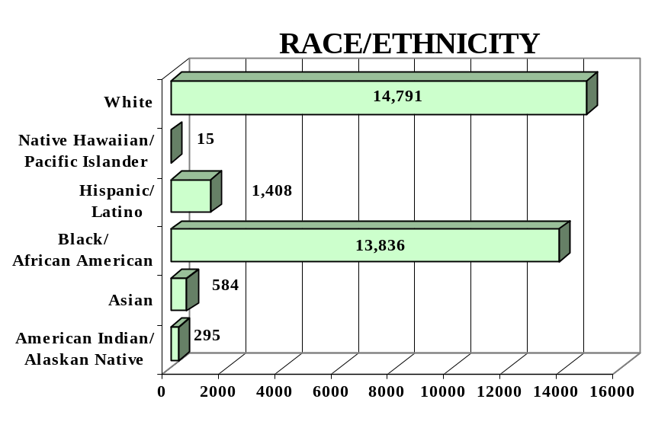
GENDER

Male - 15,747 (51%) Female - 15,182 (49%)

FEDERAL ALLOCATION
FY 2000

Basic Grant - $ 8,279,495
EL/Civics - $ 101,510

TOTAL - $ 8,381,005

LOUISIANA | Average  Performance Target | Actual  Performance | Status | Adults Completing  at Least One Level
Performance Measure I – Demonstrated Improvement in Literacy Skills  Sub Measures  Adult Basic and Secondary Education:^{1/} The percentage of adults enrolled in basic literacy programs who acquired the basic skills needed to complete the level of instruction in which they were initially enrolled.  English Literacy: ^{2/} The percentage of adults enrolled in English Literacy programs who acquired the level of English language skills needed to complete the level of instruction in which they were initially enrolled. | 30%  21% | 38%  20% | ↑  ↓ | 9,793  246
 | Performance Target | Actual  Performance | Status | Adults Achieving  Outcome
Performance Measure II – High School Completion  The percentage of adult learners with a high school completion goal who earned a high school diploma or GED.  Performance Measure III – Entered Postsecondary Education or Training  The percentage of adult learners with a goal to continue their education who enter postsecondary education or training.  Performance Measure IV - Entered Employment  The percentage of unemployed adult learners (in the workforce) with an employment goal who were employed at the end of first quarter after they exited the program.  Performance Measure V – Retained Employment  The percentage of adult learners with a) a job retention goal at the time of enrollment and b) those adults with an employment goal who obtained work by the end of the first quarter after leaving the program who were employed at the end of third quarter after exiting the program. | 38%  15%  15%  25% | 78%  15%  43%  52% | ↑  ↔  ↑  ↑ | 8296  178  1104  844

Follow-up Methodology Used to Collect Performance Data

Educational Gains
√ Standardized tests

High School Completion Measure
√ Data matching (Official state GED records)

Postsecondary Transition
√ Data matching

Entered Employment
√ Data matching (UI employment records)

Job Retention
√ Data matching (UI employment records)

Key
↑ Exceeded Performance Target
↔ Met Performance Target
↓ Did Not Meet Performance Target

^{1/} Adult Basic and Secondary Education programs consist of a series of instructional levels with each level representing a hierarchy of basic skills ranging from beginning literacy to high school completion.

^{2/} English Literacy education programs consist of a set of instructional levels with each level representing a hierarchy of English language skills ranging from beginning language literacy to oral language proficiency.

MAINE

PROGRAM FACTS – 2000-2001

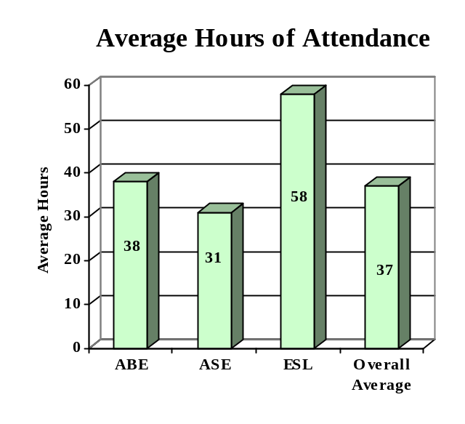

ENROLLMENT

Adult Basic Education 5,481 (44%)

Adult Secondary Education 5,687 (46%)
English Literacy 1,262 (10%)

TOTAL 12,430

PARTICIPANT STATUS

Employed - 3,915

Unemployed - 3,745

Correctional Setting - 1,826

On Public Assistance - 2,367

Other Institutionalized - 504

AGE

16 - 18 3,423 (28%)

19 - 24 3,151 (25%)
25 - 44 4,296 (35%)

45 - 59 1,124 (09%)
60 + 436 (04%)

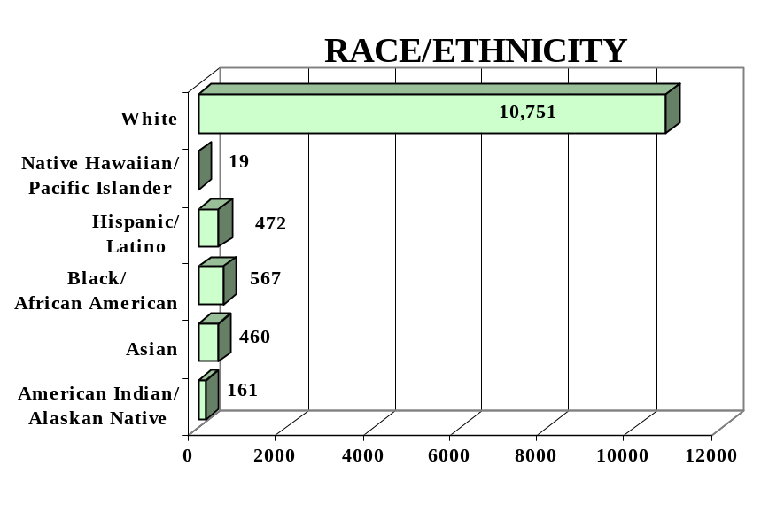
GENDER

Male - 6,166 (50%) Female - 6,264 (50%)

FEDERAL ALLOCATION
FY 2000

Basic Grant - $1,890,705
EL/Civics - $ -0-

TOTAL - $1,890,705

MAINE | Average  Performance Target | Actual  Performance | Status | Adults Completing  at Least One Level
Performance Measure I – Demonstrated Improvement in Literacy Skills  Sub Measures  Adult Basic and Secondary Education:^{1/} The percentage of adults enrolled in basic literacy programs who acquired the basic skills needed to complete the level of instruction in which they were initially enrolled.  English Literacy: ^{2/} The percentage of adults enrolled in English Literacy programs who acquired the level of English language skills needed to complete the level of instruction in which they were initially enrolled. | 25%  35% | 38%  32% | ↑  ↓ | 3,352  398
 | Performance Target | Actual  Performance | Status | Adults Achieving  Outcome
Performance Measure II – High School Completion  The percentage of adult learners with a high school completion goal who earned a high school diploma or GED.  Performance Measure III – Entered Postsecondary Education or Training  The percentage of adult learners with a goal to continue their education who enter postsecondary education or training.  Performance Measure IV - Entered Employment  The percentage of unemployed adult learners (in the workforce) with an employment goal who were employed at the end of first quarter after they exited the program.  Performance Measure V – Retained Employment  The percentage of adult learners with a) a job retention goal at the time of enrollment and b) those adults with an employment goal who obtained work by the end of the first quarter after leaving the program who were employed at the end of third quarter after exiting the program. | 25%  07%  11%  31% | 65%  50%  56%  72% | ↑  ↑  ↑  ↑ | 2,885  599  498  519

Follow-up Methodology Used to Collect Performance Data

Educational Gains
√ Standardized tests

High School Completion Measure
√ State developed individual student follow-up survey

Postsecondary Transition
√ State developed individual student follow-up survey

Entered Employment
√ State developed individual student follow-up survey

Job Retention
√ State developed individual student follow-up survey

Key
↑ Exceeded Performance Target
↔ Met Performance Target
↓ Did Not Meet Performance Target

^{1/} Adult Basic and Secondary Education programs consist of a series of instructional levels with each level representing a hierarchy of basic skills ranging from beginning literacy to high school completion.

^{2/} English Literacy education programs consist of a set of instructional levels with each level representing a hierarchy of English language skills ranging from beginning language literacy to oral language proficiency.

MARYLAND

PROGRAM FACTS – 2000-2001

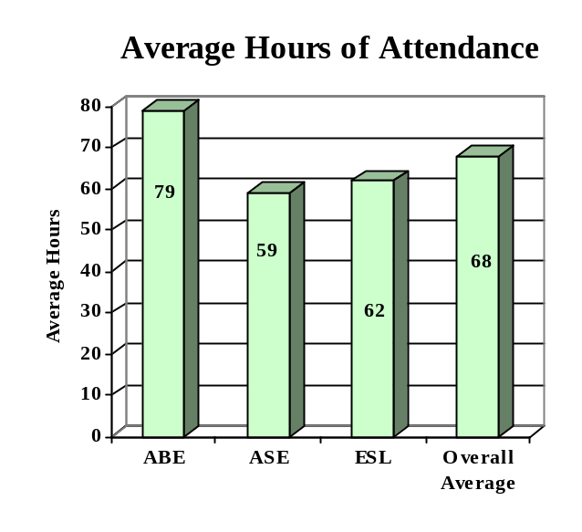

ENROLLMENT

Adult Basic Education 9,266 (41%)

Adult Secondary Education 4,203 (18%)
English Literacy 9,233 (41%)

TOTAL 22,702

PARTICIPANT STATUS

Employed -10,761

Unemployed - 7,226

Correctional Setting - 1,996

On Public Assistance - 1,535

Other Institutionalized - 260

AGE

16 - 18 3,264 (14%)

19 - 24 5,343 (24%)
25 - 44 10,688 (47%)

45 - 59 2,661 (12%)
60 + 746 (03%)

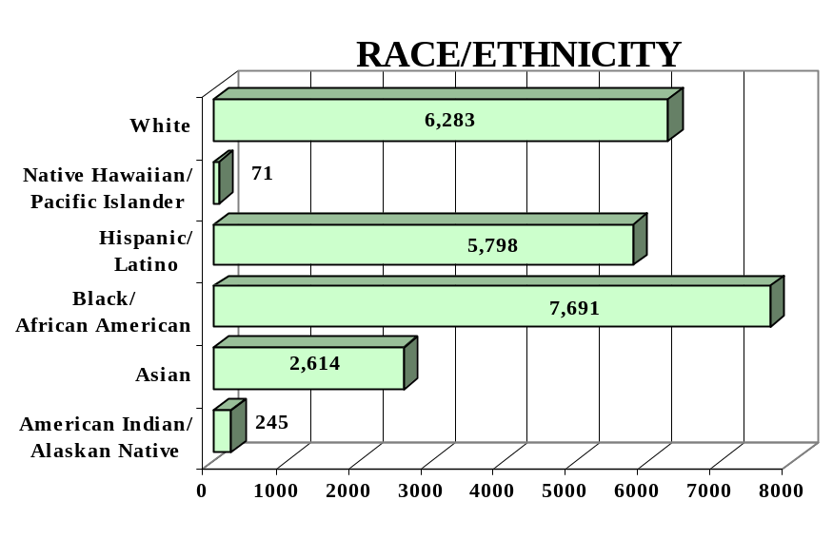
GENDER

Male - 9,936 (44%) Female -12,766 (56%)

FEDERAL ALLOCATION
FY 2000

Basic Grant - $6,944,223
EL/Civics - $ 527,650

TOTAL - $7,471,873

MARYLAND | Average  Performance Target | Actual  Performance | Status | Adults Completing  at Least One Level
Performance Measure I – Demonstrated Improvement in Literacy Skills  Sub Measures  Adult Basic and Secondary Education:^{1/} The percentage of adults enrolled in basic literacy programs who acquired the basic skills needed to complete the level of instruction in which they were initially enrolled.  English Literacy: ^{2/} The percentage of adults enrolled in English Literacy programs who acquired the level of English language skills needed to complete the level of instruction in which they were initially enrolled. | 22%  16% | 55%  43% | ↑  ↑ | 6,839  3,964
 | Performance Target | Actual  Performance | Status | Adults Achieving  Outcome
Performance Measure II – High School Completion  The percentage of adult learners with a high school completion goal who earned a high school diploma or GED.  Performance Measure III – Entered Postsecondary Education or Training  The percentage of adult learners with a goal to continue their education who enter postsecondary education or training.  Performance Measure IV - Entered Employment  The percentage of unemployed adult learners (in the workforce) with an employment goal who were employed at the end of first quarter after they exited the program.  Performance Measure V – Retained Employment  The percentage of adult learners with a) a job retention goal at the time of enrollment and b) those adults with an employment goal who obtained work by the end of the first quarter after leaving the program who were employed at the end of third quarter after exiting the program. | 28%  12%  24%  40% | 26%  13%  44%  58% | ↓  ↑  ↑  ↑ | 1,771  35  221  390

Key

Follow-up Methodology Used to Collect Performance Data

Educational Gains
√ Standardized tests

High School Completion Measure
√ Data matching (Official state GED records)

Postsecondary Transition
√ State developed individual student follow-up survey

Entered Employment
√ Data matching (UI employment records)

Job Retention
√ Data matching (UI employment records)
↑ Exceeded Performance Target
↔ Met Performance Target
↓ Did Not Meet Performance Target

^{1/} Adult Basic and Secondary Education programs consist of a series of instructional levels with each level representing a hierarchy of basic skills ranging from beginning literacy to high school completion.

^{2/} English Literacy education programs consist of a set of instructional levels with each level representing a hierarchy of English language skills ranging from beginning language literacy to oral language proficiency.

MASSACHUSETTS

PROGRAM FACTS – 2000-2001

ENROLLMENT

Adult Basic Education 6,920 (29%)

Adult Secondary Education 3,518 (15%)
English Literacy 13,615 (56%)

TOTAL 24,053
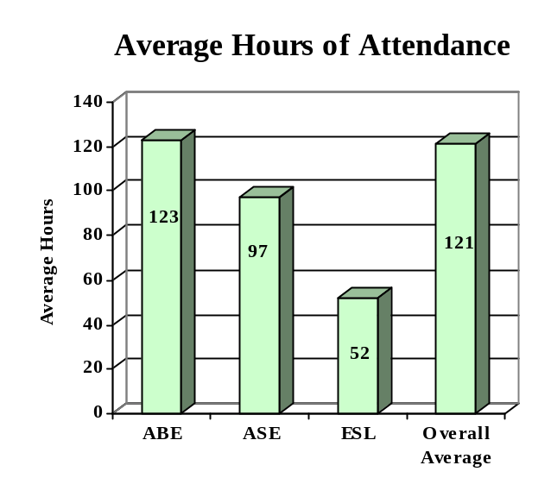

PARTICIPANT STATUS

Employed -11,738

Unemployed - 4,306

Correctional Setting - 1,203

On Public Assistance - 2,804

Other Institutionalized - 0

AGE

16 - 18 1,638 (07%)

19 - 24 4,443 (18%)
25 - 44 13,034 (54%)

45 - 59 3,908 (16%)
60 + 1,030 (04%)

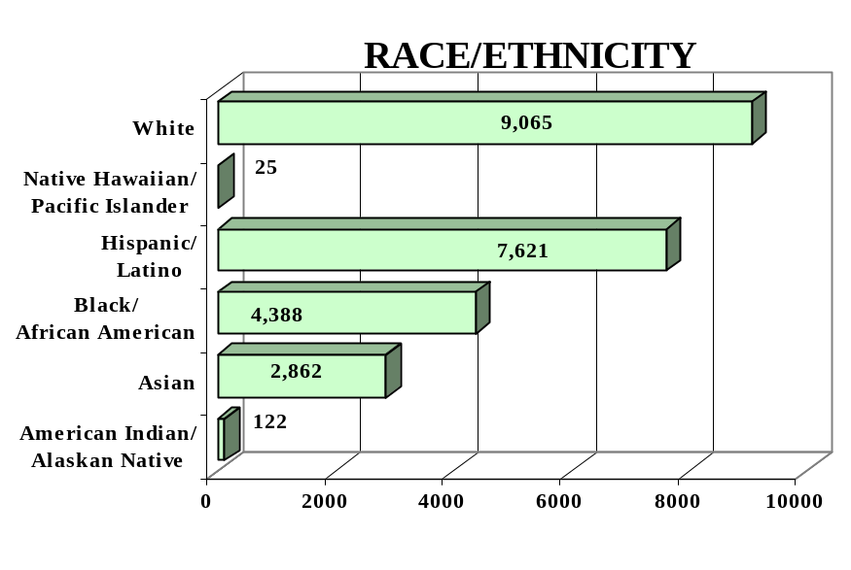

GENDER

Male - 9,618 (40%) Female -14,435 (60%)

FEDERAL ALLOCATION
FY 2000

Basic Grant - $8,078,691
EL/Civics - $ 600,839

TOTAL - $8,679,530

MASSACHUSETTS | Average  Performance Target | Actual  Performance | Status | Adults Completing  at Least One Level
Performance Measure I – Demonstrated Improvement in Literacy Skills  Sub Measures  Adult Basic and Secondary Education:^{1/} The percentage of adults enrolled in basic literacy programs who acquired the basic skills needed to complete the level of instruction in which they were initially enrolled.  English Literacy: ^{2/} The percentage of adults enrolled in English Literacy programs who acquired the level of English language skills needed to complete the level of instruction in which they were initially enrolled. | 26%  29% | 22%  35% | ↓  ↑ | 2,048  4,736
 | Performance Target | Actual  Performance | Status | Adults Achieving  Outcome
Performance Measure II – High School Completion  The percentage of adult learners with a high school completion goal who earned a high school diploma or GED.  Performance Measure III – Entered Postsecondary Education or Training  The percentage of adult learners with a goal to continue their education who enter postsecondary education or training.  Performance Measure IV - Entered Employment  The percentage of unemployed adult learners (in the workforce) with an employment goal who were employed at the end of first quarter after they exited the program.  Performance Measure V – Retained Employment  The percentage of adult learners with a) a job retention goal at the time of enrollment and b) those adults with an employment goal who obtained work by the end of the first quarter after leaving the program who were employed at the end of third quarter after exiting the program. | 37%  14%  24%  60% | 43%  95%  82%  77% | ↑  ↑  ↑  ↑ | 1,580  1,044  704  874

Key

Follow-up Methodology Used to Collect Performance Data

Educational Gains
√ Combination of Standardized tests and performance-based assessment

High School Completion Measure
√ State developed individual student follow-up survey

Postsecondary Transition
√ State developed individual student follow-up survey

Entered Employment
√ State developed individual student follow-up survey

Job Retention
√ State developed individual student follow-up survey

↑ Exceeded Performance Target
↔ Met Performance Target
↓ Did Not Meet Performance Target

^{1/} Adult Basic and Secondary Education programs consist of a series of instructional levels with each level representing a hierarchy of basic skills ranging from beginning literacy to high school completion.

^{2/} English Literacy education programs consist of a set of instructional levels with each level representing a hierarchy of English language skills ranging from beginning language literacy to oral language proficiency.

MICHIGAN

PROGRAM FACTS – 2000-2001

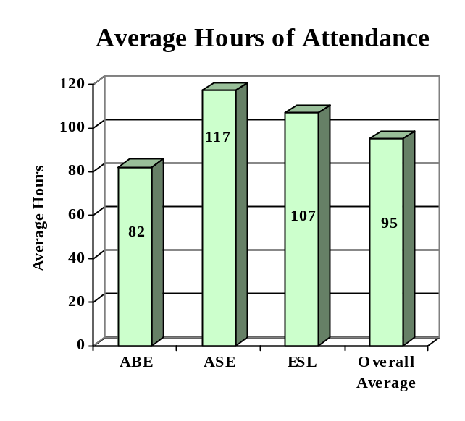

ENROLLMENT

Adult Basic Education 30,193 (54%)

Adult Secondary Education 9,815 (17%)
English Literacy 16,088 (29%)

TOTAL 56,096

PARTICIPANT STATUS

Employed - 21,375

Unemployed - 19,623

Correctional Setting - 14,609

On Public Assistance - 2,963

Other Institutionalized - 952

AGE

16 - 18 2,008 (04%)

19 - 24 17,163 (31%)
25 - 44 28,818 (51%)

45 - 59 6,167 (11%)
60 + 1,940 (03%)

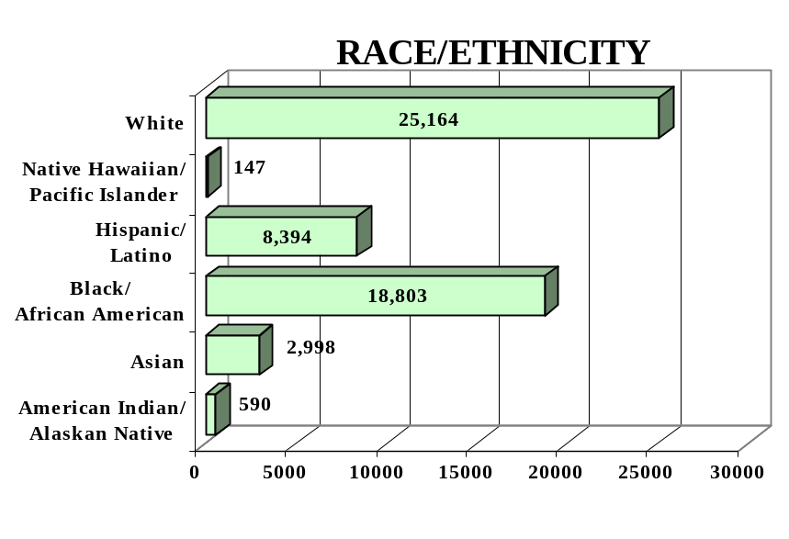
GENDER

Male - 32,194 (57%) Female - 23,902 (43%)

FEDERAL ALLOCATION
FY 2000

Basic Grant - $13,691,487
EL/Civics - $ 437,129

TOTAL - $14,128,616

MICHIGAN | Average  Performance Target | Actual  Performance | Status | Adults Completing  at Least One Level
Performance Measure I – Demonstrated Improvement in Literacy Skills  Sub Measures  Adult Basic and Secondary Education:^{1/} The percentage of adults enrolled in basic literacy programs who acquired the basic skills needed to complete the level of instruction in which they were initially enrolled.  English Literacy: ^{2/} The percentage of adults enrolled in English Literacy programs who acquired the level of English language skills needed to complete the level of instruction in which they were initially enrolled. | 17%  18% | 26%  25% | ↑  ↑ | 8,758  4,001
 | Performance Target | Actual  Performance | Status | Adults Achieving  Outcome
Performance Measure II – High School Completion  The percentage of adult learners with a high school completion goal who earned a high school diploma or GED.  Performance Measure III – Entered Postsecondary Education or Training  The percentage of adult learners with a goal to continue their education who enter postsecondary education or training.  Performance Measure IV - Entered Employment  The percentage of unemployed adult learners (in the workforce) with an employment goal who were employed at the end of first quarter after they exited the program.  Performance Measure V – Retained Employment  The percentage of adult learners with a) a job retention goal at the time of enrollment and b) those adults with an employment goal who obtained work by the end of the first quarter after leaving the program who were employed at the end of third quarter after exiting the program. | 25%  30%  30%  50% | 25%  23%  40%  64% | ↔  ↓  ↑  ↑ | 5,561  135  150  103

Key

Follow-up Methodology Used to Collect Performance Data

Educational Gains
√ Standardized tests

High School Completion Measure
√ Data matching (Official state GED records)

Postsecondary Transition
√ Individual student follow-up

Entered Employment
√ Individual student follow-up

Job Retention
√ Individual student follow-up
↑ Exceeded Performance Target
↔ Met Performance Target
↓ Did Not Meet Performance Target

^{1/} Adult Basic and Secondary Education programs consist of a series of instructional levels with each level representing a hierarchy of basic skills ranging from beginning literacy to high school completion.

^{2/} English Literacy education programs consist of a set of instructional levels with each level representing a hierarchy of English language skills ranging from beginning language literacy to oral language proficiency.

MINNESOTA

PROGRAM FACTS – 2000-2001

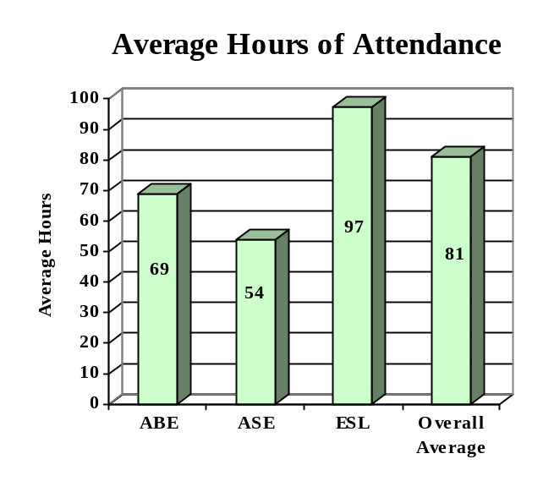

ENROLLMENT

Adult Basic Education 13,112 (31%)

Adult Secondary Education 7,036 (17%)
English Literacy 21,891 (52%)

TOTAL 42,039

PARTICIPANT STATUS

Employed - 17,224

Unemployed - 15,244

Correctional Setting - 8,854

On Public Assistance - 7,636

Other Institutionalized - 457

AGE

16 - 18 3,273 (08%)

19 - 24 10,783 (26%)
25 - 44 20,514 (49%)

45 - 59 5,156 (12%)
60 + 2,313 (05%)

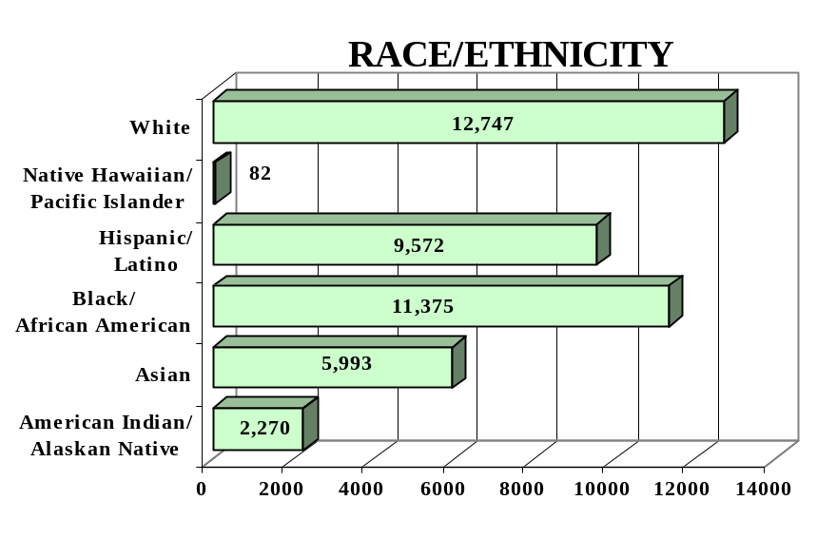
GENDER

Male - 21,083 (50%) Female - 20,956 (50%)

FEDERAL ALLOCATION
FY 2000

Basic Grant - $ 4,946,829
EL/Civics - $ 230,877

TOTAL - $ 5,177,706

MINNESOTA | Average  Performance Target | Actual  Performance | Status | Adults Completing  at Least One Level
Performance Measure I – Demonstrated Improvement in Literacy Skills  Sub Measures  Adult Basic and Secondary Education:^{1/} The percentage of adults enrolled in basic literacy programs who acquired the basic skills needed to complete the level of instruction in which they were initially enrolled.  English Literacy: ^{2/} The percentage of adults enrolled in English Literacy programs who acquired the level of English language skills needed to complete the level of instruction in which they were initially enrolled. | 28%  29% | 24%  18% | ↓  ↓ | 4,078  3,981
 | Performance Target | Actual  Performance | Status | Adults Achieving  Outcome
Performance Measure II – High School Completion  The percentage of adult learners with a high school completion goal who earned a high school diploma or GED.  Performance Measure III – Entered Postsecondary Education or Training  The percentage of adult learners with a goal to continue their education who enter postsecondary education or training.  Performance Measure IV - Entered Employment  The percentage of unemployed adult learners (in the workforce) with an employment goal who were employed at the end of first quarter after they exited the program.  Performance Measure V – Retained Employment  The percentage of adult learners with a) a job retention goal at the time of enrollment and b) those adults with an employment goal who obtained work by the end of the first quarter after leaving the program who were employed at the end of third quarter after exiting the program. | 33%  20%  20%  33% | 35%  34%  45%  76% | ↑  ↑  ↑  ↑ | 2,747  586  1,587  1,974

Follow-up Methodology Used to Collect Performance Data

Educational Gains
√ Standardized tests

High School Completion Measure
√ Data matching (Official state GED records and H.S. diploma follow-up)
√ State developed individual student follow-up survey

Postsecondary Transition
√ State developed individual student follow-up survey

Entered Employment
√ State developed individual student follow-up survey

Job Retention
√ State developed individual student follow-up survey

Key
↑ Exceeded Performance Target
↔ Met Performance Target
↓ Did Not Meet Performance Target

^{1/} Adult Basic and Secondary Education programs consist of a series of instructional levels with each level representing a hierarchy of basic skills ranging from beginning literacy to high school completion.

^{2/} English Literacy education programs consist of a set of instructional levels with each level representing a hierarchy of English language skills ranging from beginning language literacy to oral language proficiency.

MISSISSIPPI

PROGRAM FACTS – 2000-2001

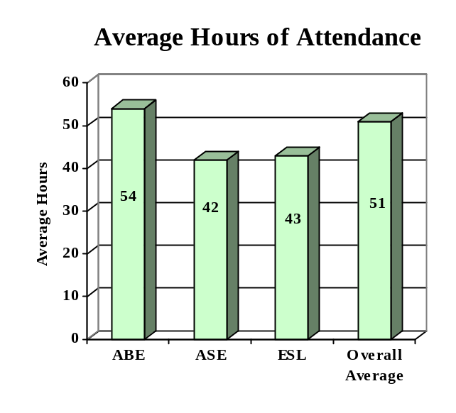

ENROLLMENT

Adult Basic Education 27,560 (73%)

Adult Secondary Education 8,072 (21%)
English Literacy 2,315 (06%)

TOTAL 37,947

PARTICIPANT STATUS

Employed - 10,265

Unemployed - 13,584

Correctional Setting - 3,804

On Public Assistance - 2,851

Other Institutionalized - 4,860

AGE

16 - 18 8,265 (22%)

19 - 24 11,640 (31%)
25 - 44 13,580 (36%)

45 - 59 3,508 (09%)
60 + 954 (02%)

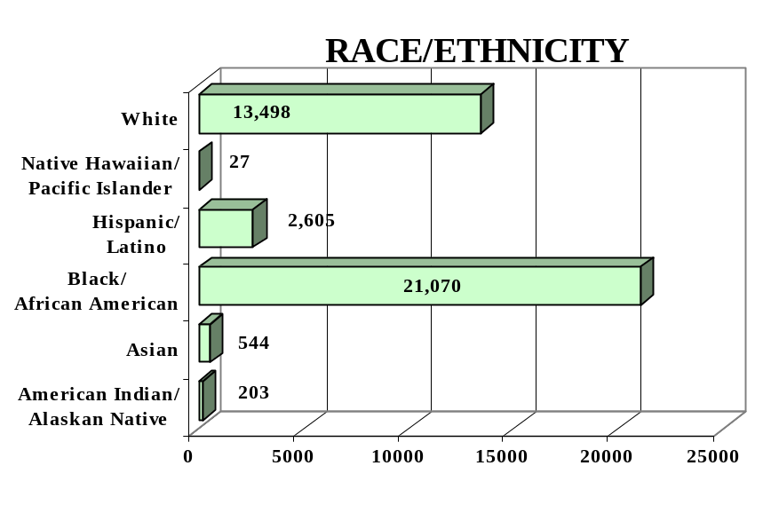
GENDER

Male - 17,896 (47%) Female - 20,051 (53%)

FEDERAL ALLOCATION
FY 2000

Basic Grant - $ 5,666,889
EL/Civics - $ 0

TOTAL - $ 5,666,889

MISSISSIPPI | Average  Performance Target | Actual  Performance | Status | Adults Completing  at Least One Level
Performance Measure I – Demonstrated Improvement in Literacy Skills  Sub Measures  Adult Basic and Secondary Education:^{1/} The percentage of adults enrolled in basic literacy programs who acquired the basic skills needed to complete the level of instruction in which they were initially enrolled.  English Literacy: ^{2/} The percentage of adults enrolled in English Literacy programs who acquired the level of English language skills needed to complete the level of instruction in which they were initially enrolled. | 23%  26% | 42%  41% | ↑  ↑ | 15,377  940
 | Performance Target | Actual  Performance | Status | Adults Achieving  Outcome
Performance Measure II – High School Completion  The percentage of adult learners with a high school completion goal who earned a high school diploma or GED.  Performance Measure III – Entered Postsecondary Education or Training  The percentage of adult learners with a goal to continue their education who enter postsecondary education or training.  Performance Measure IV - Entered Employment  The percentage of unemployed adult learners (in the workforce) with an employment goal who were employed at the end of first quarter after they exited the program.  Performance Measure V – Retained Employment  The percentage of adult learners with a) a job retention goal at the time of enrollment and b) those adults with an employment goal who obtained work by the end of the first quarter after leaving the program who were employed at the end of third quarter after exiting the program. | 25%  11%  16%  18% | 34%  26%  21%  23% | ↑  ↑  ↑  ↑ | 2,983  1,323  218  303

Follow-up Methodology Used to Collect Performance Data

Educational Gains
√ Combination of standardized tests and performance-based assessment

High School Completion Measure
√ State developed individual student follow-up survey

Postsecondary Transition
√ State developed individual student follow-up survey

Entered Employment
√ State developed individual student follow-up survey

Job Retention
√ State developed individual student follow-up survey

Key
↑ Exceeded Performance Target
↔ Met Performance Target
↓ Did Not Meet Performance Target

^{1/} Adult Basic and Secondary Education programs consist of a series of instructional levels with each level representing a hierarchy of basic skills ranging from beginning literacy to high school completion.

^{2/} English Literacy education programs consist of a set of instructional levels with each level representing a hierarchy of English language skills ranging from beginning language literacy to oral language proficiency.

MISSOURI

PROGRAM FACTS – 2000-2001

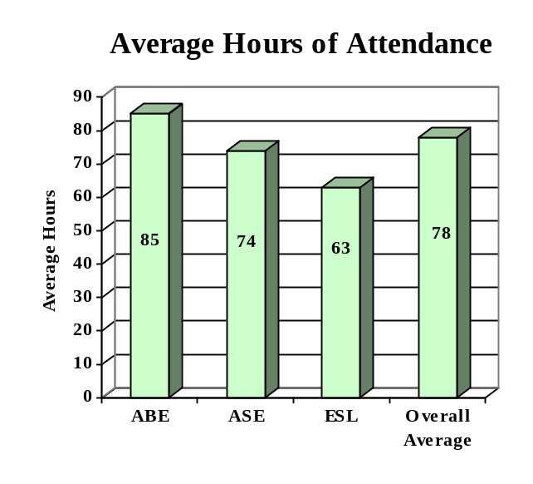

ENROLLMENT

Adult Basic Education 24,986 (61%)

Adult Secondary Education 6,399 (15%)
English Literacy 9,704 (24%)

TOTAL 41,089

PARTICIPANT STATUS

Employed - 11,781

Unemployed - 16,067

Correctional Setting - 10,868

On Public Assistance - 1,789

Other Institutionalized - 269

AGE

16 - 18 5,352 (13%)

19 - 24 12,244 (30%)
25 - 44 17,857 (43%)

45 - 59 4,194 (10%)
60 + 1,442 (04%)

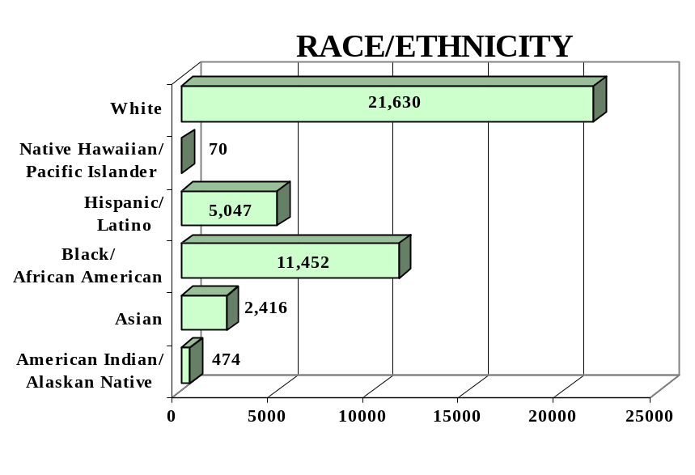
GENDER

Male - 20,409 (50%) Female - 20,680 (50%)

FEDERAL ALLOCATION
FY 2000

Basic Grant - $ 8,631,006
EL/Civics - $ 130,366

TOTAL - $ 8,761,372

MISSOURI | Average  Performance Target | Actual  Performance | Status | Adults Completing  at Least One Level
Performance Measure I – Demonstrated Improvement in Literacy Skills  Sub Measures  Adult Basic and Secondary Education:^{1/} The percentage of adults enrolled in basic literacy programs who acquired the basic skills needed to complete the level of instruction in which they were initially enrolled.  English Literacy: ^{2/} The percentage of adults enrolled in English Literacy programs who acquired the level of English language skills needed to complete the level of instruction in which they were initially enrolled. | 29%  19% | 31%  16% | ↑  ↓ | 8,761  1,532
 | Performance Target | Actual  Performance | Status | Adults Achieving  Outcome
Performance Measure II – High School Completion  The percentage of adult learners with a high school completion goal who earned a high school diploma or GED.  Performance Measure III – Entered Postsecondary Education or Training  The percentage of adult learners with a goal to continue their education who enter postsecondary education or training.  Performance Measure IV - Entered Employment  The percentage of unemployed adult learners (in the workforce) with an employment goal who were employed at the end of first quarter after they exited the program.  Performance Measure V – Retained Employment  The percentage of adult learners with a) a job retention goal at the time of enrollment and b) those adults with an employment goal who obtained work by the end of the first quarter after leaving the program who were employed at the end of third quarter after exiting the program. | 71%  23%  22%  24% | 44%  27%  44%  34% | ↓  ↑  ↑  ↑ | 1,804  645  695  486

Follow-up Methodology Used to Collect Performance Data

Educational Gains
√ Standardized tests

High School Completion Measure
√ Data matching (official state GED records)

Postsecondary Transition
√ Data matching (community college and four-year college
enrollment database)

Entered Employment
√ Data matching (UI employment records)

Job Retention
√ Data matching (UI employment records)

Key
↑ Exceeded Performance Target
↔ Met Performance Target
↓ Did Not Meet Performance Target

^{1/} Adult Basic and Secondary Education programs consist of a series of instructional levels with each level representing a hierarchy of basic skills ranging from beginning literacy to high school completion.

^{2/} English Literacy education programs consist of a set of instructional levels with each level representing a hierarchy of English language skills ranging from beginning language literacy to oral language proficiency.

MONTANA

PROGRAM FACTS – 2000-2001

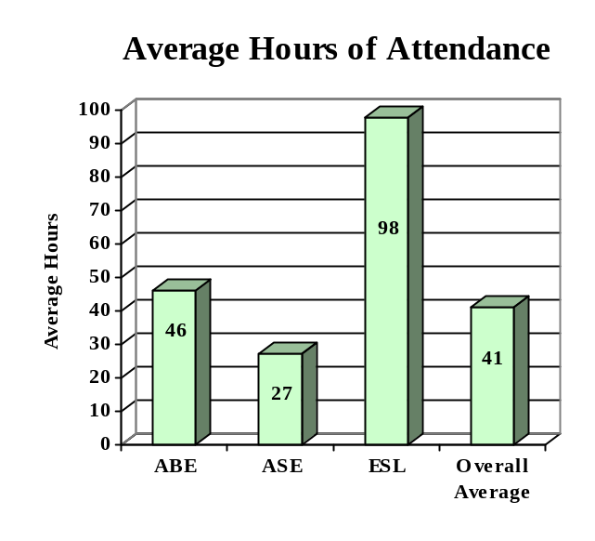

ENROLLMENT

Adult Basic Education 3,060 (63%)

Adult Secondary Education 1,726 (35%)
English Literacy 106 (02%)

TOTAL 4,892

PARTICIPANT STATUS

Employed - 2,683

Unemployed - 2,786

Correctional Setting - 1,203

On Public Assistance - 1,424

Other Institutionalized - 26

AGE

16 - 18 1,276 (26%)

19 - 24 1,326 (27%)
25 - 44 1,849 (38%)

45 - 59 423 (09%)
60 + 18 (>01%)

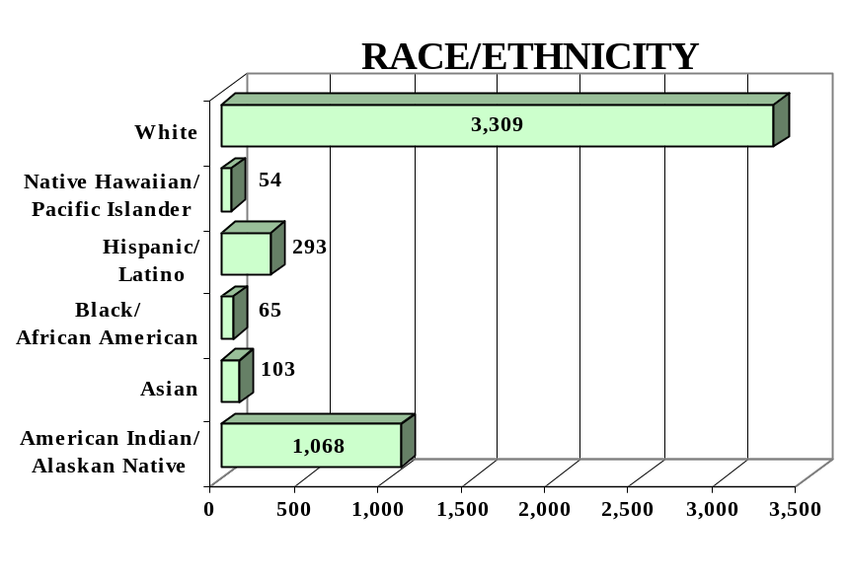
GENDER

Male - 2,483 (51%) Female - 2,409 (49%)

FEDERAL ALLOCATION
FY 2000

Basic Grant - $ 1,187,497
EL/Civics - $ 0

TOTAL - $ 1,187,497

MONTANA | Average  Performance Target | Actual  Performance | Status | Adults Completing  at Least One Level
Performance Measure I – Demonstrated Improvement in Literacy Skills  Sub Measures  Adult Basic and Secondary Education:^{1/} The percentage of adults enrolled in basic literacy programs who acquired the basic skills needed to complete the level of instruction in which they were initially enrolled.  English Literacy: ^{2/} The percentage of adults enrolled in English Literacy programs who acquired the level of English language skills needed to complete the level of instruction in which they were initially enrolled. | 32%  37% | 53%  75% | ↑  ↑ | 2,089  80
 | Performance Target | Actual  Performance | Status | Adults Achieving  Outcome
Performance Measure II – High School Completion  The percentage of adult learners with a high school completion goal who earned a high school diploma or GED.  Performance Measure III – Entered Postsecondary Education or Training  The percentage of adult learners with a goal to continue their education who enter postsecondary education or training.  Performance Measure IV - Entered Employment  The percentage of unemployed adult learners (in the workforce) with an employment goal who were employed at the end of first quarter after they exited the program.  Performance Measure V – Retained Employment  The percentage of adult learners with a) a job retention goal at the time of enrollment and b) those adults with an employment goal who obtained work by the end of the first quarter after leaving the program who were employed at the end of third quarter after exiting the program. | 10%  17%  18%  07% | 35%  40%  52%  61% | ↑  ↑  ↑  ↑ | 811  164  134  27

Follow-up Methodology Used to Collect Performance Data

Educational Gains
√ Combination of standardized tests and performance-based assessment

High School Completion Measure
√ Individual student follow-up survey

Postsecondary Transition
√ Individual student follow-up survey

Entered Employment
√ Individual student follow-up survey

Job Retention
√ Individual student follow-up survey

Key
↑ Exceeded Performance Target
↔ Met Performance Target
↓ Did Not Meet Performance Target

^{1/} Adult Basic and Secondary Education programs consist of a series of instructional levels with each level representing a hierarchy of basic skills ranging from beginning literacy to high school completion.

^{2/} English Literacy education programs consist of a set of instructional levels with each level representing a hierarchy of English language skills ranging from beginning language literacy to oral language proficiency.

NEBRASKA

PROGRAM FACTS – 2000-2001

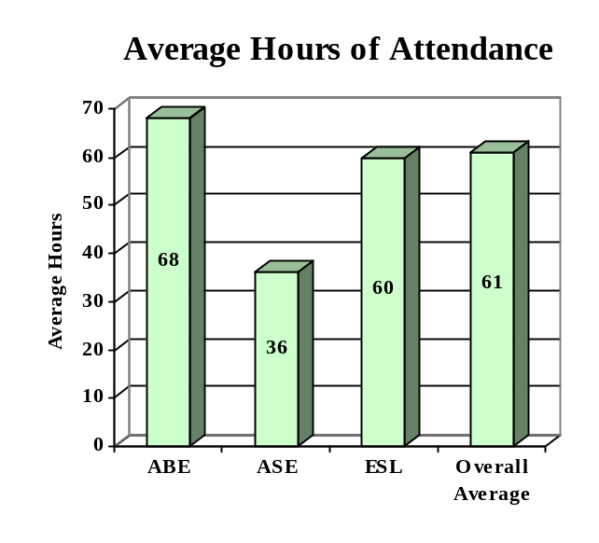

ENROLLMENT

Adult Basic Education 4,057 (51%)

Adult Secondary Education 957 (12%)
English Literacy 2,903 (37%)

TOTAL 7,917

PARTICIPANT STATUS

Employed - 3,447

Unemployed - 3,265

Correctional Setting - 1,209

On Public Assistance - 884

Other Institutionalized - 0

AGE

16 - 18 1,656 (21%)

19 - 24 2,207 (28%)
25 - 44 3,333 (42%)

45 - 59 601 (08%)
60 + 120 (01%)

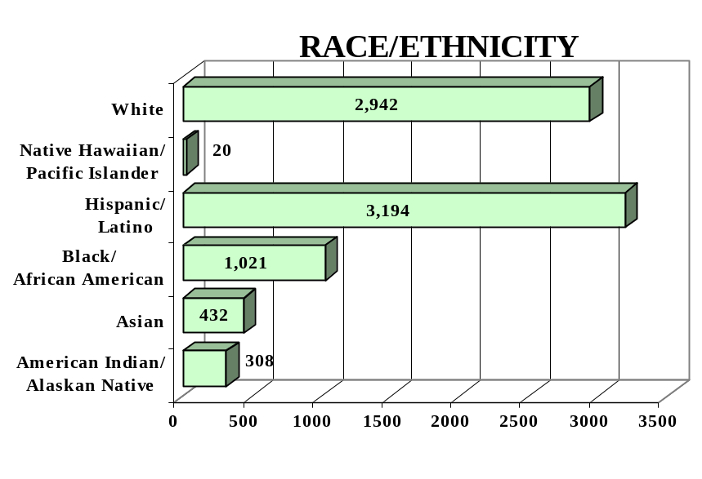
GENDER

Male - 4,124 (52%) Female - 3,793 (48%)

FEDERAL ALLOCATION
FY 2000

Basic Grant - $ 1,989,737
EL/Civics - $ 0

TOTAL - $ 1,989,737

NEBRASKA | Average  Performance Target | Actual  Performance | Status | Adults Completing  at Least One Level
Performance Measure I – Demonstrated Improvement in Literacy Skills  Sub Measures  Adult Basic and Secondary Education:^{1/} The percentage of adults enrolled in basic literacy programs who acquired the basic skills needed to complete the level of instruction in which they were initially enrolled.  English Literacy: ^{2/} The percentage of adults enrolled in English Literacy programs who acquired the level of English language skills needed to complete the level of instruction in which they were initially enrolled. | 29%  21% | 30%  23% | ↑  ↑ | 1,386  664
 | Performance Target | Actual  Performance | Status | Adults Achieving  Outcome
Performance Measure II – High School Completion  The percentage of adult learners with a high school completion goal who earned a high school diploma or GED.  Performance Measure III – Entered Postsecondary Education or Training  The percentage of adult learners with a goal to continue their education who enter postsecondary education or training.  Performance Measure IV - Entered Employment  The percentage of unemployed adult learners (in the workforce) with an employment goal who were employed at the end of first quarter after they exited the program.  Performance Measure V – Retained Employment  The percentage of adult learners with a) a job retention goal at the time of enrollment and b) those adults with an employment goal who obtained work by the end of the first quarter after leaving the program who were employed at the end of third quarter after exiting the program. | 32%  20%  30%  25% | 35%  28%  28%  28% | ↑  ↑  ↓  ↑ | 1,084  117  200  142

Follow-up Methodology Used to Collect Performance Data

Educational Gains
√ Standardized tests

High School Completion Measure
√ Data matching (Official state GED records)

Postsecondary Transition
√ State developed individual student follow-up survey

Entered Employment
√ Data matching (UI employment records)
√ State developed individual student follow-up survey

Job Retention
√ Data matching (UI employment records)
√ State developed individual student follow-up survey

Key
↑ Exceeded Performance Target
↔ Met Performance Target
↓ Did Not Meet Performance Target

^{1/} Adult Basic and Secondary Education programs consist of a series of instructional levels with each level representing a hierarchy of basic skills ranging from beginning literacy to high school completion.

^{2/} English Literacy education programs consist of a set of instructional levels with each level representing a hierarchy of English language skills ranging from beginning language literacy to oral language proficiency.

NEVADA

PROGRAM FACTS – 2000-2001

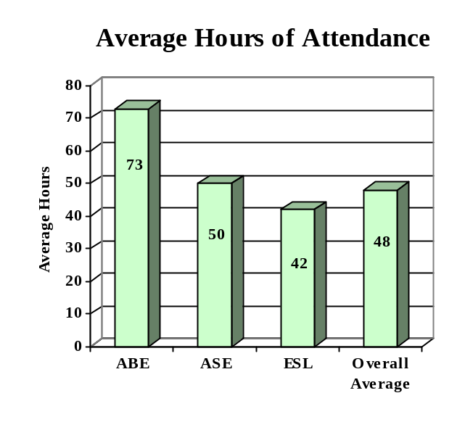

ENROLLMENT

Adult Basic Education 1,445 (06%)

Adult Secondary Education 10,353 (45%)
English Literacy 11,194 (49%)

TOTAL 22,992

PARTICIPANT STATUS

Employed - 9,089

Unemployed - 9,505

Correctional Setting - 3,797

On Public Assistance - 788

Other Institutionalized - 8

AGE

16 - 18 3,675 (16%)

19 - 24 7,172 (31%)
25 - 44 10,116 (44%)

45 - 59 1,697 (07%)
60 + 332 (02%)

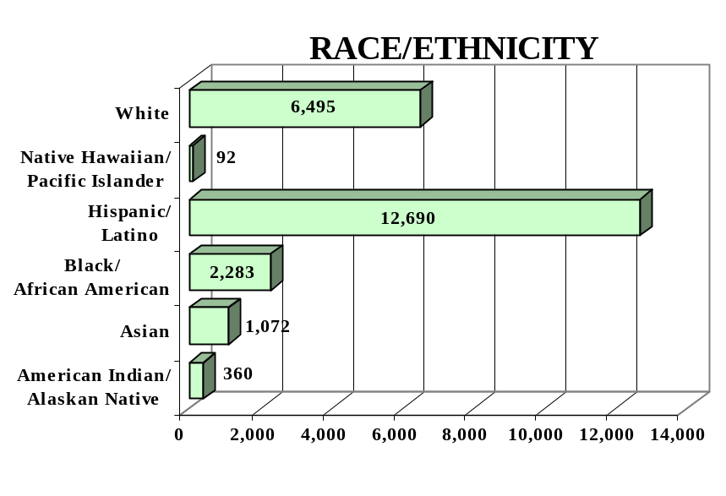
GENDER

Male - 13,116 (57%) Female - 9,876 (43%)

FEDERAL ALLOCATION
FY 2000

Basic Grant - $ 1,986,144
EL/Civics - $ 181,589

TOTAL - $ 2,167,733

NEVADA | Average  Performance Target | Actual  Performance | Status | Adults Completing  at Least One Level
Performance Measure I – Demonstrated Improvement in Literacy Skills  Sub Measures  Adult Basic and Secondary Education:^{1/} The percentage of adults enrolled in basic literacy programs who acquired the basic skills needed to complete the level of instruction in which they were initially enrolled.  English Literacy: ^{2/} The percentage of adults enrolled in English Literacy programs who acquired the level of English language skills needed to complete the level of instruction in which they were initially enrolled. | 22%  20% | 31%  37% | ↑  ↑ | 1,568  4,136
 | Performance Target | Actual  Performance | Status | Adults Achieving  Outcome
Performance Measure II – High School Completion  The percentage of adult learners with a high school completion goal who earned a high school diploma or GED.  Performance Measure III – Entered Postsecondary Education or Training  The percentage of adult learners with a goal to continue their education who enter postsecondary education or training.  Performance Measure IV - Entered Employment  The percentage of unemployed adult learners (in the workforce) with an employment goal who were employed at the end of first quarter after they exited the program.  Performance Measure V – Retained Employment  The percentage of adult learners with a) a job retention goal at the time of enrollment and b) those adults with an employment goal who obtained work by the end of the first quarter after leaving the program who were employed at the end of third quarter after exiting the program. | 20%  20%  20%  20% | 38%  43%  70%  83% | ↑  ↑  ↑  ↑ | 2,746  182  1,264  4,749

Follow-up Methodology Used to Collect Performance Data

Educational Gains
√ Individual student follow-up survey

High School Completion Measure
√ Individual student follow-up survey

Postsecondary Transition
√ Individual student follow-up survey

Entered Employment
√ Individual student follow-up survey

Job Retention
√ Individual student follow-up survey

Key
↑ Exceeded Performance Target
↔ Met Performance Target
↓ Did Not Meet Performance Target

^{1/} Adult Basic and Secondary Education programs consist of a series of instructional levels with each level representing a hierarchy of basic skills ranging from beginning literacy to high school completion.

^{2/} English Literacy education programs consist of a set of instructional levels with each level representing a hierarchy of English language skills ranging from beginning language literacy to oral language proficiency.

NEW HAMPSHIRE

PROGRAM FACTS – 2000-2001

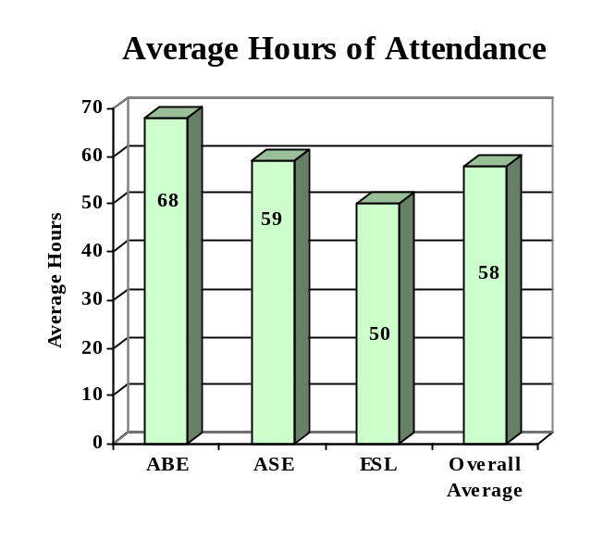

ENROLLMENT

Adult Basic Education 1,566 (26%)

Adult Secondary Education 2,467 (41%)
English Literacy 1,929 (33%)

TOTAL 5,962

PARTICIPANT STATUS

Employed - 3,387

Unemployed - 1,983

Correctional Setting - 262

On Public Assistance - 528

Other Institutionalized - 58

AGE

16 - 18 1,084 (18%)

19 - 24 1,715 (29%)
25 - 44 2,343 (39%)

45 - 59 659 (11%)
60 + 161 (03%)

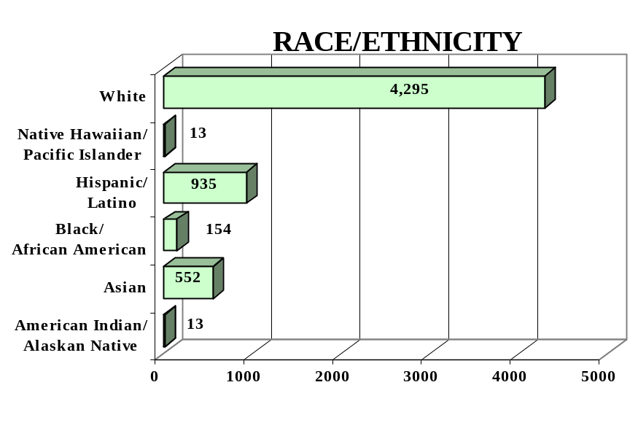
GENDER

Male - 2,475 (42%) Female - 3,487 (58%)

FEDERAL ALLOCATION
FY 2000

Basic Grant - $1,529,304
EL/Civics - $ -0-

TOTAL - $1,529,304

NEW HAMPSHIRE | Average  Performance Target | Actual  Performance | Status | Adults Completing  at Least One Level
Performance Measure I – Demonstrated Improvement in Literacy Skills  Sub Measures  Adult Basic and Secondary Education:^{1/} The percentage of adults enrolled in basic literacy programs who acquired the basic skills needed to complete the level of instruction in which they were initially enrolled.  English Literacy: ^{2/} The percentage of adults enrolled in English Literacy programs who acquired the level of English language skills needed to complete the level of instruction in which they were initially enrolled. | 22%  16% | 55%  36% | ↑  ↑ | 1,048  813
 | Performance Target | Actual  Performance | Status | Adults Achieving  Outcome
Performance Measure II – High School Completion  The percentage of adult learners with a high school completion goal who earned a high school diploma or GED.  Performance Measure III – Entered Postsecondary Education or Training  The percentage of adult learners with a goal to continue their education who enter postsecondary education or training.  Performance Measure IV - Entered Employment  The percentage of unemployed adult learners (in the workforce) with an employment goal who were employed at the end of first quarter after they exited the program.  Performance Measure V – Retained Employment  The percentage of adult learners with a) a job retention goal at the time of enrollment and b) those adults with an employment goal who obtained work by the end of the first quarter after leaving the program who were employed at the end of third quarter after exiting the program. | 30%  20%  21%  30% | 55%  55%  59%  78% | ↑  ↑  ↑  ↑ | 677  114  134  54

Follow-up Methodology Used to Collect Performance Data

Educational Gains
√ Standardized tests

High School Completion Measure
√ State developed individual student follow-up survey

Postsecondary Transition
√ State developed individual student follow-up survey

Entered Employment
√ State developed individual student follow-up survey

Job Retention
√ State developed individual student follow-up survey

Key
↑ Exceeded Performance Target
↔ Met Performance Target
↓ Did Not Meet Performance Target

^{1/} Adult Basic and Secondary Education programs consist of a series of instructional levels with each level representing a hierarchy of basic skills ranging from beginning literacy to high school completion.

^{2/} English Literacy education programs consist of a set of instructional levels with each level representing a hierarchy of English language skills ranging from beginning language literacy to oral language proficiency.

NEW JERSEY

PROGRAM FACTS – 2000-2001

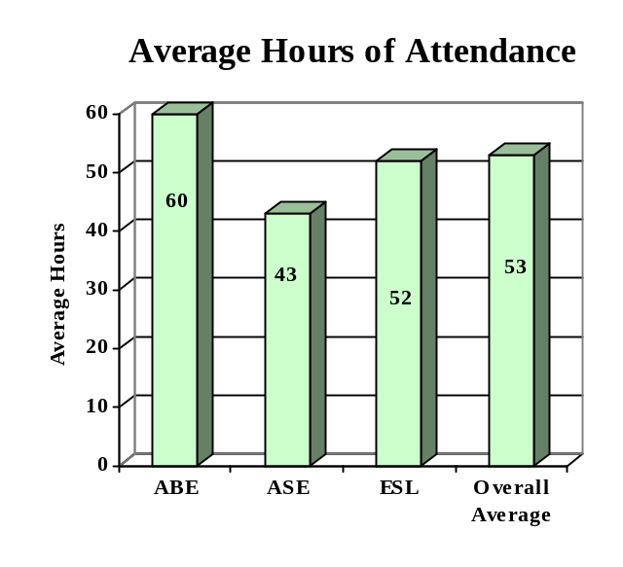

ENROLLMENT

Adult Basic Education 11,804 (26%)

Adult Secondary Education 6,985 (16%)
English Literacy 25,528 (58%)

TOTAL 44,317

PARTICIPANT STATUS

Employed - 21,369

Unemployed - 9,592

Correctional Setting - 3,914

On Public Assistance - 2,490

Other Institutionalized - 333

AGE

16 - 18 3,833 (50%)

19 - 24 9,223 (18%)
25 - 44 22,841 (26%)

45 - 59 6,723 (05%)
60 + 1,697 (01%)

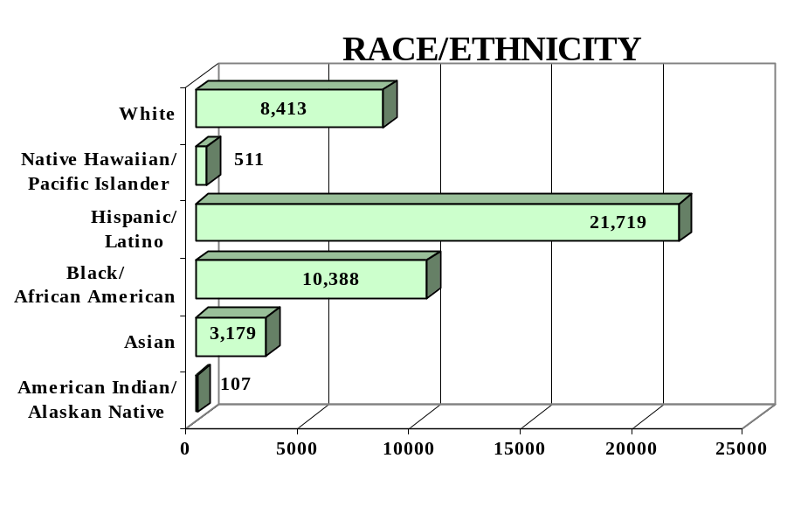
GENDER

Male - 19,980 (45%) Female - 24,337 (55%)

FEDERAL ALLOCATION
FY 2000

Basic Grant - $12,000,766
EL/Civics - $ 1,395,520

TOTAL - $13,396,286

NEW JERSEY | Average  Performance Target | Actual  Performance | Status | Adults Completing  at Least One Level
Performance Measure I – Demonstrated Improvement in Literacy Skills  Sub Measures  Adult Basic and Secondary Education:^{1/} The percentage of adults enrolled in basic literacy programs who acquired the basic skills needed to complete the level of instruction in which they were initially enrolled.  English Literacy: ^{2/} The percentage of adults enrolled in English Literacy programs who acquired the level of English language skills needed to complete the level of instruction in which they were initially enrolled. | 21%  22% | 27%  38% | ↑  ↑ | 4,218  9,761
 | Performance Target | Actual  Performance | Status | Adults Achieving  Outcome
Performance Measure II – High School Completion  The percentage of adult learners with a high school completion goal who earned a high school diploma or GED.  Performance Measure III – Entered Postsecondary Education or Training  The percentage of adult learners with a goal to continue their education who enter postsecondary education or training.  Performance Measure IV - Entered Employment  The percentage of unemployed adult learners (in the workforce) with an employment goal who were employed at the end of first quarter after they exited the program.  Performance Measure V – Retained Employment  The percentage of adult learners with a) a job retention goal at the time of enrollment and b) those adults with an employment goal who obtained work by the end of the first quarter after leaving the program who were employed at the end of third quarter after exiting the program. | 28%  50%  18%  71% | 30%  25%  41%  89% | ↑  ↓  ↑  ↑ | 1,667  697  2,020  12,253

Follow-up Methodology Used to Collect Performance Data

Educational Gains
√ Standardized tests

High School Completion Measure
√ State developed individual student follow-up survey

Postsecondary Transition
√ State developed individual student follow-up survey

Entered Employment
√ State developed individual student follow-up survey

Job Retention
√ State developed individual student follow-up survey

Key
↑ Exceeded Performance Target
↔ Met Performance Target
↓ Did Not Meet Performance Target

^{1/} Adult Basic and Secondary Education programs consist of a series of instructional levels with each level representing a hierarchy of basic skills ranging from beginning literacy to high school completion.

^{2/} English Literacy education programs consist of a set of instructional levels with each level representing a hierarchy of English language skills ranging from beginning language literacy to oral language proficiency.

NEW MEXICO

PROGRAM FACTS – 2000-2001

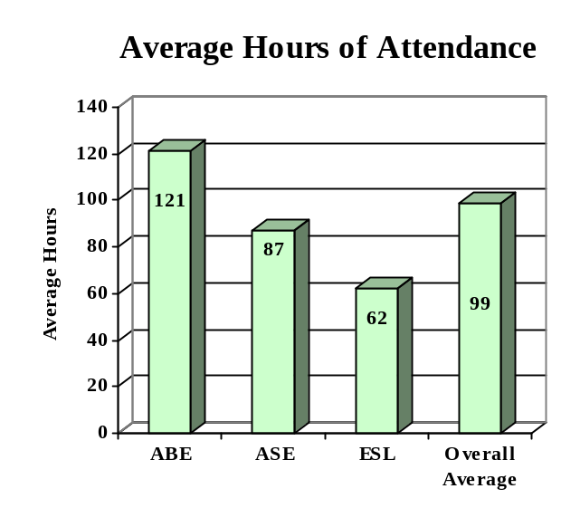

ENROLLMENT

Adult Basic Education 13,418 (58%)

Adult Secondary Education 2,486 (11%)
English Literacy 7,339 (31%)

TOTAL 23,243

PARTICIPANT STATUS

Employed - 8,209

Unemployed - 8,925

Correctional Setting - 3,416

On Public Assistance - 4,912

Other Institutionalized - 451

AGE

16 - 18 2,894 (12%)

19 - 24 6,256 (27%)
25 - 44 11,158 (48%)

45 - 59 2,310 (10%)
60 + 625 (03%)

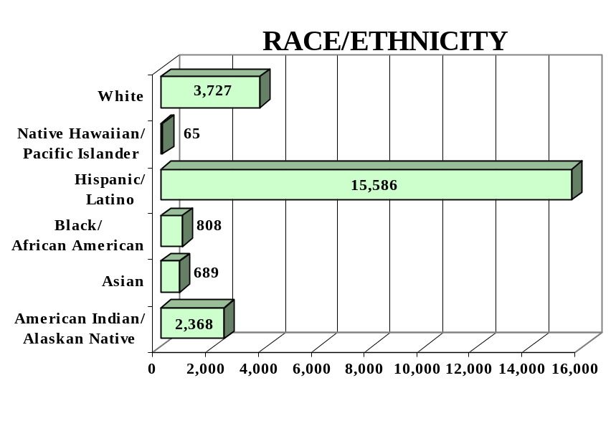
GENDER

Male - 9,943 (43%) Female - 13,300 (57%)

FEDERAL ALLOCATION
FY 2000

Basic Grant - $ 2,556,935
EL/Civics - $ 128,216

TOTAL - $ 2,685,151

NEW MEXICO | Average  Performance Target | Actual  Performance | Status | Adults Completing  at Least One Level
Performance Measure I – Demonstrated Improvement in Literacy Skills  Sub Measures  Adult Basic and Secondary Education:^{1/} The percentage of adults enrolled in basic literacy programs who acquired the basic skills needed to complete the level of instruction in which they were initially enrolled.  English Literacy: ^{2/} The percentage of adults enrolled in English Literacy programs who acquired the level of English language skills needed to complete the level of instruction in which they were initially enrolled. | 23%  18% | 42%  45% | ↑  ↑ | 6,299  3,362
 | Performance Target | Actual  Performance | Status | Adults Achieving  Outcome
Performance Measure II – High School Completion  The percentage of adult learners with a high school completion goal who earned a high school diploma or GED.  Performance Measure III – Entered Postsecondary Education or Training  The percentage of adult learners with a goal to continue their education who enter postsecondary education or training.  Performance Measure IV - Entered Employment  The percentage of unemployed adult learners (in the workforce) with an employment goal who were employed at the end of first quarter after they exited the program.  Performance Measure V – Retained Employment  The percentage of adult learners with a) a job retention goal at the time of enrollment and b) those adults with an employment goal who obtained work by the end of the first quarter after leaving the program who were employed at the end of third quarter after exiting the program. | 25%  10%  10%  10% | 25%  20%  26%  25% | ↔  ↑  ↑  ↑ | 1,665  851  407  42

Follow-up Methodology Used to Collect Performance Data

Educational Gains
√ Standardized tests

High School Completion Measure
√ Data matching (Official state GED records)
√ State developed individual student follow-up survey

Postsecondary Transition
√ State developed individual student follow-up survey

Entered Employment
√ Data matching (UI employment records)
√ State developed individual student follow-up survey

Job Retention
√ Data matching (UI employment records)
√ State developed individual student follow-up survey

Key
↑ Exceeded Performance Target
↔ Met Performance Target
↓ Did Not Meet Performance Target

^{1/} Adult Basic and Secondary Education programs consist of a series of instructional levels with each level representing a hierarchy of basic skills ranging from beginning literacy to high school completion.

^{2/} English Literacy education programs consist of a set of instructional levels with each level representing a hierarchy of English language skills ranging from beginning language literacy to oral language proficiency.

NEW YORK

PROGRAM FACTS – 2000-2001

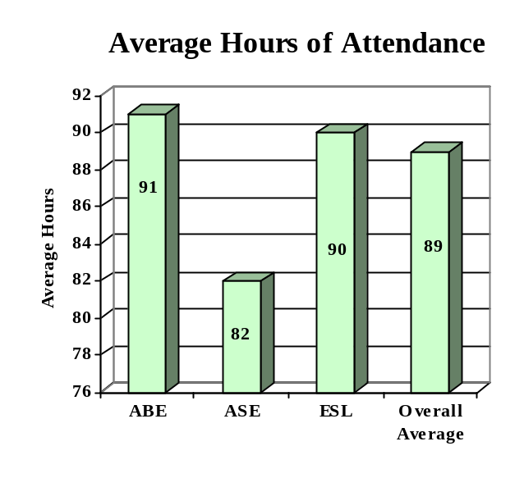

ENROLLMENT

Adult Basic Education 59,425 (34%)

Adult Secondary Education 26,079 (15%)
English Literacy 90,735 (51%)

TOTAL 176,239

PARTICIPANT STATUS

Employed - 77,081

Unemployed - 53,732

Correctional Setting - 8,006

On Public Assistance - 20,678

Other Institutionalized - 3,652

AGE

16 - 18 12,513 (07%)

19 - 24 41,453 (24%)
25 - 44 90,822 (51%)

45 - 59 24,472 (14%)
60 + 6,979 (04%)

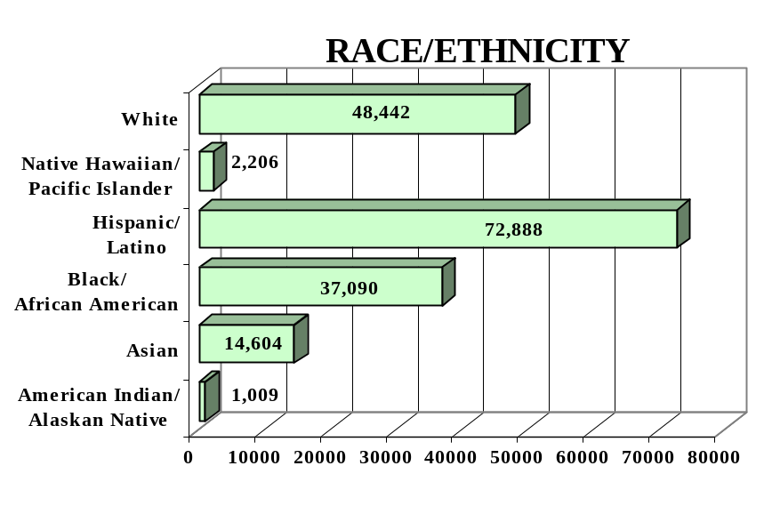
GENDER

Male - 76,235 (43%) Female -100,004 (57%)

FEDERAL ALLOCATION
FY 2000

Basic Grant - $29,532,561
EL/Civics - $ 3,990,611

TOTAL - $33,523,172

NEW YORK | Average  Performance Target | Actual  Performance | Status | Adults Completing  at Least One Level
Performance Measure I – Demonstrated Improvement in Literacy Skills  Sub Measures  Adult Basic and Secondary Education:^{1/} The percentage of adults enrolled in basic literacy programs who acquired the basic skills needed to complete the level of instruction in which they were initially enrolled.  English Literacy: ^{2/} The percentage of adults enrolled in English Literacy programs who acquired the level of English language skills needed to complete the level of instruction in which they were initially enrolled. | 20%  19% | 35%  46% | ↑  ↑ | 25,232  41,600
 | Performance Target | Actual  Performance | Status | Adults Achieving  Outcome
Performance Measure II – High School Completion  The percentage of adult learners with a high school completion goal who earned a high school diploma or GED.  Performance Measure III – Entered Postsecondary Education or Training  The percentage of adult learners with a goal to continue their education who enter postsecondary education or training.  Performance Measure IV - Entered Employment  The percentage of unemployed adult learners (in the workforce) with an employment goal who were employed at the end of first quarter after they exited the program.  Performance Measure V – Retained Employment  The percentage of adult learners with a) a job retention goal at the time of enrollment and b) those adults with an employment goal who obtained work by the end of the first quarter after leaving the program who were employed at the end of third quarter after exiting the program. | 42%  20%  20%  20% | 35%  59%  48%  70% | ↓  ↑  ↑  ↑ | 6,714  6,447  6,518  9,002

Follow-up Methodology Used to Collect Performance Data

Educational Gains
√ Standardized tests

High School Completion Measure
√ State developed individual follow-up survey

Postsecondary Transition
√ State developed individual follow-up survey

Entered Employment
√ State developed individual follow-up survey

Job Retention
√ State developed individual follow-up survey

Entered Employment
√ Data matching (UI employment records)

Job Retention
√ Data matching (UI employment records)

Key
↑ Exceeded Performance Target
↔ Met Performance Target
↓ Did Not Meet Performance Target

^{1/} Adult Basic and Secondary Education programs consist of a series of instructional levels with each level representing a hierarchy of basic skills ranging from beginning literacy to high school completion.

^{2/} English Literacy education programs consist of a set of instructional levels with each level representing a hierarchy of English language skills ranging from beginning language literacy to oral language proficiency.

NORTH CAROLINA

PROGRAM FACTS – 2000-2001

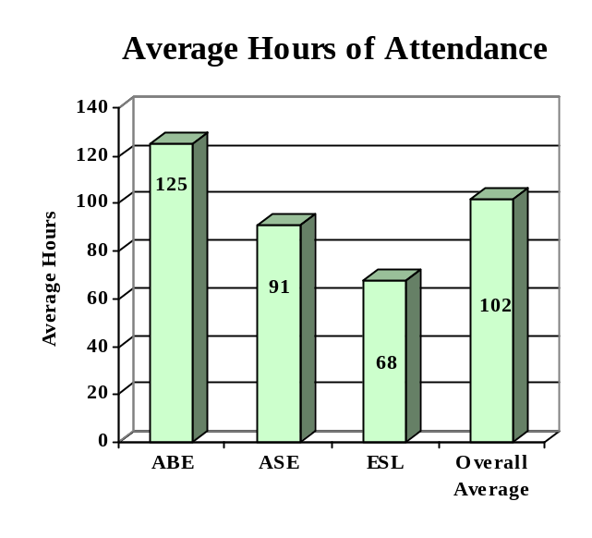

ENROLLMENT

Adult Basic Education 54,092 (50%)

Adult Secondary Education 26,000 (24%)
English Literacy 27,412 (26%)

TOTAL 107,504

PARTICIPANT STATUS

Employed - 46,838

Unemployed - 38,856

Correctional Setting - 12,651

On Public Assistance - 6,694

Other Institutionalized - 4,562

AGE

16 - 18 21,159 (20%)

19 - 24 30,812 (29%)
25 - 44 41,950 (39%)

45 - 59 10,808 (10%)
60 + 2,775 (02%)

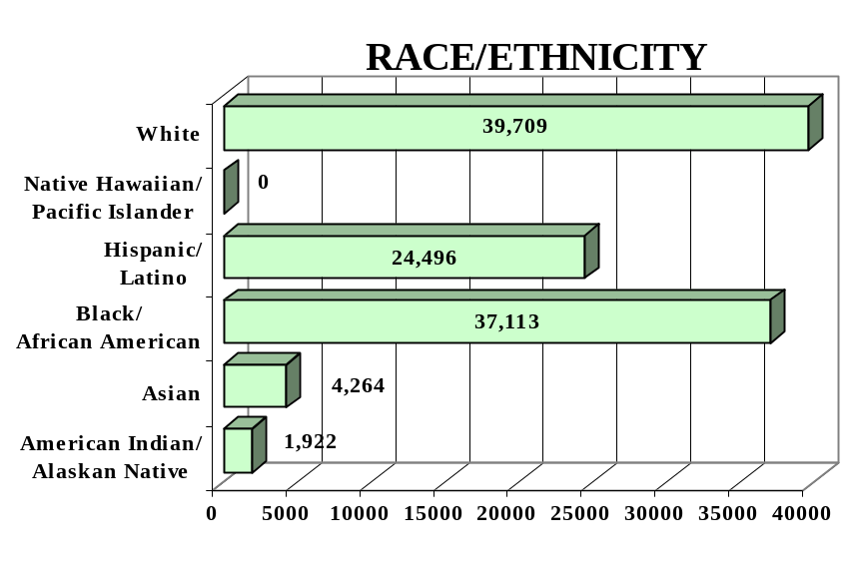
GENDER

Male - 57,701 (54%) Female - 49,803 (46%)

FEDERAL ALLOCATION
FY 2000

Basic Grant - $ 12,818,209
EL/Civics - $ 200,918

TOTAL - $ 13,019,127

NORTH CAROLINA | Average  Performance Target | Actual  Performance | Status | Adults Completing  at Least One Level
Performance Measure I – Demonstrated Improvement in Literacy Skills  Sub Measures  Adult Basic and Secondary Education:^{1/} The percentage of adults enrolled in basic literacy programs who acquired the basic skills needed to complete the level of instruction in which they were initially enrolled.  English Literacy: ^{2/} The percentage of adults enrolled in English Literacy programs who acquired the level of English language skills needed to complete the level of instruction in which they were initially enrolled. | 20%  19% | 36%  25% | ↑  ↑ | 26,582  6,888
 | Performance Target | Actual  Performance | Status | Adults Achieving  Outcome
Performance Measure II – High School Completion  The percentage of adult learners with a high school completion goal who earned a high school diploma or GED.  Performance Measure III – Entered Postsecondary Education or Training  The percentage of adult learners with a goal to continue their education who enter postsecondary education or training.  Performance Measure IV - Entered Employment  The percentage of unemployed adult learners (in the workforce) with an employment goal who were employed at the end of first quarter after they exited the program.  Performance Measure V – Retained Employment  The percentage of adult learners with a) a job retention goal at the time of enrollment and b) those adults with an employment goal who obtained work by the end of the first quarter after leaving the program who were employed at the end of third quarter after exiting the program. | 35%  13%  18%  10% | 38%  12%  15%  25% | ↑  ↓  ↓  ↑ | 20,584  2,507  1,819  3,767

Follow-up Methodology Used to Collect Performance Data

Educational Gains
√ Standardized tests

High School Completion Measure
√ Data matching (Official state GED records)

Postsecondary Transition
√ Data matching

Entered Employment
√ Data matching (UI employment records)

Job Retention
√ Data matching (UI employment records)

Key
↑ Exceeded Performance Target
↔ Met Performance Target
↓ Did Not Meet Performance Target

^{1/} Adult Basic and Secondary Education programs consist of a series of instructional levels with each level representing a hierarchy of basic skills ranging from beginning literacy to high school completion.

^{2/} English Literacy education programs consist of a set of instructional levels with each level representing a hierarchy of English language skills ranging from beginning language literacy to oral language proficiency.

NORTH DAKOTA

PROGRAM FACTS – 2000-2001

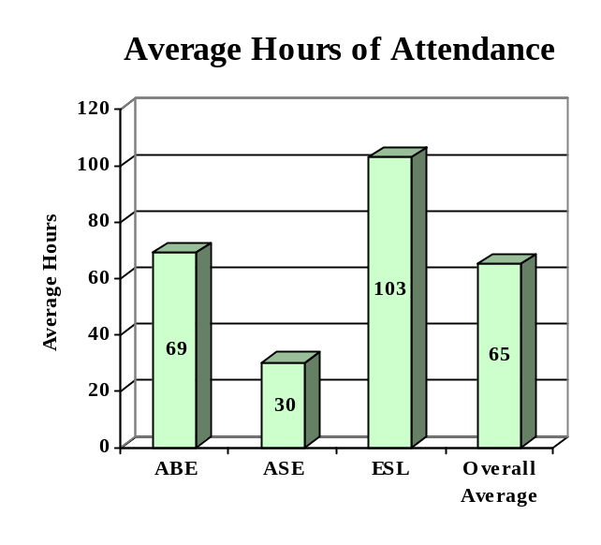

ENROLLMENT

Adult Basic Education 1,302 (61%)

Adult Secondary Education 485 (23%)
English Literacy 337 (16%)

TOTAL 2,124

PARTICIPANT STATUS

Employed - 782

Unemployed - 936

Correctional Setting - 280

On Public Assistance - 687

Other Institutionalized - 9

AGE

16 - 18 309 (14%)

19 - 24 888 (42%)
25 - 44 714 (34%)

45 - 59 167 (08%)
60 + 46 (02%)

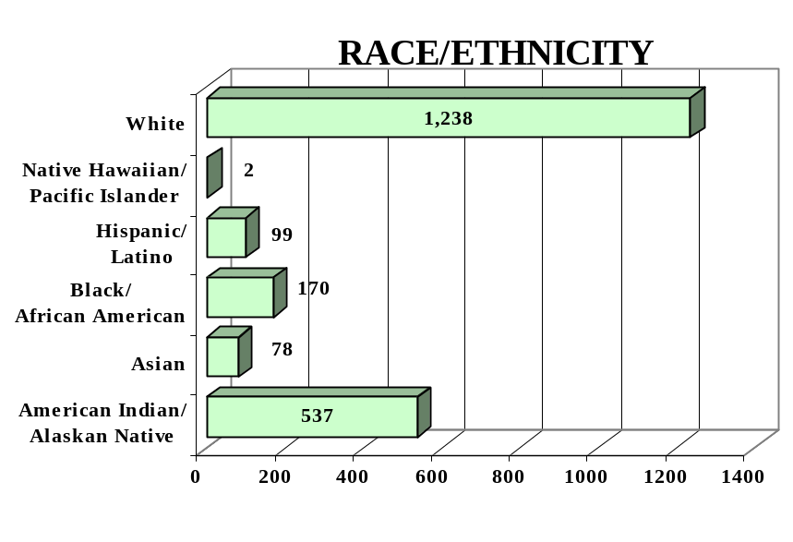
GENDER

Male - 1,092 (51%) Female - 1,032 (49%)

FEDERAL ALLOCATION
FY 2000

Basic Grant - $ 1,110,596
EL/Civics - $ 0

TOTAL - $ 1,110,596

NORTH DAKOTA | Average  Performance Target | Actual  Performance | Status | Adults Completing  at Least One Level
Performance Measure I – Demonstrated Improvement in Literacy Skills  Sub Measures  Adult Basic and Secondary Education:^{1/} The percentage of adults enrolled in basic literacy programs who acquired the basic skills needed to complete the level of instruction in which they were initially enrolled.  English Literacy: ^{2/} The percentage of adults enrolled in English Literacy programs who acquired the level of English language skills needed to complete the level of instruction in which they were initially enrolled. | 31%  32% | 82%  66% | ↑  ↑ | 1,275  223
 | Performance Target | Actual  Performance | Status | Adults Achieving  Outcome
Performance Measure II – High School Completion  The percentage of adult learners with a high school completion goal who earned a high school diploma or GED.  Performance Measure III – Entered Postsecondary Education or Training  The percentage of adult learners with a goal to continue their education who enter postsecondary education or training.  Performance Measure IV - Entered Employment  The percentage of unemployed adult learners (in the workforce) with an employment goal who were employed at the end of first quarter after they exited the program.  Performance Measure V – Retained Employment  The percentage of adult learners with a) a job retention goal at the time of enrollment and b) those adults with an employment goal who obtained work by the end of the first quarter after leaving the program who were employed at the end of third quarter after exiting the program. | 42%  25%  43%  35% | 71%  50%  67%  78% | ↑  ↑  ↑  ↑ | 733  05  302  343

Follow-up Methodology Used to Collect Performance Data

Educational Gains
√ Standardized tests

High School Completion Measure
√ Data matching (Official state GED records)

Postsecondary Transition
√ State developed individual student follow-up survey

Entered Employment
√ State developed individual student follow-up survey

Job Retention
√ State developed individual student follow-up survey

Key
↑ Exceeded Performance Target
↔ Met Performance Target
↓ Did Not Meet Performance Target

^{1/} Adult Basic and Secondary Education programs consist of a series of instructional levels with each level representing a hierarchy of basic skills ranging from beginning literacy to high school completion.

^{2/} English Literacy education programs consist of a set of instructional levels with each level representing a hierarchy of English language skills ranging from beginning language literacy to oral language proficiency.

OHIO

PROGRAM FACTS – 2000-2001

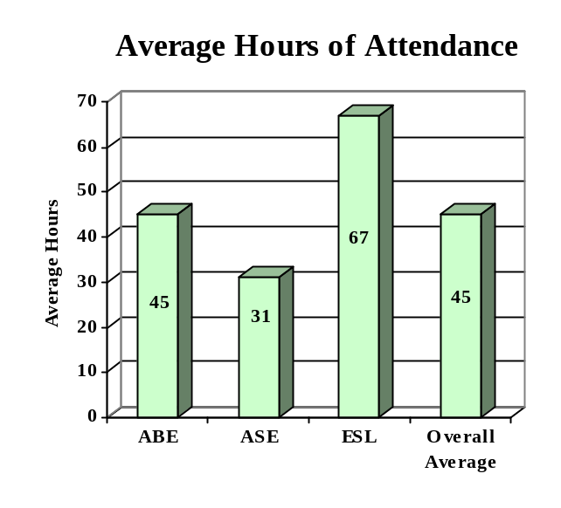

ENROLLMENT

Adult Basic Education 42,690 (65%)

Adult Secondary Education 14,080 (22%)
English Literacy 8,809 (13%)

TOTAL 65,579

PARTICIPANT STATUS

Employed - 32,494

Unemployed - 19,217

Correctional Setting - 5,573

On Public Assistance - 9,264

Other Institutionalized - 754

AGE

16 - 18 8,147 (12%)

19 - 24 19,291 (29%)
25 - 44 27,264 (42%)

45 - 59 8,449 (13%)
60 + 2,428 (04%)

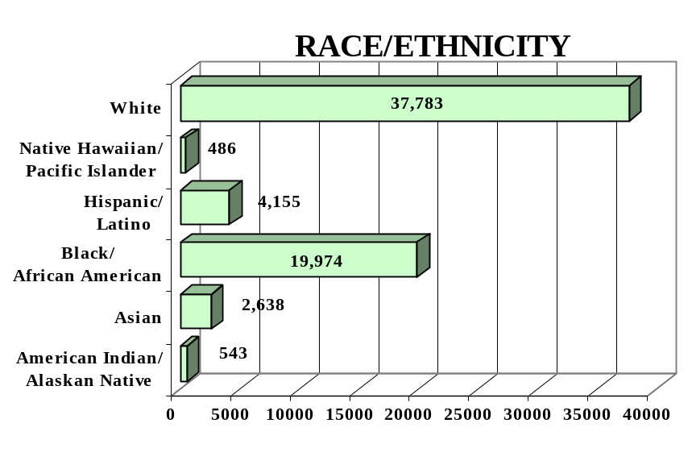
GENDER

Male - 32,982 (50%) Female - 32,597 (50%)

FEDERAL ALLOCATION
FY 2000

Basic Grant - $ 16,674,044
EL/Civics - $ 260,532

TOTAL - $ 16,934,576

OHIO | Average  Performance Target | Actual  Performance | Status | Adults Completing  at Least One Level
Performance Measure I – Demonstrated Improvement in Literacy Skills  Sub Measures  Adult Basic and Secondary Education:^{1/} The percentage of adults enrolled in basic literacy programs who acquired the basic skills needed to complete the level of instruction in which they were initially enrolled.  English Literacy: ^{2/} The percentage of adults enrolled in English Literacy programs who acquired the level of English language skills needed to complete the level of instruction in which they were initially enrolled. | 31%  30% | 59%  41% | ↑  ↑ | 30,728  3,649
 | Performance Target | Actual  Performance | Status | Adults Achieving  Outcome
Performance Measure II – High School Completion  The percentage of adult learners with a high school completion goal who earned a high school diploma or GED.  Performance Measure III – Entered Postsecondary Education or Training  The percentage of adult learners with a goal to continue their education who enter postsecondary education or training.  Performance Measure IV - Entered Employment  The percentage of unemployed adult learners (in the workforce) with an employment goal who were employed at the end of first quarter after they exited the program.  Performance Measure V – Retained Employment  The percentage of adult learners with a) a job retention goal at the time of enrollment and b) those adults with an employment goal who obtained work by the end of the first quarter after leaving the program who were employed at the end of third quarter after exiting the program. | 40%  20%  25%  50% | 56%  45%  74%  93% | ↑  ↑  ↑  ↑ | 6,536  1,201  6,930  7,469

Follow-up Methodology Used to Collect Performance Data

Educational Gains
√ Combination of standardized tests and performance-based assessment

High School Completion Measure
√ Data matching (Official state GED records)

Postsecondary Transition
√ State developed individual student follow-up survey

Entered Employment
√ Data matching (UI employment records)

Job Retention
√ Data matching (UI employment records)

Key
↑ Exceeded Performance Target
↔ Met Performance Target
↓ Did Not Meet Performance Target

^{1/} Adult Basic and Secondary Education programs consist of a series of instructional levels with each level representing a hierarchy of basic skills ranging from beginning literacy to high school completion.

^{2/} English Literacy education programs consist of a set of instructional levels with each level representing a hierarchy of English language skills ranging from beginning language literacy to oral language proficiency.

OKLAHOMA

PROGRAM FACTS – 2000-2001

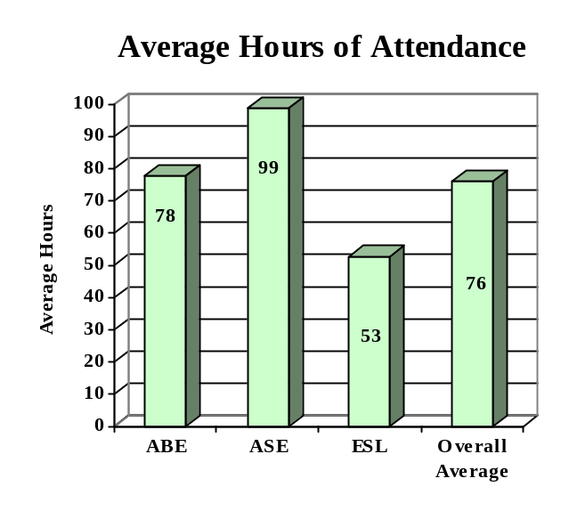

ENROLLMENT

Adult Basic Education 13,975 (69%)

Adult Secondary Education 2,378 (12%)
English Literacy 3,748 (19%)

TOTAL 20,101

PARTICIPANT STATUS

Employed - 6,269

Unemployed - 7,074

Correctional Setting - 5,494

On Public Assistance - 1,998

Other Institutionalized - 943

AGE

16 - 18 3,815 (19%)

19 - 24 5,022 (25%)
25 - 44 9,009 (45%)

45 - 59 1,761 (09%)
60 + 494 (02%)

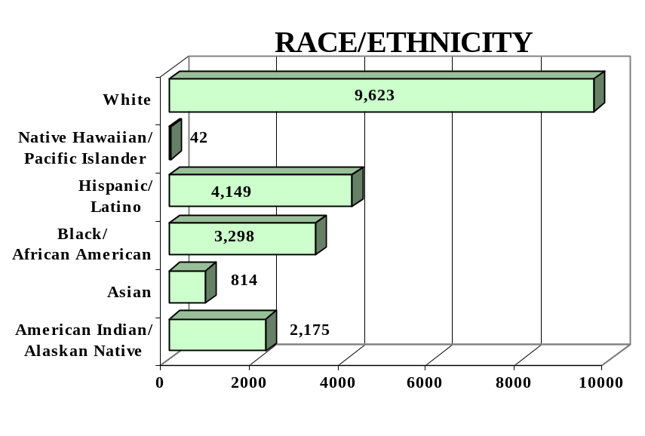
GENDER

Male - 9,797 (49%) Female - 10,304 (51%)

FEDERAL ALLOCATION
FY 2000

Basic Grant - $ 5,218,316
EL/Civics - $ 97,530

TOTAL - $ 5,315,846

OKLAHOMA | Average  Performance Target | Actual  Performance | Status | Adults Completing  at Least One Level
Performance Measure I – Demonstrated Improvement in Literacy Skills  Sub Measures  Adult Basic and Secondary Education:^{1/} The percentage of adults enrolled in basic literacy programs who acquired the basic skills needed to complete the level of instruction in which they were initially enrolled.  English Literacy: ^{2/} The percentage of adults enrolled in English Literacy programs who acquired the level of English language skills needed to complete the level of instruction in which they were initially enrolled. | 27%  25% | 29%  28% | ↑  ↑ | 4,391  1,033
 | Performance Target | Actual  Performance | Status | Adults Achieving  Outcome
Performance Measure II – High School Completion  The percentage of adult learners with a high school completion goal who earned a high school diploma or GED.  Performance Measure III – Entered Postsecondary Education or Training  The percentage of adult learners with a goal to continue their education who enter postsecondary education or training.  Performance Measure IV - Entered Employment  The percentage of unemployed adult learners (in the workforce) with an employment goal who were employed at the end of first quarter after they exited the program.  Performance Measure V – Retained Employment  The percentage of adult learners with a) a job retention goal at the time of enrollment and b) those adults with an employment goal who obtained work by the end of the first quarter after leaving the program who were employed at the end of third quarter after exiting the program. | 33%  11%  19%  25% | 30%  53%  39%  57% | ↓  ↑  ↑  ↑ | 1,701  360  594  562

Follow-up Methodology Used to Collect Performance Data

Educational Gains
√ Standardized tests

High School Completion Measure
√ Data matching (Official state GED records)

Postsecondary Transition
√ State developed individual student follow-up survey

Entered Employment
√ State developed individual student follow-up survey

Job Retention
√ State developed individual student follow-up survey

Key
↑ Exceeded Performance Target
↔ Met Performance Target
↓ Did Not Meet Performance Target

^{1/} Adult Basic and Secondary Education programs consist of a series of instructional levels with each level representing a hierarchy of basic skills ranging from beginning literacy to high school completion.

^{2/} English Literacy education programs consist of a set of instructional levels with each level representing a hierarchy of English language skills ranging from beginning language literacy to oral language proficiency.

OREGON

PROGRAM FACTS – 2000-2001

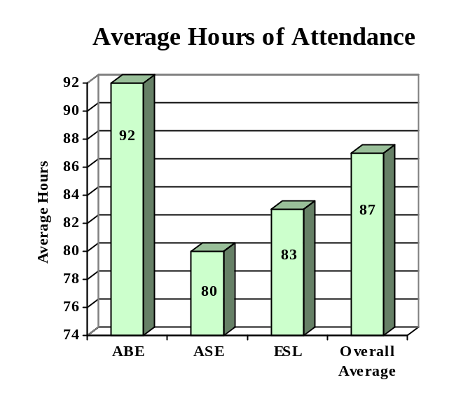

ENROLLMENT

Adult Basic Education 11,894 (47%)

Adult Secondary Education 1,250 (05%)
English Literacy 12,084 (48%)

TOTAL 25,228

PARTICIPANT STATUS

Employed - 10,096

Unemployed - 8,976

Correctional Setting - 3,824

On Public Assistance - 1,923

Other Institutionalized - NA

AGE

16 - 18 3,995 (16%)

19 - 24 6,574 (26%)
25 - 44 11,930 (47%)

45 - 59 2,236 (09%)
60 + 493 (02%)

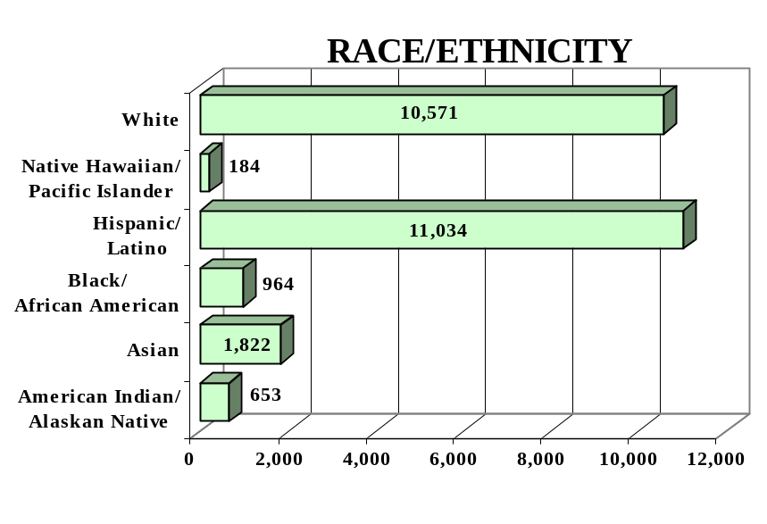
GENDER

Male - 13,547 (54%) Female -11,681 (46%)

FEDERAL ALLOCATION
FY 2000

Basic Grant - $ 3,743,300
EL/Civics - $ 226,975

TOTAL - $ 3,970,275

OREGON | Average  Performance Target | Actual  Performance | Status | Adults Completing  at Least One Level
Performance Measure I – Demonstrated Improvement in Literacy Skills  Sub Measures  Adult Basic and Secondary Education:^{1/} The percentage of adults enrolled in basic literacy programs who acquired the basic skills needed to complete the level of instruction in which they were initially enrolled.  English Literacy: ^{2/} The percentage of adults enrolled in English Literacy programs who acquired the level of English language skills needed to complete the level of instruction in which they were initially enrolled. | 38%  34% | 43%  26% | ↑  ↓ | 5,509  3,129
 | Average  Performance Target | Actual  Performance | Status | Adults Achieving  Outcome
Performance Measure II – High School Completion  The percentage of adult learners with a high school completion goal who earned a high school diploma or GED.  Performance Measure III – Entered Postsecondary Education or Training  The percentage of adult learners with a goal to continue their education who enter postsecondary education or training.  Performance Measure IV - Entered Employment  The percentage of unemployed adult learners (in the workforce) with an employment goal who were employed at the end of first quarter after they exited the program.  Performance Measure V – Retained Employment  The percentage of adult learners with a) a job retention goal at the time of enrollment and b) those adults with an employment goal who obtained work by the end of the first quarter after leaving the program who were employed at the end of third quarter after exiting the program. | 39%  19%  44%  38% | 48%  21%  38%  64% | ↑  ↑  ↓  ↑ | 2,186  191  591  321

Follow-up Methodology Used to Collect Performance Data

Educational Gains
√ Standardized tests

High School Completion Measure
√ Data matching (Official state GED records)

Postsecondary Transition
√ Data matching (Official state GED records)

Entered Employment
√ Data matching (UI employment records)

Job Retention
√ Data matching (UI employment records)

Key
↑ Exceeded Performance Target
↔ Met Performance Target
↓ Did Not Meet Performance Target

^{1/} Adult Basic and Secondary Education programs consist of a series of instructional levels with each level representing a hierarchy of basic skills ranging from beginning literacy to high school completion.

^{2/} English Literacy education programs consist of a set of instructional levels with each level representing a hierarchy of English language skills ranging from beginning language literacy to oral language proficiency.

PENNSYLVANIA

PROGRAM FACTS – 2000-2001

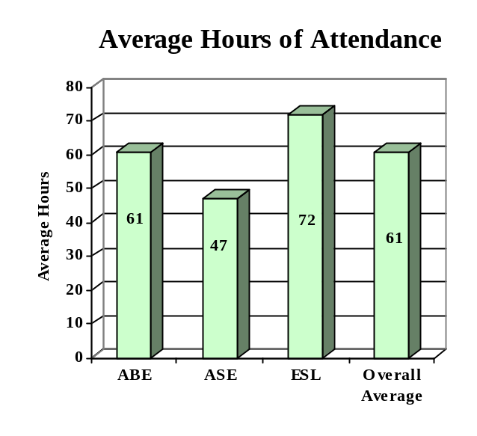

ENROLLMENT

Adult Basic Education 21,059 (43%)

Adult Secondary Education 12,470 (25%)
English Literacy 15,840 (32%)

TOTAL 49,369

PARTICIPANT STATUS

Employed - 19,646

Unemployed - 16,384

Correctional Setting - 6,131

On Public Assistance - 9,527

Other Institutionalized - 3,010

AGE

16 - 18 6,144 (12%)

19 - 24 11,567 (23%)
25 - 44 22,632 (46%)

45 - 59 6,488 (13%)
60 + 2,538 (05%)

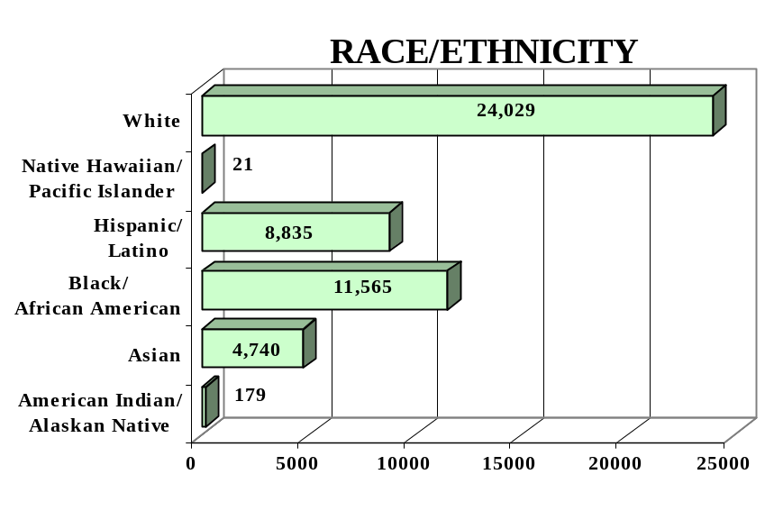
GENDER

Male - 22,879 (46%) Female -26,490 (54%)

FEDERAL ALLOCATION
FY 2000

Basic Grant - $19,415,981
EL/Civics - $ 444,777

TOTAL - $19,860,758

PENNSYLVANIA | Average  Performance Target | Actual  Performance | Status | Adults Completing  at Least One Level
Performance Measure I – Demonstrated Improvement in Literacy Skills  Sub Measures  Adult Basic and Secondary Education:^{1/} The percentage of adults enrolled in basic literacy programs who acquired the basic skills needed to complete the level of instruction in which they were initially enrolled.  English Literacy: ^{2/} The percentage of adults enrolled in English Literacy programs who acquired the level of English language skills needed to complete the level of instruction in which they were initially enrolled. | 19%  19% | 29%  27% | ↑  ↑ | 7,919  4,247
 | Performance Target | Actual  Performance | Status | Adults Achieving  Outcome
Performance Measure II – High School Completion  The percentage of adult learners with a high school completion goal who earned a high school diploma or GED.  Performance Measure III – Entered Postsecondary Education or Training  The percentage of adult learners with a goal to continue their education who enter postsecondary education or training.  Performance Measure IV - Entered Employment  The percentage of unemployed adult learners (in the workforce) with an employment goal who were employed at the end of first quarter after they exited the program.  Performance Measure V – Retained Employment  The percentage of adult learners with a) a job retention goal at the time of enrollment and b) those adults with an employment goal who obtained work by the end of the first quarter after leaving the program who were employed at the end of third quarter after exiting the program. | 19%  07%  19%  20% | 37%  30%  42%  42% | ↑  ↑  ↑  ↑ | 3,290  181  824  457

Follow-up Methodology Used to Collect Performance Data

Educational Gains
√ Combination of standardized tests and performance-based assessment

High School Completion Measure
√ Data matching (Official state GED records and H.S. graduation records)

Postsecondary Transition
√ State developed individual student follow-up survey

Entered Employment
√ Data matching (UI employment records)

Job Retention
√ Data matching (UI employment records)

Key
↑ Exceeded Performance Target
↔ Met Performance Target
↓ Did Not Meet Performance Target

^{1/} Adult Basic and Secondary Education programs consist of a series of instructional levels with each level representing a hierarchy of basic skills ranging from beginning literacy to high school completion.

^{2/} English Literacy education programs consist of a set of instructional levels with each level representing a hierarchy of English language skills proficiency.

PUERTO RICO

PROGRAM FACTS – 2000-2001

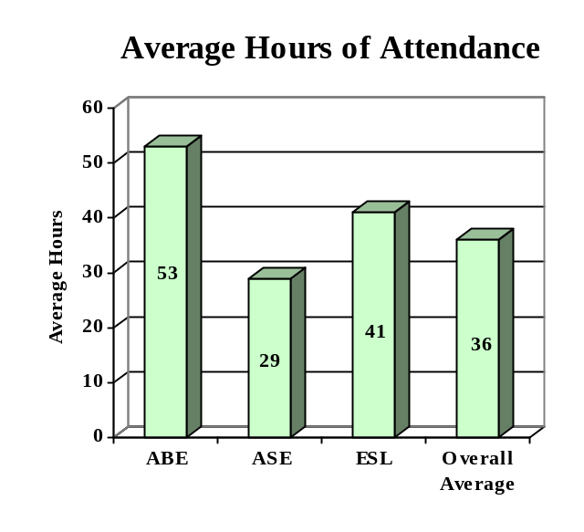

ENROLLMENT

Adult Basic Education 10,871 (27%)

Adult Secondary Education 28,083 (68%)
English Literacy 2,089 (05%)

TOTAL 41,043

PARTICIPANT STATUS

Employed - 2,995

Unemployed - 5,406

Correctional Setting - 2,592

On Public Assistance - 4,869

Other Institutionalized - 954

AGE

16 - 18 10,272 (25%)

19 - 24 11,581 (28%)
25 - 44 8,933 (22%)

45 - 59 5,574 (14%)
60 + 4,683 (11%)

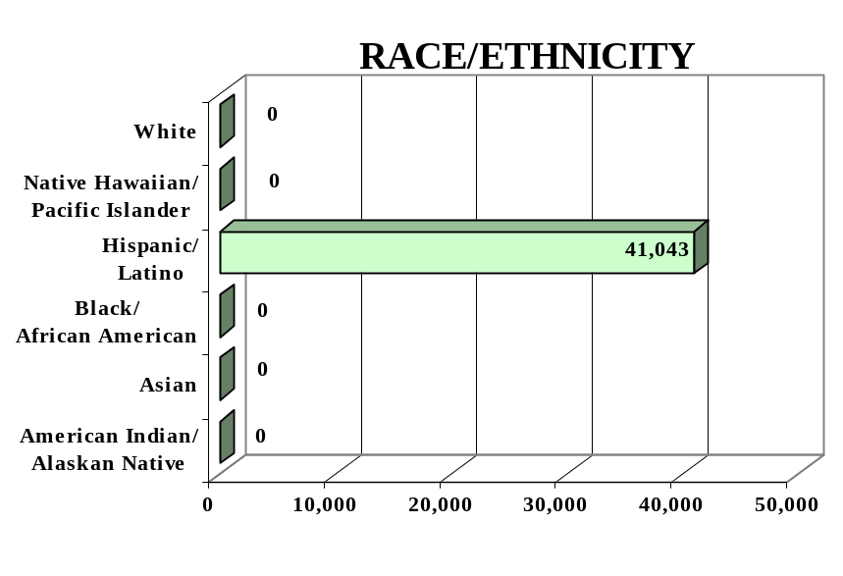
GENDER

Male - 20,839 (51%) Female - 20,204 (49%)

FEDERAL ALLOCATION
FY 2000

Basic Grant - $ 10,188,600
EL/Civics - $ 0

TOTAL - $ 10,188,600

PUERTO RICO | Average  Performance Target | Actual  Performance | Status | Adults Completing  at Least One Level
Performance Measure I – Demonstrated Improvement in Literacy Skills  Sub Measures  Adult Basic and Secondary Education:^{1/} The percentage of adults enrolled in basic literacy programs who acquired the basic skills needed to complete the level of instruction in which they were initially enrolled.  English Literacy: ^{2/} The percentage of adults enrolled in English Literacy programs who acquired the level of English language skills needed to complete the level of instruction in which they were initially enrolled. | 28%  24% | 75%  76% | ↑  ↑ | 16,343  1,584
 | Performance Target | Actual  Performance | Status | Adults Achieving  Outcome
Performance Measure II – High School Completion  The percentage of adult learners with a high school completion goal who earned a high school diploma or GED.  Performance Measure III – Entered Postsecondary Education or Training  The percentage of adult learners with a goal to continue their education who enter postsecondary education or training.  Performance Measure IV - Entered Employment  The percentage of unemployed adult learners (in the workforce) with an employment goal who were employed at the end of first quarter after they exited the program.  Performance Measure V – Retained Employment  The percentage of adult learners with a) a job retention goal at the time of enrollment and b) those adults with an employment goal who obtained work by the end of the first quarter after leaving the program who were employed at the end of third quarter after exiting the program. | 31%  18%  19%  22% | 32%  46%  31%  75% | ↑  ↑  ↑  ↑ | 4,250  3,800  1,681  2,246

Follow-up Methodology Used to Collect Performance Data

Educational Gains
√ Standardized tests

High School Completion Measure
√ Data matching (Official state GED records & approved data collection
system)

Postsecondary Transition
√ Data matching

Entered Employment
√ Data matching (UI employment records)

Job Retention
√ Data matching (UI employment records)

Key
↑ Exceeded Performance Target
↔ Met Performance Target
↓ Did Not Meet Performance Target

^{1/} Adult Basic and Secondary Education programs consist of a series of instructional levels with each level representing a hierarchy of basic skills ranging from beginning literacy to high school completion.

^{2/} English Literacy education programs consist of a set of instructional levels with each level representing a hierarchy of English language skills ranging from beginning language literacy to oral language proficiency.

RHODE ISLAND

PROGRAM FACTS – 2000-2001

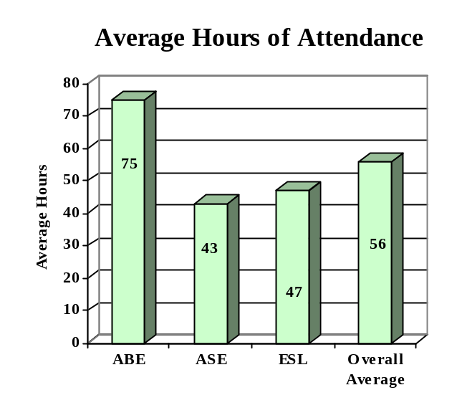

ENROLLMENT

Adult Basic Education 1,980 (35%)

Adult Secondary Education 1,506 (27%)
English Literacy 2,106 (38%)

TOTAL 5,592

PARTICIPANT STATUS

Employed - 1,742

Unemployed - 1,262

Correctional Setting - 522

On Public Assistance - 608

Other Institutionalized - 25

AGE

16 - 18 682 (12%)

19 - 24 1,423 (25%)
25 - 44 2,464 (44%)

45 - 59 876 (16%)
60 + 147 (03%)

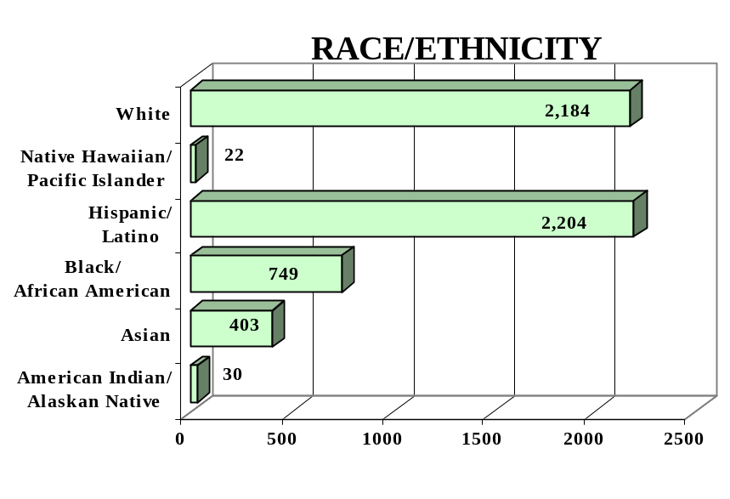
GENDER

Male - 2,360 (42%) Female -3,232 (58%)

FEDERAL ALLOCATION
FY 2000

Basic Grant - $2,055,994
EL/Civics - $ -0-

TOTAL - $2,055,994

RHODE ISLAND | Average  Performance Target | Actual  Performance | Status | Adults Completing  at Least One Level
Performance Measure I – Demonstrated Improvement in Literacy Skills  Sub Measures  Adult Basic and Secondary Education:^{1/} The percentage of adults enrolled in basic literacy programs who acquired the basic skills needed to complete the level of instruction in which they were initially enrolled.  English Literacy: ^{2/} The percentage of adults enrolled in English Literacy programs who acquired the level of English language skills needed to complete the level of instruction in which they were initially enrolled. | 19%  25% | 55%  46% | ↑  ↑ | 3,732  1,785
 | Performance Target | Actual  Performance | Status | Adults Achieving  Outcome
Performance Measure II – High School Completion  The percentage of adult learners with a high school completion goal who earned a high school diploma or GED.  Performance Measure III – Entered Postsecondary Education or Training  The percentage of adult learners with a goal to continue their education who enter postsecondary education or training.  Performance Measure IV - Entered Employment  The percentage of unemployed adult learners (in the workforce) with an employment goal who were employed at the end of first quarter after they exited the program.  Performance Measure V – Retained Employment  The percentage of adult learners with a) a job retention goal at the time of enrollment and b) those adults with an employment goal who obtained work by the end of the first quarter after leaving the program who were employed at the end of third quarter after exiting the program. | 52%  16%  38%  23% | 52%  43%  44%  28% | ↔  ↑  ↑  ↑ | 924  224  102  29

Follow-up Methodology Used to Collect Performance Data

Educational Gains
√ Standardized tests

High School Completion Measure
√ Data matching (Official state GED records & approved data collection system)

Postsecondary Transition
√ State developed individual student follow-up survey

Entered Employment
√ State developed individual student follow-up survey

Job Retention
√ State developed individual student follow-up survey

Key
↑ Exceeded Performance Target
↔ Met Performance Target
↓ Did Not Meet Performance Target

^{1/} Adult Basic and Secondary Education programs consist of a series of instructional levels with each level representing a hierarchy of basic skills ranging from beginning literacy to high school completion.

^{2/} English Literacy education programs consist of a set of instructional levels with each level representing a hierarchy of English language skills proficiency.

SOUTH CAROLINA

PROGRAM FACTS – 2000-2001

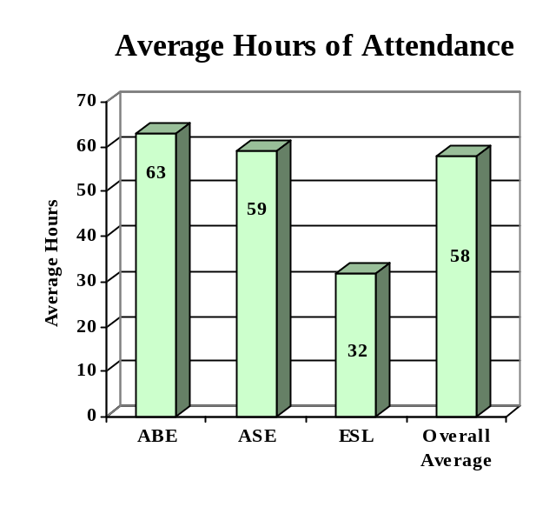

ENROLLMENT

Adult Basic Education 32,181 (34%)

Adult Secondary Education 55,464 (59%)
English Literacy 6,807 (07%)

TOTAL 94,452

PARTICIPANT STATUS

Employed - 36,977

Unemployed - 14,682

Correctional Setting - 11,425

On Public Assistance - 2,826

Other Institutionalized - 797

AGE

16 - 18 14,143 (15%)

19 - 24 25,433 (27%)
25 - 44 34,535 (37%)

45 - 59 11,708 (12%)
60 + 8,633 (09%)

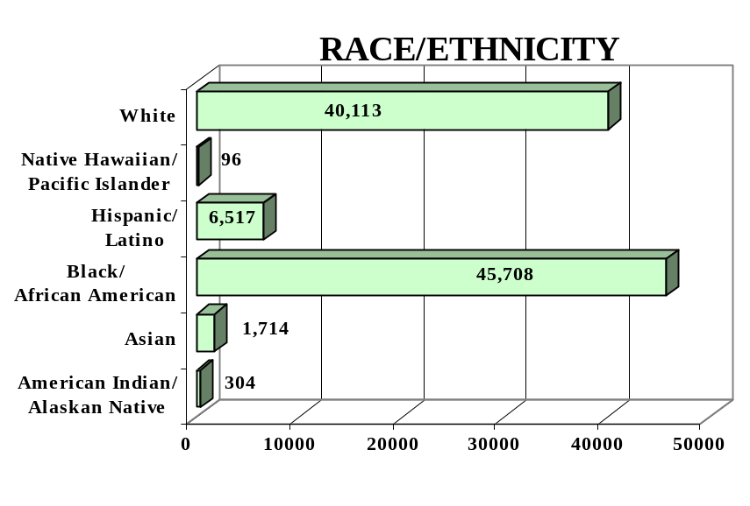
GENDER

Male - 41,508 (44%) Female - 52,944 (56%)

FEDERAL ALLOCATION
FY 2000

Basic Grant - $ 7,025,604
EL/Civics - $ 0

TOTAL - $ 7,025,604

SOUTH CAROLINA | Average  Performance Target | Actual  Performance | Status | Adults Completing  at Least One Level
Performance Measure I – Demonstrated Improvement in Literacy Skills  Sub Measures  Adult Basic and Secondary Education:^{1/} The percentage of adults enrolled in basic literacy programs who acquired the basic skills needed to complete the level of instruction in which they were initially enrolled.  English Literacy: ^{2/} The percentage of adults enrolled in English Literacy programs who acquired the level of English language skills needed to complete the level of instruction in which they were initially enrolled. | 22%  21% | 20%  14% | ↓  ↓ | 10,151  940
 | Performance Target | Actual  Performance | Status | Adults Achieving  Outcome
Performance Measure II – High School Completion  The percentage of adult learners with a high school completion goal who earned a high school diploma or GED.  Performance Measure III – Entered Postsecondary Education or Training  The percentage of adult learners with a goal to continue their education who enter postsecondary education or training.  Performance Measure IV - Entered Employment  The percentage of unemployed adult learners (in the workforce) with an employment goal who were employed at the end of first quarter after they exited the program.  Performance Measure V – Retained Employment  The percentage of adult learners with a) a job retention goal at the time of enrollment and b) those adults with an employment goal who obtained work by the end of the first quarter after leaving the program who were employed at the end of third quarter after exiting the program. | 30%  18%  18%  20% | 64%  62%  44%  41% | ↑  ↑  ↑  ↑ | 5,462  219  392  366

Follow-up Methodology Used to Collect Performance Data

Educational Gains
√ Standardized tests

High School Completion Measure
√ Data matching (Official state GED records)
√ State developed individual student follow-up survey

Postsecondary Transition
√ State developed individual student follow-up survey

Entered Employment
√ Data matching (UI employment records)
√ State developed individual student follow-up survey

Job Retention
√ Data matching (UI employment records)
√ State developed individual student follow-up survey

Key
↑ Exceeded Performance Target
↔ Met Performance Target
↓ Did Not Meet Performance Target

^{1/} Adult Basic and Secondary Education programs consist of a series of instructional levels with each level representing a hierarchy of basic skills ranging from beginning literacy to high school completion.

^{2/} English Literacy education programs consist of a set of instructional levels with each level representing a hierarchy of English language skills ranging from beginning language literacy to oral language proficiency.

SOUTH DAKOTA

PROGRAM FACTS – 2000-2001

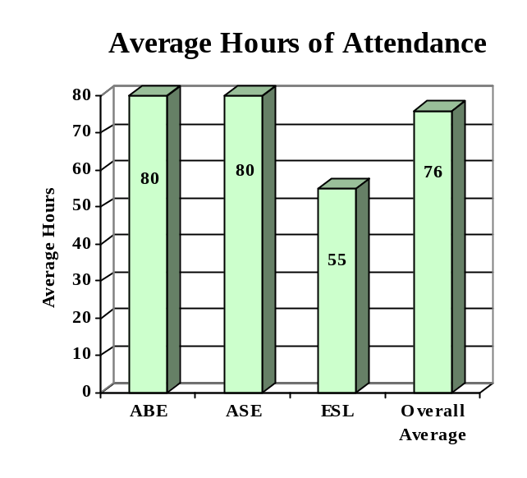

ENROLLMENT

Adult Basic Education 3,215 (57%)

Adult Secondary Education 1,620 (29%)
English Literacy 802 (14%)

TOTAL 5,637

PARTICIPANT STATUS

Employed - 2,106

Unemployed - 1,968

Correctional Setting - 1,371

On Public Assistance - 1,556

Other Institutionalized - 243

AGE

16 - 18 1,442 (26%)

19 - 24 1,738 (31%)
25 - 44 2,020 (36%)

45 - 59 363 (06%)
60 + 74 (01%)

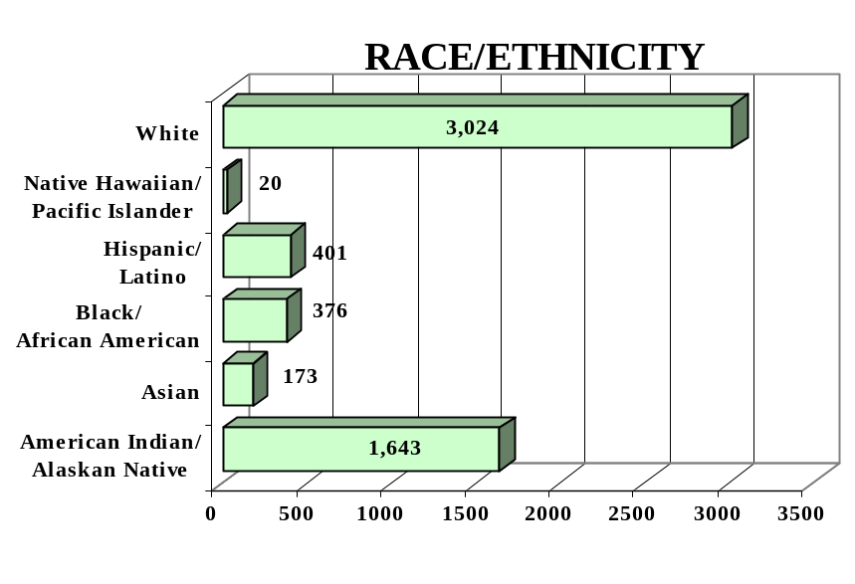
GENDER

Male - 3,136 (56%) Female - 2,501 (44%)

FEDERAL ALLOCATION
FY 2000

Basic Grant - $ 1,195,276
EL/Civics - $ 0

TOTAL - $ 1,195,276

SOUTH DAKOTA | Average  Performance Target | Actual  Performance | Status | Adults Completing  at Least One Level
Performance Measure I – Demonstrated Improvement in Literacy Skills  Sub Measures  Adult Basic and Secondary Education:^{1/} The percentage of adults enrolled in basic literacy programs who acquired the basic skills needed to complete the level of instruction in which they were initially enrolled.  English Literacy: ^{2/} The percentage of adults enrolled in English Literacy programs who acquired the level of English language skills needed to complete the level of instruction in which they were initially enrolled. | 25%  28% | 34%  63% | ↑  ↑ | 1,388  502
 | Performance Target | Actual  Performance | Status | Adults Achieving  Outcome
Performance Measure II – High School Completion  The percentage of adult learners with a high school completion goal who earned a high school diploma or GED.  Performance Measure III – Entered Postsecondary Education or Training  The percentage of adult learners with a goal to continue their education who enter postsecondary education or training.  Performance Measure IV - Entered Employment  The percentage of unemployed adult learners (in the workforce) with an employment goal who were employed at the end of first quarter after they exited the program.  Performance Measure V – Retained Employment  The percentage of adult learners with a) a job retention goal at the time of enrollment and b) those adults with an employment goal who obtained work by the end of the first quarter after leaving the program who were employed at the end of third quarter after exiting the program. | 26%  25%  25%  25% | 56%  46%  47%  56% | ↑  ↑  ↑  ↑ | 1,072  132  309  557

Follow-up Methodology Used to Collect Performance Data

Educational Gains
√ Standardized tests

High School Completion Measure
√ State developed individual student follow-up survey

Postsecondary Transition
√ State developed individual student follow-up survey

Entered Employment
√ State developed individual student follow-up survey

Job Retention
√ State developed individual student follow-up survey

Key
↑ Exceeded Performance Target
↔ Met Performance Target
↓ Did Not Meet Performance Target

^{1/} Adult Basic and Secondary Education programs consist of a series of instructional levels with each level representing a hierarchy of basic skills ranging from beginning literacy to high school completion.

^{2/} English Literacy education programs consist of a set of instructional levels with each level representing a hierarchy of English language skills ranging from beginning language literacy to oral language proficiency.

TENNESSEE

PROGRAM FACTS – 2000-2001

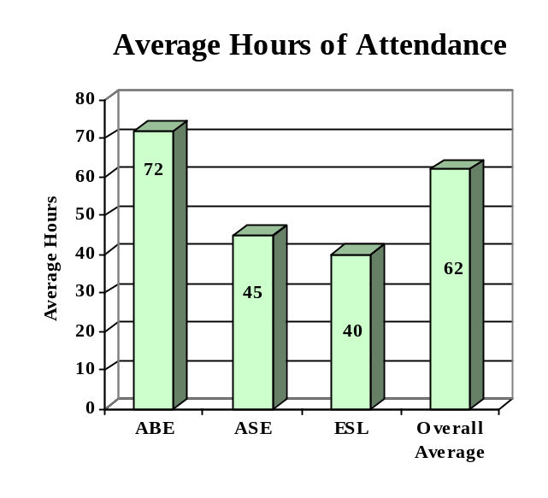

ENROLLMENT

Adult Basic Education 26,288 (65%)

Adult Secondary Education 8,235 (20%)
English Literacy 6,092 (15%)

TOTAL 40,615

PARTICIPANT STATUS

Employed - 15,340

Unemployed - 15,018

Correctional Setting - 2,541

On Public Assistance - 9,069

Other Institutionalized - 388

AGE

16 - 18 5,594 (14%)

19 - 24 11,696 (28%)
25 - 44 17,639 (44%)

45 - 59 4,537 (11%)
60 + 1,149 (03%)

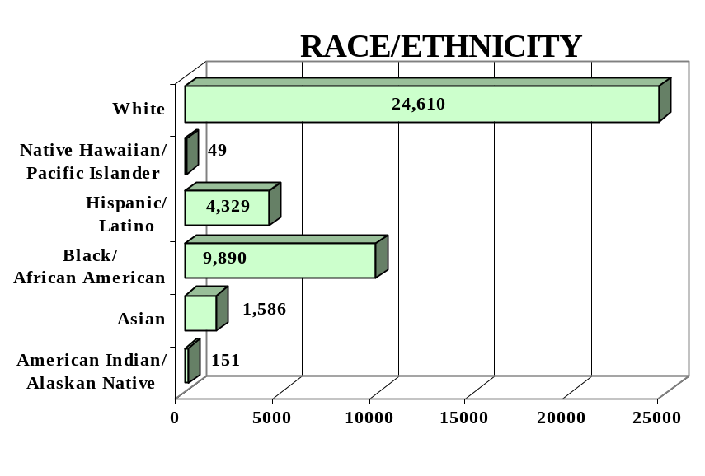
GENDER

Male - 16,366 (40%) Female - 24,249 (60%)

FEDERAL ALLOCATION
FY 2000

Basic Grant - $ 10,402,265
EL/Civics - $ 110,229

TOTAL - $ 10,512,494

TENNESSEE | Average  Performance Target | Actual  Performance | Status | Adults Completing  at Least One Level
Performance Measure I – Demonstrated Improvement in Literacy Skills  Sub Measures  Adult Basic and Secondary Education:^{1/} The percentage of adults enrolled in basic literacy programs who acquired the basic skills needed to complete the level of instruction in which they were initially enrolled.  English Literacy: ^{2/} The percentage of adults enrolled in English Literacy programs who acquired the level of English language skills needed to complete the level of instruction in which they were initially enrolled. | 25%  18% | 38%  32% | ↑  ↑ | 11,816  1,960
 | Performance Target | Actual  Performance | Status | Adults Achieving  Outcome
Performance Measure II – High School Completion  The percentage of adult learners with a high school completion goal who earned a high school diploma or GED.  Performance Measure III – Entered Postsecondary Education or Training  The percentage of adult learners with a goal to continue their education who enter postsecondary education or training.  Performance Measure IV - Entered Employment  The percentage of unemployed adult learners (in the workforce) with an employment goal who were employed at the end of first quarter after they exited the program.  Performance Measure V – Retained Employment  The percentage of adult learners with a) a job retention goal at the time of enrollment and b) those adults with an employment goal who obtained work by the end of the first quarter after leaving the program who were employed at the end of third quarter after exiting the program. | 28%  14%  17%  17% | 42%  67%  50%  72% | ↑  ↑  ↑  ↑ | 5,967  2,586  3,820  5,259

Follow-up Methodology Used to Collect Performance Data

Educational Gains
√ Standardized tests

High School Completion Measure
√ Individual student follow-up survey

Postsecondary Transition
√ Individual student follow-up survey

Entered Employment
√ Individual student follow-up survey

Job Retention
√ Individual student follow-up survey

Key
↑ Exceeded Performance Target
↔ Met Performance Target
↓ Did Not Meet Performance Target

^{1/} Adult Basic and Secondary Education programs consist of a series of instructional levels with each level representing a hierarchy of basic skills ranging from beginning literacy to high school completion.

^{2/} English Literacy education programs consist of a set of instructional levels with each level representing a hierarchy of English language skills ranging from beginning language literacy to oral language proficiency.

TEXAS

PROGRAM FACTS – 2000-2001

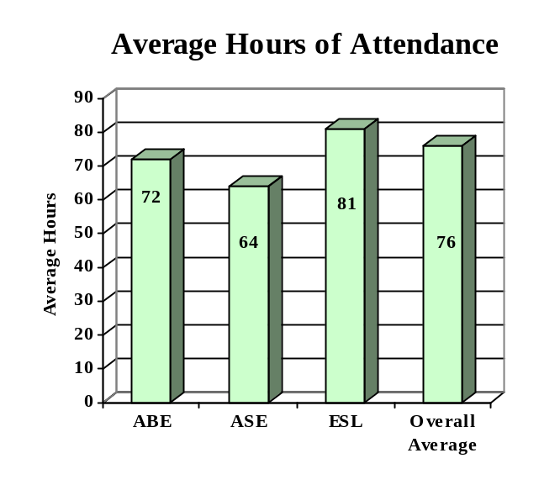

ENROLLMENT

Adult Basic Education 45,998 (41%)

Adult Secondary Education 9,700 (09%)
English Literacy 55,813 (50%)

TOTAL 111,511

PARTICIPANT STATUS

Employed - 50,698

Unemployed - 30,368

Correctional Setting - 14,001

On Public Assistance - 7,681

Other Institutionalized - 1,821

AGE

16 - 18 13,673 (12%)

19 - 24 26,159 (24%)
25 - 44 56,743 (51%)

45 - 59 12,316 (11%)
60 + 2,620 (02%)

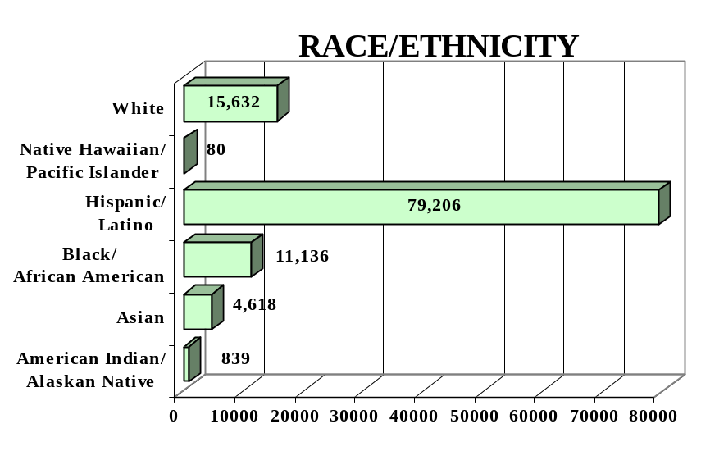
GENDER

Male - 46,112 (41%) Female - 65,399 (59%)

FEDERAL ALLOCATION
FY 2000

Basic Grant - $ 29,516,587
EL/Civics - $ 2,225,169

TOTAL - $ 31,767,756

TEXAS | Average  Performance Target | Actual  Performance | Status | Adults Completing  at Least One Level
Performance Measure I – Demonstrated Improvement in Literacy Skills  Sub Measures  Adult Basic and Secondary Education:^{1/} The percentage of adults enrolled in basic literacy programs who acquired the basic skills needed to complete the level of instruction in which they were initially enrolled.  English Literacy: ^{2/} The percentage of adults enrolled in English Literacy programs who acquired the level of English language skills needed to complete the level of instruction in which they were initially enrolled. | 20%  20% | 25%  31% | ↑  ↑ | 13,213  17,525
 | Performance Target | Actual  Performance | Status | Adults Achieving  Outcome
Performance Measure II – High School Completion  The percentage of adult learners with a high school completion goal who earned a high school diploma or GED.  Performance Measure III – Entered Postsecondary Education or Training  The percentage of adult learners with a goal to continue their education who enter postsecondary education or training.  Performance Measure IV - Entered Employment  The percentage of unemployed adult learners (in the workforce) with an employment goal who were employed at the end of first quarter after they exited the program.  Performance Measure V – Retained Employment  The percentage of adult learners with a) a job retention goal at the time of enrollment and b) those adults with an employment goal who obtained work by the end of the first quarter after leaving the program who were employed at the end of third quarter after exiting the program. | 25%  15%  14%  15% | 22%  06%  08%  19% | ↓  ↓  ↓  ↑ | 6,490  728  2,949  9,978

Follow-up Methodology Used to Collect Performance Data

Educational Gains
√ Standardized tests

High School Completion Measure
√ Data matching (Official state GED records)

Postsecondary Transition
√ Data matching

Entered Employment
√ Data matching (UI employment records)

Job Retention
√ Data matching (UI employment records)

Key
↑ Exceeded Performance Target
↔ Met Performance Target
↓ Did Not Meet Performance Target

^{1/} Adult Basic and Secondary Education programs consist of a series of instructional levels with each level representing a hierarchy of basic skills ranging from beginning literacy to high school completion.

^{2/} English Literacy education programs consist of a set of instructional levels with each level representing a hierarchy of English language skills ranging from beginning language literacy to oral language proficiency.

UTAH

PROGRAM FACTS – 2000-2001

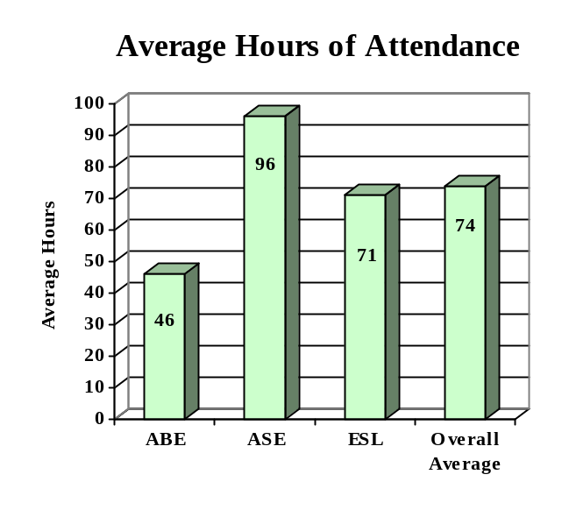

ENROLLMENT

Adult Basic Education 8,394 (27%)

Adult Secondary Education 11,759 (38%)
English Literacy 10,561 (35%)

TOTAL 30,714

PARTICIPANT STATUS

Employed - 12,134

Unemployed - 10,279

Correctional Setting - 6,708

On Public Assistance - 5,628

Other Institutionalized - 289

AGE

16 - 18 4,326 (14%)

19 - 24 10,851 (35%)
25 - 44 12,415 (41%)

45 - 59 2,532 (08%)
60 + 590 (02%)

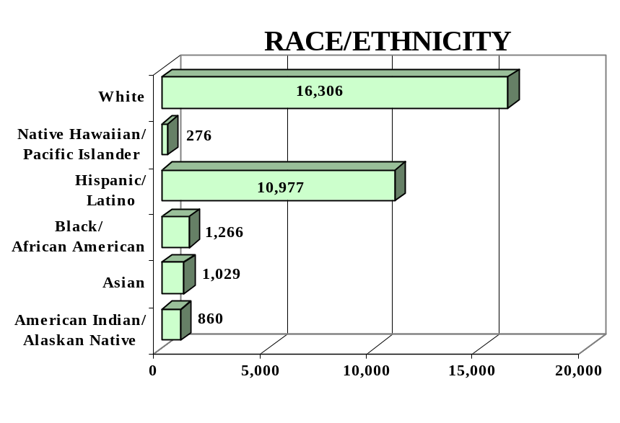
GENDER

Male - 17,001 (55%) Female -13,713 (45%)

FEDERAL ALLOCATION
FY 2000

Basic Grant - $ 1,676,233
EL/Civics - $ 102,963

TOTAL - $ 1,779,196

UTAH | Average  Performance Target | Actual  Performance | Status | Adults Completing  at Least One Level
Performance Measure I – Demonstrated Improvement in Literacy Skills  Sub Measures  Adult Basic and Secondary Education:^{1/} The percentage of adults enrolled in basic literacy programs who acquired the basic skills needed to complete the level of instruction in which they were initially enrolled.  English Literacy: ^{2/} The percentage of adults enrolled in English Literacy programs who acquired the level of English language skills needed to complete the level of instruction in which they were initially enrolled. | 32%  37% | 43%  34% | ↑  ↓ | 5,685  3,617
 | Performance Target | Actual  Performance | Status | Adults Achieving  Outcome
Performance Measure II – High School Completion  The percentage of adult learners with a high school completion goal who earned a high school diploma or GED.  Performance Measure III – Entered Postsecondary Education or Training  The percentage of adult learners with a goal to continue their education who enter postsecondary education or training.  Performance Measure IV - Entered Employment  The percentage of unemployed adult learners (in the workforce) with an employment goal who were employed at the end of first quarter after they exited the program.  Performance Measure V – Retained Employment  The percentage of adult learners with a) a job retention goal at the time of enrollment and b) those adults with an employment goal who obtained work by the end of the first quarter after leaving the program who were employed at the end of third quarter after exiting the program. | 29%  18%  21%  25% | 41%  34%  37%  85% | ↑  ↑  ↑  ↑ | 2,745  331  985  1,927

Follow-up Methodology Used to Collect Performance Data

Educational Gains
√ Standardized tests

High School Completion Measure
√ State developed individual student follow-up survey

Postsecondary Transition
√ State developed individual student follow-up survey

Entered Employment
√ State developed individual student follow-up survey

Job Retention
√ State developed individual student follow-up survey

Key
↑ Exceeded Performance Target
↔ Met Performance Target
↓ Did Not Meet Performance Target

^{1/} Adult Basic and Secondary Education programs consist of a series of instructional levels with each level representing a hierarchy of basic skills ranging from beginning literacy to high school completion.

^{2/} English Literacy education programs consist of a set of instructional levels with each level representing a hierarchy of English language skills ranging from beginning language literacy to oral language proficiency.

VERMONT

PROGRAM FACTS – 2000-2001

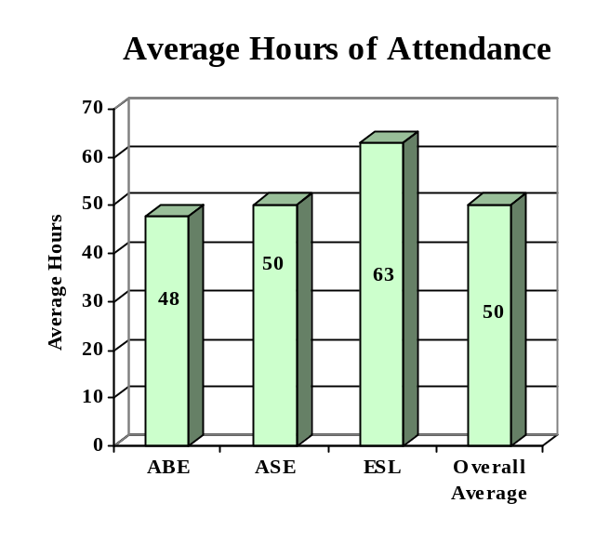

ENROLLMENT

Adult Basic Education 766 (67%)

Adult Secondary Education 210 (18%)
English Literacy 170 (15%)

TOTAL 1,146

PARTICIPANT STATUS

Employed - 440

Unemployed - 358

Correctional Setting - 35

On Public Assistance - 472

Other Institutionalized - 0

AGE

16 - 18 59 (05%)

19 - 24 289 (25%)
25 - 44 545 (48%)

45 - 59 189 (16%)
60 + 64 (06%)

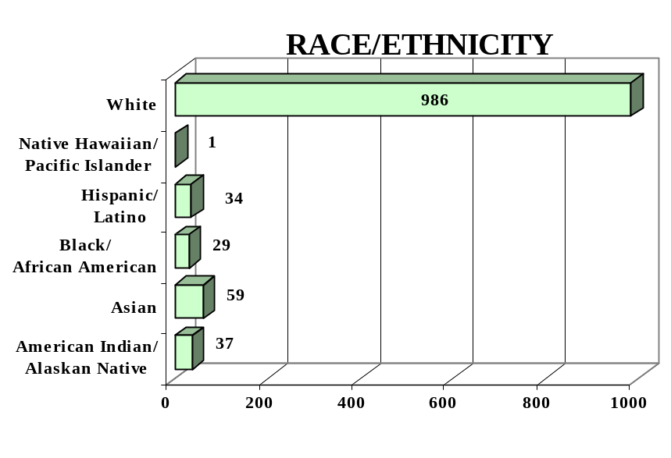
GENDER

Male - 351 (31%) Female - 795 (69%)

FEDERAL ALLOCATION
FY 2000

Basic Grant - $ 927,106
EL/Civics - $ -0-

TOTAL - $ 927,106

VERMONT | Average  Performance Target | Actual  Performance | Status | Adults Completing  at Least One Level
Performance Measure I – Demonstrated Improvement in Literacy Skills  Sub Measures  Adult Basic and Secondary Education:^{1/} The percentage of adults enrolled in basic literacy programs who acquired the basic skills needed to complete the level of instruction in which they were initially enrolled.  English Literacy: ^{2/} The percentage of adults enrolled in English Literacy programs who acquired the level of English language skills needed to complete the level of instruction in which they were initially enrolled. | 19%  25% | 10%  03% | ↓  ↓ | 901  165
 | Performance Target | Actual  Performance | Status | Adults Achieving  Outcome
Performance Measure II – High School Completion  The percentage of adult learners with a high school completion goal who earned a high school diploma or GED.  Performance Measure III – Entered Postsecondary Education or Training  The percentage of adult learners with a goal to continue their education who enter postsecondary education or training.  Performance Measure IV - Entered Employment  The percentage of unemployed adult learners (in the workforce) with an employment goal who were employed at the end of first quarter after they exited the program.  Performance Measure V – Retained Employment  The percentage of adult learners with a) a job retention goal at the time of enrollment and b) those adults with an employment goal who obtained work by the end of the first quarter after leaving the program who were employed at the end of third quarter after exiting the program. | 20%  30%  25%  20% | 23%  71%  75%  86% | ↑  ↑  ↑  ↑ | 106  37  21  18

Follow-up Methodology Used to Collect Performance Data

Educational Gains
√ Standardized tests

High School Completion Measure
√ Data matching (Official state GED records & approved data collection system

Postsecondary Transition
√ Data matching

Entered Employment
√ Data matching (UI employment records)

Job Retention
√ Data matching (UI employment records)

Key
↑ Exceeded Performance Target
↔ Met Performance Target
↓ Did Not Meet Performance Target

^{1/} Adult Basic and Secondary Education programs consist of a series of instructional levels with each level representing a hierarchy of basic skills ranging from beginning literacy to high school completion.

^{2/} English Literacy education programs consist of a set of instructional levels with each level representing a hierarchy of English language skills proficiency.

VIRGINIA

PROGRAM FACTS – 2000-2001

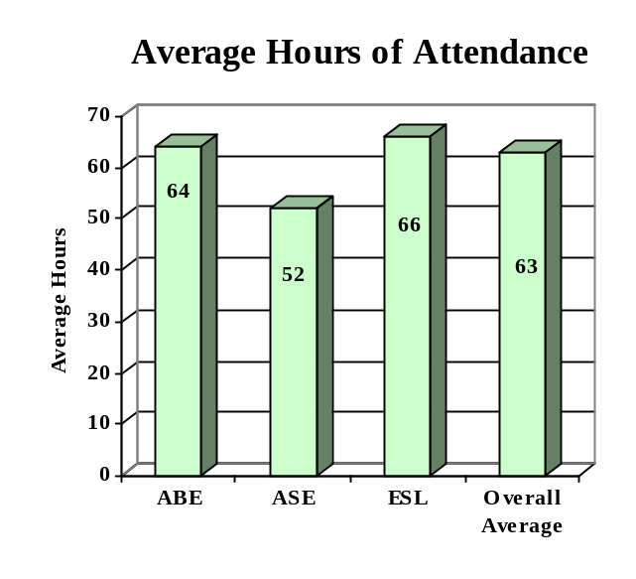

ENROLLMENT

Adult Basic Education 14,476 (41%)

Adult Secondary Education 5,574 (16%)
English Literacy 15,211 (43%)

TOTAL 35,261

PARTICIPANT STATUS

Employed - 1,593

Unemployed - 10,190

Correctional Setting - 3,572

On Public Assistance - 4,872

Other Institutionalized - 191

AGE

16 - 18 2,894 (08%)

19 - 24 8,166 (23%)
25 - 44 17,265 (49%)

45 - 59 5,355 (15%)
60 + 1,581 (05%)

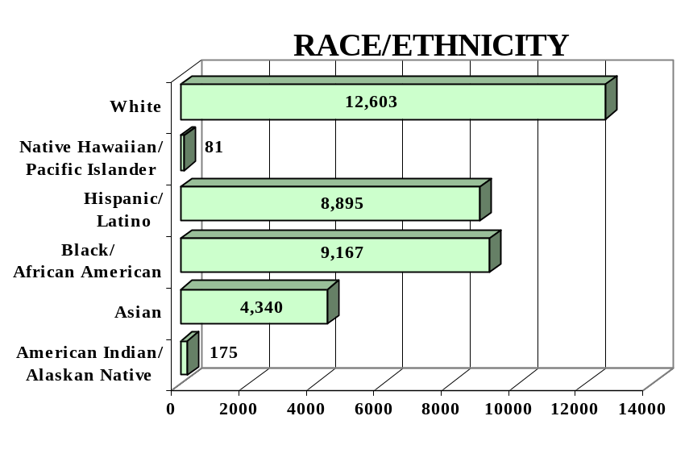
GENDER

Male - 15,130 (43%) Female - 20,131 (57%)

FEDERAL ALLOCATION
FY 2000

Basic Grant - $ 10,000,586
EL/Civics - $ 551,515

TOTAL - $ 10,552,101

VIRGINIA | Average  Performance Target | Actual  Performance | Status | Adults Completing  at Least One Level
Performance Measure I – Demonstrated Improvement in Literacy Skills  Sub Measures  Adult Basic and Secondary Education:^{1/} The percentage of adults enrolled in basic literacy programs who acquired the basic skills needed to complete the level of instruction in which they were initially enrolled.  English Literacy: ^{2/} The percentage of adults enrolled in English Literacy programs who acquired the level of English language skills needed to complete the level of instruction in which they were initially enrolled. | 27%  29% | 30%  28 | ↑  ↓ | 5,089  4,245
 | Performance Target | Actual  Performance | Status | Adults Achieving  Outcome
Performance Measure II – High School Completion  The percentage of adult learners with a high school completion goal who earned a high school diploma or GED.  Performance Measure III – Entered Postsecondary Education or Training  The percentage of adult learners with a goal to continue their education who enter postsecondary education or training.  Performance Measure IV - Entered Employment  The percentage of unemployed adult learners (in the workforce) with an employment goal who were employed at the end of first quarter after they exited the program.  Performance Measure V – Retained Employment  The percentage of adult learners with a) a job retention goal at the time of enrollment and b) those adults with an employment goal who obtained work by the end of the first quarter after leaving the program who were employed at the end of third quarter after exiting the program. | 28%  20%  18%  20% | 54%  58%  54%  66% | ↑  ↑  ↑  ↑ | 2,248  568  1,578  2,661

Follow-up Methodology Used to Collect Performance Data

Educational Gains
√ Standardized tests

High School Completion Measure
√ Data matching (Official state GED records)

Postsecondary Transition
√ State developed individual student follow-up survey

Entered Employment
√ State developed individual student follow-up survey

Job Retention
√ State developed individual student follow-up survey

Key
↑ Exceeded Performance Target
↔ Met Performance Target
↓ Did Not Meet Performance Target

^{1/} Adult Basic and Secondary Education programs consist of a series of instructional levels with each level representing a hierarchy of basic skills ranging from beginning literacy to high school completion.

^{2/} English Literacy education programs consist of a set of instructional levels with each level representing a hierarchy of English language skills ranging from beginning language literacy to oral language proficiency.

WASHINGTON

PROGRAM FACTS – 2000-2001

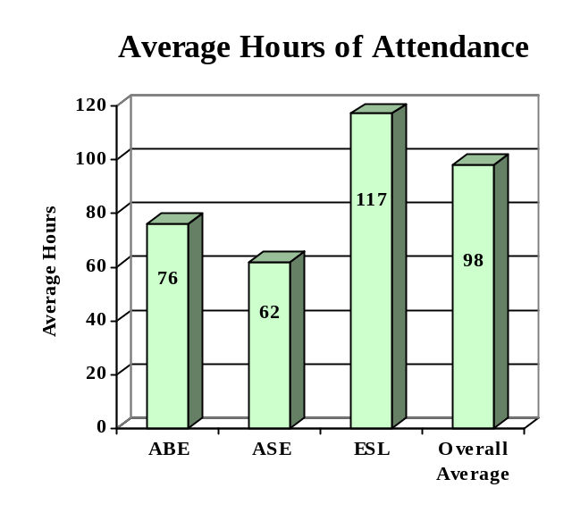

ENROLLMENT

Adult Basic Education 20,205 (38%)

Adult Secondary Education 3,441 (06%)
English Literacy 29,814 (56%)

TOTAL 53,460

PARTICIPANT STATUS

Employed - 17,397

Unemployed - 16,758

Correctional Setting - 7,533

On Public Assistance - 8,932

Other Institutionalized - 0

AGE

16 - 18 3,393 (06%)

19 - 24 13,245 (25%)
25 - 44 28,096 (53%)

45 - 59 6,624 (12%)
60 + 2,102 (04%)

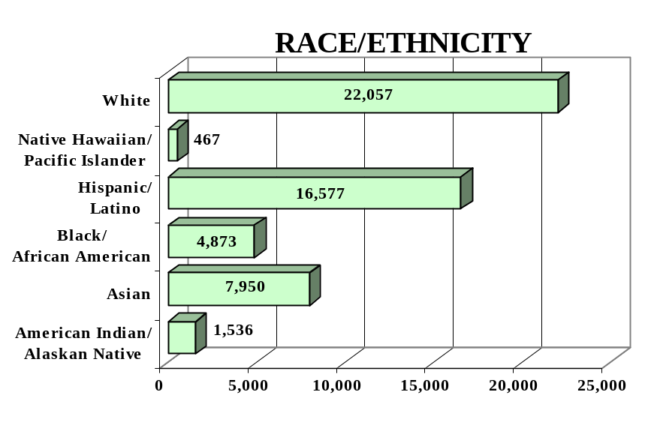
GENDER

Male - 25,740 (48%) Female -27,720 (52%)

FEDERAL ALLOCATION
FY 2000

Basic Grant - $ 5,426,074
EL/Civics - $ 543,549

TOTAL - $ 5,969,623

WASHINGTON | Average  Performance Target | Actual  Performance | Status | Adults Completing  at Least One Level
Performance Measure I – Demonstrated Improvement in Literacy Skills  Sub Measures  Adult Basic and Secondary Education:^{1/} The percentage of adults enrolled in basic literacy programs who acquired the basic skills needed to complete the level of instruction in which they were initially enrolled.  English Literacy: ^{2/} The percentage of adults enrolled in English Literacy programs who acquired the level of English language skills needed to complete the level of instruction in which they were initially enrolled. | 35%  30% | 33%  39% | ↓  ↑ | 7,832  11,655
 | Performance Target | Actual  Performance | Status | Adults Achieving  Outcome
Performance Measure II – High School Completion  The percentage of adult learners with a high school completion goal who earned a high school diploma or GED.  Performance Measure III – Entered Postsecondary Education or Training  The percentage of adult learners with a goal to continue their education who enter postsecondary education or training.  Performance Measure IV - Entered Employment  The percentage of unemployed adult learners (in the workforce) with an employment goal who were employed at the end of first quarter after they exited the program.  Performance Measure V – Retained Employment  The percentage of adult learners with a) a job retention goal at the time of enrollment and b) those adults with an employment goal who obtained work by the end of the first quarter after leaving the program who were employed at the end of third quarter after exiting the program. | 44%  61%  22%  60% | 25%  60%  31%  80% | ↓  ↓  ↑  ↑ | 1,974  2,472  1,813  5,811

Follow-up Methodology Used to Collect Performance Data

Educational Gains
√ Combination of standardized tests and performance-based assessment

High School Completion Measure
√ Data matching (Official state GED records)

Postsecondary Transition
√ Data matching

Entered Employment
√ Data matching (UI employment records)

Job Retention
√ Data matching (UI employment records)

Key
↑ Exceeded Performance Target
↔ Met Performance Target
↓ Did Not Meet Performance Target

^{1/} Adult Basic and Secondary Education programs consist of a series of instructional levels with each level representing a hierarchy of basic skills ranging from beginning literacy to high school completion.

^{2/} English Literacy education programs consist of a set of instructional levels with each level representing a hierarchy of English language skills ranging from beginning language literacy to oral language proficiency.

WEST VIRGINIA

PROGRAM FACTS – 2000-2001

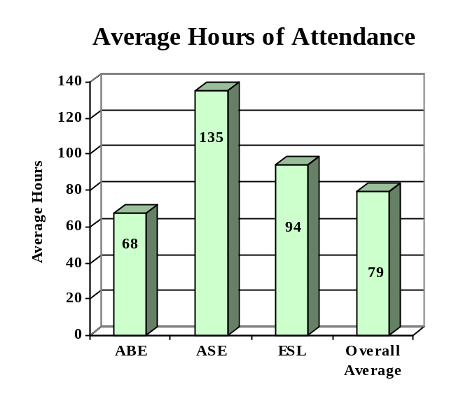

ENROLLMENT

Adult Basic Education 10,915 (84%)

Adult Secondary Education 1,858 (14%)
English Literacy 299 (02%)

TOTAL 13,072

PARTICIPANT STATUS

Employed - 4,271

Unemployed - 3,771

Correctional Setting - 2,273

On Public Assistance - 2,495

Other Institutionalized - 0

AGE

16 - 18 1,315 (10%)

19 - 24 3,456 (27%)
25 - 44 5,626 (43%)

45 - 59 1,532 (12%)
60 + 1,143 (08%)

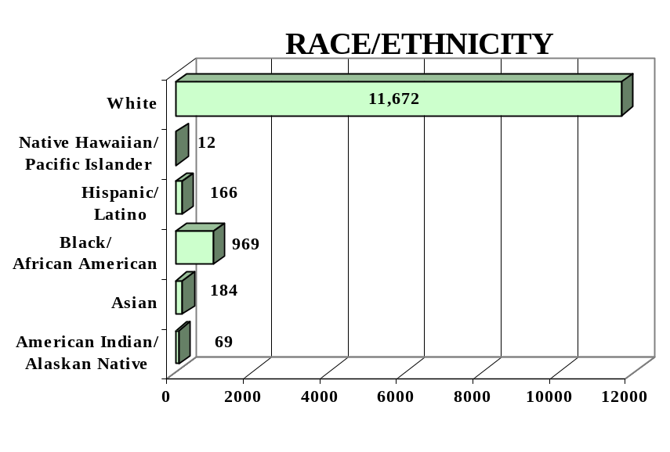
GENDER

Male - 5,640 (43%) Female - 7,432 (57%)

FEDERAL ALLOCATION
FY 2000

Basic Grant - $ 4,088,283
EL/Civics - $ 0

TOTAL - $ 4,088,283

WEST VIRGINIA | Average  Performance Target | Actual  Performance | Status | Adults Completing  at Least One Level
Performance Measure I – Demonstrated Improvement in Literacy Skills  Sub Measures  Adult Basic and Secondary Education:^{1/} The percentage of adults enrolled in basic literacy programs who acquired the basic skills needed to complete the level of instruction in which they were initially enrolled.  English Literacy: ^{2/} The percentage of adults enrolled in English Literacy programs who acquired the level of English language skills needed to complete the level of instruction in which they were initially enrolled. | 26%  24% | 55%  47% | ↑  ↑ | 6,677  141
 | Performance Target | Actual  Performance | Status | Adults Achieving  Outcome
Performance Measure II – High School Completion  The percentage of adult learners with a high school completion goal who earned a high school diploma or GED.  Performance Measure III – Entered Postsecondary Education or Training  The percentage of adult learners with a goal to continue their education who enter postsecondary education or training.  Performance Measure IV - Entered Employment  The percentage of unemployed adult learners (in the workforce) with an employment goal who were employed at the end of first quarter after they exited the program.  Performance Measure V – Retained Employment  The percentage of adult learners with a) a job retention goal at the time of enrollment and b) those adults with an employment goal who obtained work by the end of the first quarter after leaving the program who were employed at the end of third quarter after exiting the program. | 30%  20%  20%  28% | 47%  76%  49%  50% | ↑  ↑  ↑  ↑ | 636  531  239  55

Follow-up Methodology Used to Collect Performance Data

Educational Gains
√ Combination of standardized tests and performance-based assessment

High School Completion Measure
√ Data matching (Official state GED records)

Postsecondary Transition
√ State developed individual student follow-up survey

Entered Employment
√ Data matching (UI employment records)

Job Retention
√ Data matching (UI employment records)

Key
↑ Exceeded Performance Target
↔ Met Performance Target
↓ Did Not Meet Performance Target

^{1/} Adult Basic and Secondary Education programs consist of a series of instructional levels with each level representing a hierarchy of basic skills ranging from beginning literacy to high school completion.

^{2/} English Literacy education programs consist of a set of instructional levels with each level representing a hierarchy of English language skills ranging from beginning language literacy to oral language proficiency.

WISCONSIN

PROGRAM FACTS – 2000-2001

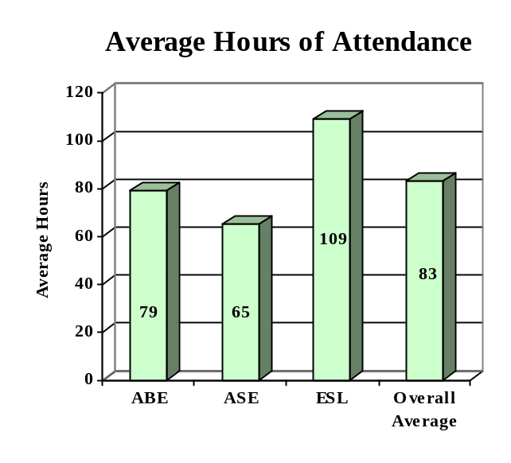

ENROLLMENT

Adult Basic Education 14,178 (52%)

Adult Secondary Education 6,626 (24%)
English Literacy 6,500 (24%)

TOTAL 27,304

PARTICIPANT STATUS

Employed - 10,014

Unemployed - 6,441

Correctional Setting - 2,348

On Public Assistance - 855

Other Institutionalized - 0

AGE

16 - 18 4,494 (16%)

19 - 24 8,357 (31%)
25 - 44 11,634 (43%)

45 - 59 2,414 (09%)
60 + 405 (01%)

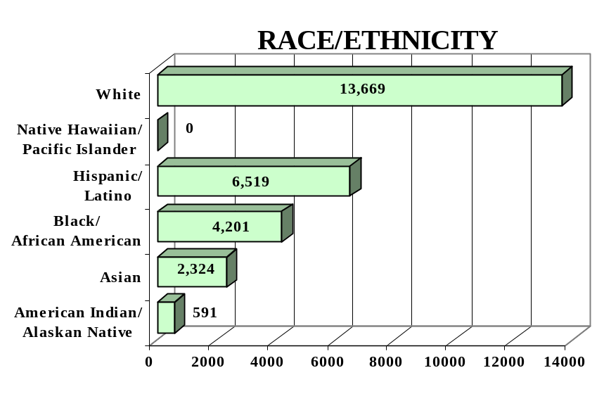
GENDER

Male - 13,034 (48%) Female - 14,270 (52%)

FEDERAL ALLOCATION
FY 2000

Basic Grant - $ 6,648,433
EL/Civics - $ 117,930

TOTAL - $ 6,766,363

WISCONSIN | Average  Performance Target | Actual  Performance | Status | Adults Completing  at Least One Level
Performance Measure I – Demonstrated Improvement in Literacy Skills  Sub Measures  Adult Basic and Secondary Education:^{1/} The percentage of adults enrolled in basic literacy programs who acquired the basic skills needed to complete the level of instruction in which they were initially enrolled.  English Literacy: ^{2/} The percentage of adults enrolled in English Literacy programs who acquired the level of English language skills needed to complete the level of instruction in which they were initially enrolled. | 25%  24% | 57%  43% | ↑  ↑ | 10,211  2,819
 | Performance Target | Actual  Performance | Status | Adults Achieving  Outcome
Performance Measure II – High School Completion  The percentage of adult learners with a high school completion goal who earned a high school diploma or GED.  Performance Measure III – Entered Postsecondary Education or Training  The percentage of adult learners with a goal to continue their education who enter postsecondary education or training.  Performance Measure IV - Entered Employment  The percentage of unemployed adult learners (in the workforce) with an employment goal who were employed at the end of first quarter after they exited the program.  Performance Measure V – Retained Employment  The percentage of adult learners with a) a job retention goal at the time of enrollment and b) those adults with an employment goal who obtained work by the end of the first quarter after leaving the program who were employed at the end of third quarter after exiting the program. | 28%  15%  18%  23% | 29%  35%  18%  72% | ↑  ↑  ↔  ↑ | 1,364  1,808  875  5,115

Follow-up Methodology Used to Collect Performance Data

Educational Gains
√ Combination of standardized tests and performance-based assessment

High School Completion Measure
√ Data matching (Official state GED records)

Postsecondary Transition
√ Data matching (community college enrollment data base)

Entered Employment
√ Data matching (UI employment records)

Job Retention
√ Data matching (UI employment records)

Key
↑ Exceeded Performance Target
↔ Met Performance Target
↓ Did Not Meet Performance Target

^{1/} Adult Basic and Secondary Education programs consist of a series of instructional levels with each level representing a hierarchy of basic skills ranging from beginning literacy to high school completion.

^{2/} English Literacy education programs consist of a set of instructional levels with each level representing a hierarchy of English language skills ranging from beginning language literacy to oral language proficiency.

WYOMING

PROGRAM FACTS – 2000-2001

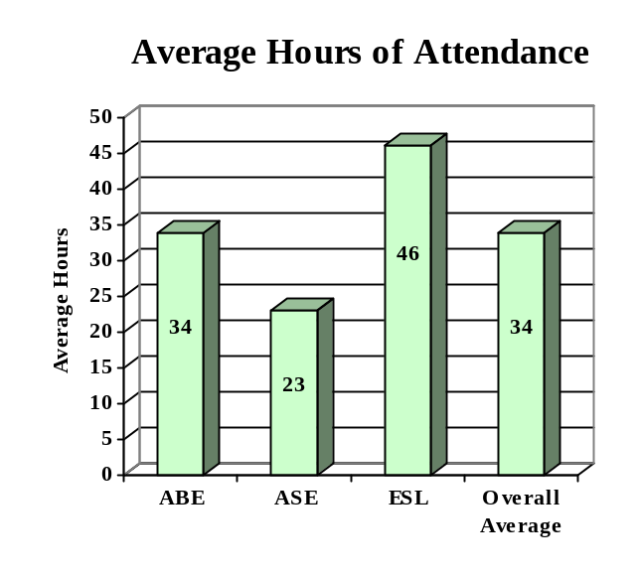

ENROLLMENT

Adult Basic Education 1,702 (61%)

Adult Secondary Education 635 (23%)
English Literacy 430 (16%)

TOTAL 2,767

PARTICIPANT STATUS

Employed - 1,091

Unemployed - 953

Correctional Setting - 384

On Public Assistance - 497

Other Institutionalized - 32

AGE

16 - 18 722 (26%)

19 - 24 849 (31%)
25 - 44 871 (32%)

45 - 59 260 (09%)
60 + 65 (02%)

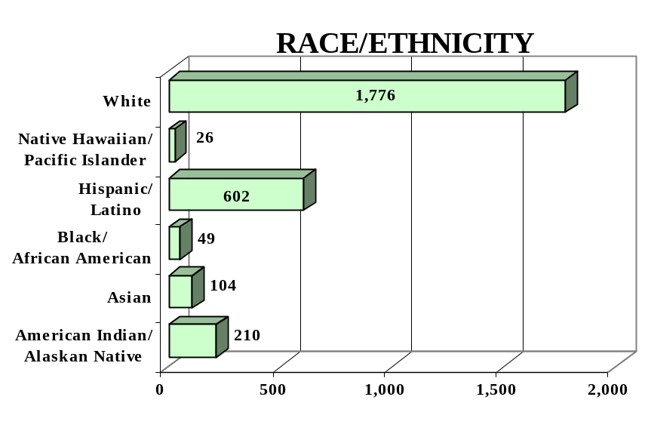
GENDER

Male - 1,363 (49%) Female - 1,404 (51%)

FEDERAL ALLOCATION
FY 2000

Basic Grant - $ 711,161
EL/Civics - $ 0

TOTAL - $ 711,161

WYOMING | Average  Performance Target | Actual  Performance | Status | Adults Completing  at Least One Level
Performance Measure I – Demonstrated Improvement in Literacy Skills  Sub Measures  Adult Basic and Secondary Education:^{1/} The percentage of adults enrolled in basic literacy programs who acquired the basic skills needed to complete the level of instruction in which they were initially enrolled.  English Literacy: ^{2/} The percentage of adults enrolled in English Literacy programs who acquired the level of English language skills needed to complete the level of instruction in which they were initially enrolled. | 34%  28% | 48%  35% | ↑  ↑ | 976  149
 | Average  Performance Target | Actual  Performance | Status | Adults Achieving  Outcome
Performance Measure II – High School Completion  The percentage of adult learners with a high school completion goal who earned a high school diploma or GED.  Performance Measure III – Entered Postsecondary Education or Training  The percentage of adult learners with a goal to continue their education who enter postsecondary education or training.  Performance Measure IV - Entered Employment  The percentage of unemployed adult learners (in the workforce) with an employment goal who were employed at the end of first quarter after they exited the program.  Performance Measure V – Retained Employment  The percentage of adult learners with a) a job retention goal at the time of enrollment and b) those adults with an employment goal who obtained work by the end of the first quarter after leaving the program who were employed at the end of third quarter after exiting the program. | 24%  11%  10%  25% | 46%  39%  41%  26% | ↑  ↑  ↑  ↑ | 583  159  139  90

Follow-up Methodology Used to Collect Performance Data

Educational Gains
√ Combination of standardized tests and performance-based assessment

High School Completion Measure
√ Data matching (Official state GED records)

Postsecondary Transition
√ Data matching (Official state GED records)

Entered Employment
√ State developed individual student follow-up survey

Job Retention
√ State developed individual student follow-up survey

Key
↑ Exceeded Performance Target
↔ Met Performance Target
↓ Did Not Meet Performance Target

^{1/} Adult Basic and Secondary Education programs consist of a series of instructional levels with each level representing a hierarchy of basic skills ranging from beginning literacy to high school completion.

^{2/} English Literacy education programs consist of a set of instructional levels with each level representing a hierarchy of English language skills ranging from beginning language literacy to oral language proficiency.

GUAM

PROGRAM FACTS – 2000-2001

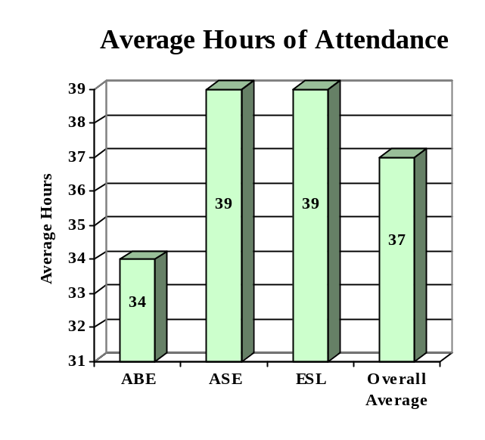

ENROLLMENT

Adult Basic Education 380 (35%)

Adult Secondary Education 522 (48%)
English Literacy 190 (17%)

TOTAL 1,092

PARTICIPANT STATUS

Employed - 394

Unemployed - 480

Correctional Setting - 21

On Public Assistance - 141

Other Institutionalized - 0

AGE

16 - 18 215 (20%)

19 - 24 415 (38%)
25 - 44 409 (37%)

45 - 59 43 (04%)
60 + 10 (01%)

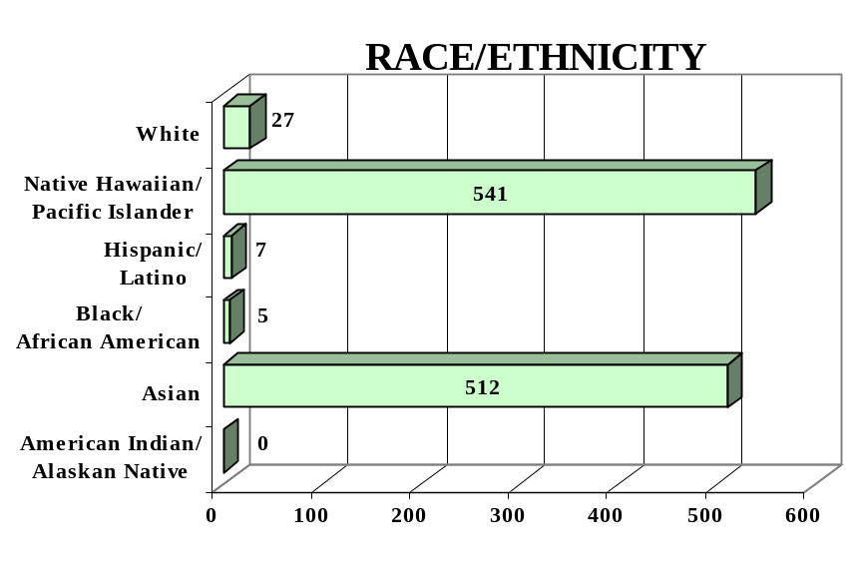

GENDER

Male - 555 (51%) Female - 537 (49%)

FEDERAL ALLOCATION
FY 2000

Basic Grant - $ 292,359
EL/Civics - $ 0

TOTAL - $ 292,359

GUAM | Average  Performance Target | Actual  Performance | Status | Adults Completing  at Least One Level
Performance Measure I – Demonstrated Improvement in Literacy Skills  Sub Measures  Adult Basic and Secondary Education:^{1/} The percentage of adults enrolled in basic literacy programs who acquired the basic skills needed to complete the level of instruction in which they were initially enrolled.  English Literacy: ^{2/} The percentage of adults enrolled in English Literacy programs who acquired the level of English language skills needed to complete the level of instruction in which they were initially enrolled. | 18%  24% | 28%  45% | ↑  ↑ | 108  85
 | Performance Target | Actual  Performance | Status | Adults Achieving  Outcome
Performance Measure II – High School Completion  The percentage of adult learners with a high school completion goal who earned a high school diploma or GED.  Performance Measure III – Entered Postsecondary Education or Training  The percentage of adult learners with a goal to continue their education who enter postsecondary education or training.  Performance Measure IV - Entered Employment  The percentage of unemployed adult learners (in the workforce) with an employment goal who were employed at the end of first quarter after they exited the program.  Performance Measure V – Retained Employment  The percentage of adult learners with a) a job retention goal at the time of enrollment and b) those adults with an employment goal who obtained work by the end of the first quarter after leaving the program who were employed at the end of third quarter after exiting the program. | 62%  11%  10%  16% | 39%  27%  60%  NA | ↓  ↑  ↑ | 199  NA  NA  NA

Follow-up Methodology Used to Collect Performance Data

Educational Gains
√ Standardized tests

High School Completion Measure
√ Data matching (Official state GED records)
√ State developed individual student follow-up survey

Postsecondary Transition
√ State developed individual student follow-up survey

Entered Employment
√ Data matching (UI employment records)
√ State developed individual student follow-up survey

Job Retention
√ Data matching (UI employment records)
√ State developed individual student follow-up survey

Key
↑ Exceeded Performance Target
↔ Met Performance Target
↓ Did Not Meet Performance Target

^{1/} Adult Basic and Secondary Education programs consist of a series of instructional levels with each level representing a hierarchy of basic skills ranging from beginning literacy to high school completion.

^{2/} English Literacy education programs consist of a set of instructional levels with each level representing a hierarchy of English language skills ranging from beginning language literacy to oral language proficiency.

1 As used in this report, the term “State” includes the 50 States, the District of Columbia, and Puerto Rico. While the report includes a separate table showing performance and other statistical data for Guam, these data are not discussed in the summary of national results that begins on page 6.
 The average performance of all sub-measures exceeded the average performance target for all sub-measures.
 The average performance of all sub-measures exceeded the average performance targets for all sub-measures.

